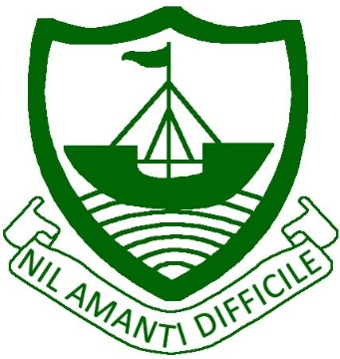
RAMSEY
Isle of Man
IM8 2RG

Telephone: 01624 811100
Fax: 01624 811101
E Mail: RGSenquiries@sch.im

Ramsey Grammar School
Scoill Ghrammeydys Rhumsaa

Headteacher
Ardynseyder
A G Baker M Ed NPQH

25th February 2020

Dear Parents/Carers

Year 9 Vaccination Consent Form

An immunisation booster vaccination session for Tetanus, Diphtheria, Polio and Meningitis ACWY/Septicaemia is due to be held on Tuesday 3rd March at the school.

If you wish your child to receive the booster, please complete the enclosed consent form and return it to school prior to the sessions taking place. Similarly, if you do not give consent, please mark the form accordingly.

The session will be run by staff from the Ramsey Group Practice and they or the Public Health Directorate will be able to give further advice should you need it. The consent form contains contact details and a web link.

Yours sincerely,

Mr L Dewick
Head of Year 9

