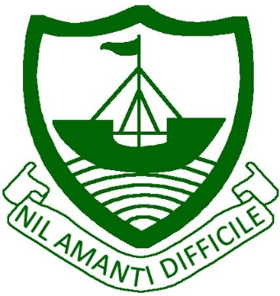
RAMSEY
Isle of Man
IM8 2RG

Telephone: 01624 811100
Fax: 01624 811101
E Mail: RGSenquiries@sch.im

Ramsey Grammar School
Scoill Ghrammeydys Rhumsaa

Headteacher
Ardynseyder
A G Baker M Ed NPQH

April 3rd 2020

Dear Parent/Carer,

Today, we have received further guidance from Ofqual, regarding how examination grades will be calculated for Year 11 and 13 students in the coming months. They have also published a letter to students (available alongside this letter). The guidance is pertinent to the following examination boards:

- AQA
- OCR
- Pearson
- WJEC Eduqas
- ASDAN
- City & Guilds

Please be aware, we are awaiting guidance from Cambridge Assessment, which should be forthcoming in the next few days.

Please do not contact individual members of staff, as the assessment process will be administered centrally, in accordance with the regulations.

With best wishes to you and your family.

Yours sincerely

Annette Baker
Headteacher

