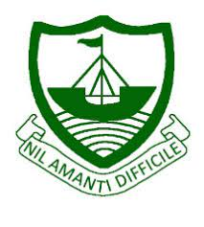
RGS Newsletter
Friday 8th October 2021 – Issue 4

Headteacher’s Award Winners - This week once again we held our Headteacher’s Friday Tea Party. The Headteacher’s award winners were invited along to share their experiences and the reasons for their nomination for this prestigious award. They were chosen by the staff at RGS over all other students in their year group to be recognised as students of excellence. They were nominated for many reasons, but these included house point levels, positivity, exceeding targets, overcoming adversity, determination, resilience, trustworthiness, kindness to others, smart appearance, being proactive, and peer support. A truly inspirational group of young people who really do embody our way of being here at Ramsey Grammar School. We are so proud to have these students as a part of our school community. Well done to them all.

part of our school community. Well done to them all.

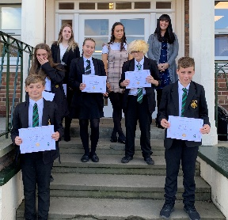
- Year 7 – Oliver Fox
- Year 8 – Mackenzie McLean
- Year 9 – Breesha Logan Cowley
- Year 10 – Orla Goddard
- Year 11 – Jasmine Arthur
- Year 12 – Aalin Penketh
- Year 13 – Ava Brown

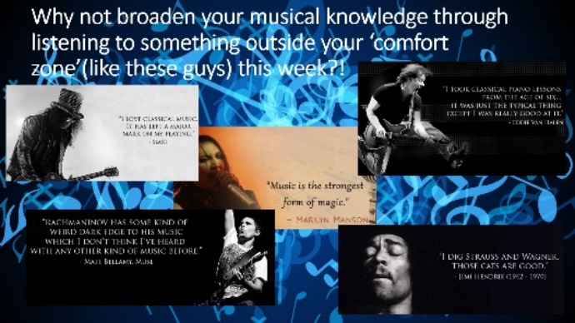
International Day of Music Assembly - This week we have a wonderful assembly hosted by our Head of Music Ms Will. She shared with the students some thoughts and quotes about music around the world. She asked the student to consider why music is important within different cultures around the world. Students were challenged to listen to music outside of their ‘comfort zone’ A wonderfully thought-provoking assembly where we were left considering the fact that, “Music is language itself. It should not have any barriers of caste, creed, language or anything. Music is one, only cultures are different. Music is the language of languages. It is the ultimate mother of languages." A R Rahman

Year 7 and 8 Parents’ Evening 4 – 7 pm – We look forward to welcoming Year 7 and 8 parents/carers into school on Tuesday 5th October. Letters have been sent home with students asking you to arrange a 5 minute appointment with your child’s tutor to discuss how your he/she is progressing at RGS. Form Tutors are the people who are most regularly in contact with students during the school day and therefore play a very important role throughout the whole of the academic year. We hope you will take the opportunity to join us to discuss your child’s progress. Copies of the letter are available on our website here if you need further information.
Uniform Reminder – A reminder please to ensure that students are coming to school in the correct school uniform and looking smart. Once again; Very short tight-fitting lycra skirts have never been permitted at Ramsey Grammar School and students wearing these have been told by form tutors that they will need to purchase a suitable school skirt. Nose piercings must be clear and nose rings are not allowed to be worn. If you have any concerns, please contact the school and speak with your child's form tutor.

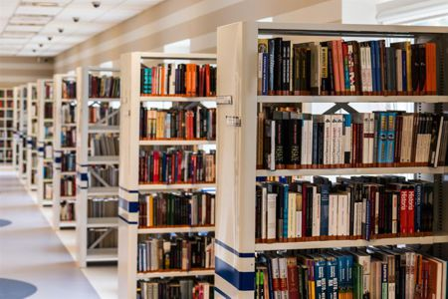
Library Reopening – We are very pleased to announce that the library is now ready to reopen to students. Our librarian and her team of helpers have completed a full stocktake of all the books we hold in the library and prepared them all for the launch of the accelerated reader program starting with Year 7 and Year 8 soon. We have begun the process of appointing student librarians for this academic year and have loved reading the students applications. We will be introducing the new librarian to you in next week’s newsletter so watch this space.

Department Update - KS3 Science - Students in Year 7 have now completed their introduction to ‘Safety in a lab’. Now, Year 7 students will be studying three units this term - Cells (Tissue and Transplants), Acids and Alkalis and Energy resources (Energy and sustainable living). Year 8 students have had a great start to this first term. The topics they are studying are Food and digestion, Atoms and elements and Forces (On the Move). We have started the core science content of the IGCSE with Year 9s. This term students will be covering the content of three units. Biology – Living processes and the environment; Chemistry – Principles of Chemistry; Physics – General Physics, Matter and Forces.
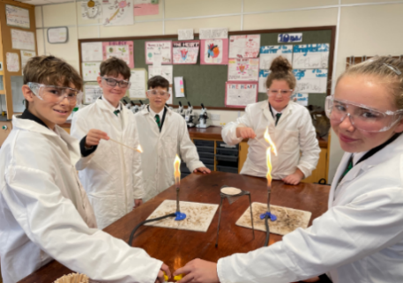
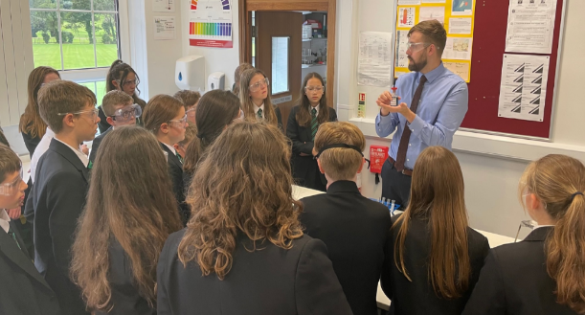
Year 8 Science with Mr Barlow
Year 7 Lab Safety

Department Update - KS4 Science – Year 10 students following the IGCSE pathway are studying Biology – Transpiration, Transport and Human Impact on the Environment. Chemistry- Particulate nature of matter inc. balancing formula. Physics – Forces and motion, Energy Transfer & Electricity. Students following the BTEC pathway have been busy covering content to allow them to complete the first two assignments due in shortly. These assignments are based on Diet and Exercise and Exothermic and Endothermic Reactions. Our Year 11 Co-Science students have been studying; Biology – Homeostasis, Immune and Nervous systems; Chemistry – Chemical bonding, The Mole and Stoichiometry; Physics – Magnets and Electromagnets. Students following the BTEC pathway are working hard on their assignment writing skills. Entry Level students have been studying the science behind Basic First Aid, Having a Baby, Specialised Cells and Food Testing.
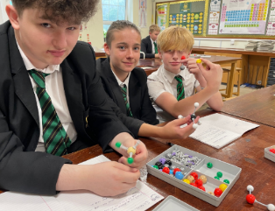
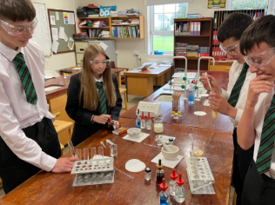
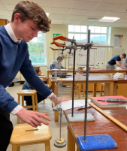
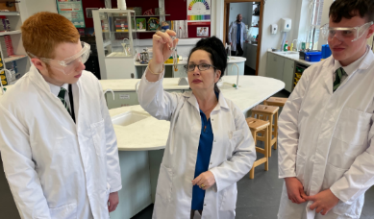

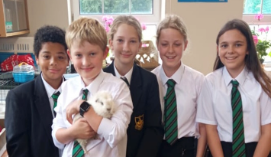
Department Update - KS5 Sciences - Year 12 students in Biology, Physics, Chemistry and Geology have had a great start, with students finding their way with the new academic challenges these courses have to offer. Science offers several lunchtime clubs for students to attend. Here are some of the small animal club members with Snowy our resident guinea pig. Animals and students all doing well!
Department Update – Music - The Music Department has made a positive start to the academic year – getting back to practical music-making in Key Stage 3 and focusing on preparation for examinations in Key Stage 4 and 5. Year 7 are currently focusing on developing their understanding of the elements of music, Year 8 are learning about music from different cultures, and Year 9 are exploring the different facets to minimalism in music. This term, we have started using the online software Focus on Sound with all of our Key Stage 3 students to consolidate their knowledge of music by setting listening tasks for them to complete at home. Students will be given their usernames and password details during lessons, but for logging on they can access the website through the following QR code:
They should then select ‘sign in with application cloud’ (the third option on the list), followed by:
- Country: United Kingdom
- School ID: rgs

At this point, they will be asked for their individual username and password which has been provided by the Music Department. Students currently studying for theory exams, or simply trying to broaden their musical knowledge may find the ‘lessons’ and ‘dictionary’ useful resources on this website.

Instrumental lessons - All students who are currently learning an instrument (or voice) with the Instrumental Music Service should now have resumed their lessons with our visiting staff for this academic year. There are still a few spaces for woodwind and vocal lessons, so if your child is interested in developing a new skill in this area – please get in touch.

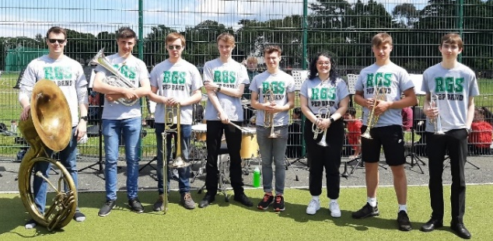
Extra curricular music - All ensembles are ON! After a brief (18 month!) hiatus due to Covid 19, we are proud to announce that our musical ensembles and extra-curricular activities are all starting up again. Amongst other things, we are *starting* to prepare for our annual Carol Service – to be held on December 15th at St Paul’s Church, Ramsey. Here’s a picture of our fabulous Pep Band – who performed at our Sports Day last summer. They are currently preparing for some exciting opportunities this year – we’ll keep you posted!

Our current timetable of extra-curricular activities is as follows:
DAY | TIME | ACTIVITY | LOCATION | STAFF | WHO CAN JOIN?
MONDAY | 12.45 | MUSIC THEORY CLUB | ROOM 11 | Miss Will | Anyone – KS3-KS5
TUESDAY | 12.45 | GCSE/A LEVEL MUSIC COURSEWORK | ROOM 11 | Miss Will | GCSE/A Level / BTEC students
WEDNESDAY | 12.45 | STRING ENSEMBLE | ROOM 11 | Miss Will | All students learning violin/viola/cello/double bass
WEDNESDAY | 12.45 | GUITAR CLUB | MUSIC CENTRE | Mr Brough | Currently GCSE Students
WEDNESDAY | 3.40 | PEP BAND | ROOM 11 | Mr Wood | Invited students only
THURSDAY | 12.45 | CHOIR | ROOM 11 | Miss Will | Anyone – students and staff!
FRIDAY | 12.45 | SENIOR STRINGS | MUSIC CENTRE | Miss Will | Invited students only
FRIDAY | 1.15 | JUNIOR PEP BAND | ROOM 11 | Mr Wood | Invited students only

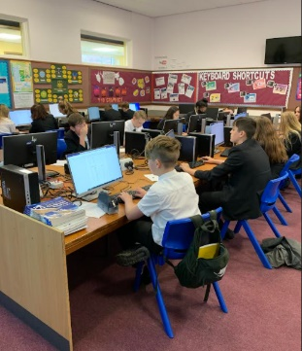
Department Update – Design & Information Technologies - It has been very busy and exciting in the D&IT department since we returned to school in September. There has been a whirlwind of logging on, registering, designing and making, and some excellent products have been produced already! In ICT, the students new to the school have had their Google accounts created and they have also been logged on to their Teams accounts. For those not sure of their logon details, they are as follows: -
Google: firstnamesurname@online.sch.im
Teams: 14firstnamesurname@sch.im
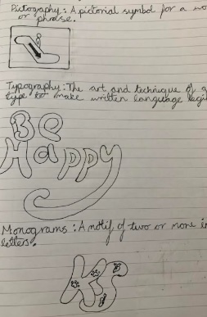
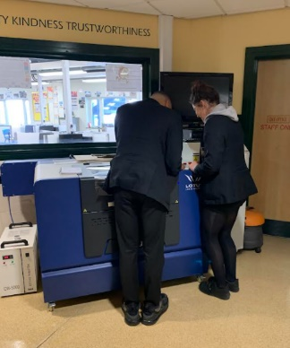
In class, year 7 have been concentrating on their core skills, working with Microsoft and other digital programmes to ensure their knowledge and understanding is up-to-date and ready for not only their ICT lessons but all subjects and ICT activities across the school curriculum. Year 8 have progressed to creating their very own magazines, the budding journalists of the future are enjoying learning the necessary skills to layout and record information making it interesting and appealing for their readers to enjoy. Year 9 are concentrating on binary, which is a method of recording and storing numbers digitally. Mr Skillan has introduced a new topic this year, using the latest graphical technology packages available, year 7 are designing stickers and key rings. From using information technology, students are then moving on to use the vinal machine and the laser cutter. To the right is an example of the early design stages.

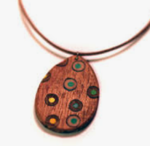
Department Update - Product Design - students are getting their heads around very complicated puzzles. By using hand tools and machinery they are developing new skills, drilling, sawing, filing and vacuum forming thermoplastics to create their very own puzzles complete with packaging. Parents and carers can look forward to solving these masterpieces once finished. Year 8 are producing items of body adornment – the jewellery is taking shape nicely and the results promise to be of very high quality!
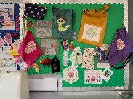
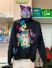
Department Update – Textiles - It has been a hive of activity in Textiles, with students creating items such as mobile bean bags, felt hats, cushions and their very own items of clothing. The photos speak for themselves of the high levels of design and the many ranges of skills used.
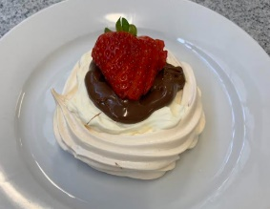
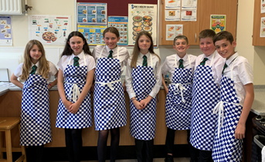
Department Update - Food students have been mixing / mingling / blending / steaming / boiling and baking producing some fantastic products this term. We bought some new aprons this year and the students look very professional. Great food has been leaving the classroom to the delight of the lucky folk at home who either have their dinner made for them after a busy day or a delicious dessert like these amazing meringues put together by year 10 this week.

Key Dates Next Week:
Monday 4th October – World Space Week
Tuesday 5th October – Year 7 and Year 8 Tutor Evening
Tuesday 5th October – World Teachers Day
Wednesday 6th October Readathon Mad Hatter Day
Wednesday 6th of October – Walk to School Day

