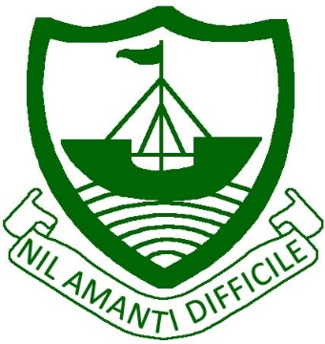
RAMSEY
Isle of Man
IM8 2RG

Telephone: 01624 811100
Fax: 01624 811101
E Mail: enquiries@rgs.sch.im

Ramsey Grammar School
Scoill Ghrammadys Rhumsaa

Headteacher
Ardynseyder
A G Baker M Ed NPQH

Dear Parent / Carer,

Easter Ski Trip 2021 – Friday 26th March – Friday 2nd April 2021 – Tirol Zugspitze Arena, Austria (Zugspitze, Lermoos, Ehrwald)
*****Held at 2018, 2019 & 2020 prices - £999*****
*****Flight from the Isle of Man to UK and then on to Austria*****

I would like to introduce you to the RGS Ski Trip for 2021. As trip leader, I have witnessed the positive impact that this trip has in developing life-long friendships across all school year groups and I would like to extend this invite to your child.

I have successfully negotiated a great deal, meaning no increase on 2018, 2019 & 2020 prices, allowing us once again, to fly from the Isle of Man to the UK and then onto Austria.

We will be travelling to the beautiful Austrian ski area of Tirol Zugspitze - in a fantastic location just over 1hr NW of Innsbruck, close to the famous Zugspitze Glacier, which borders Bavaria. It is a superb resort offering guaranteed snow and no less than 213kms of piste, in the resorts of the Zugspitze Glacier, Lermoos and Ehrwald. Fantastic for all grades of skier with a variety of blue, red and black runs.

Ski Trip Inclusions:-

> Return flights from the Isle of Man > 7 night’s Half Board accommodation (daily lunch to be bought)
> 6 day lift pass > 6 day ski & boot hire
> 6 day helmet hire > A selection of evening activities
> Comprehensive ski travel insurance > Bag carriage

The cost of the trip is £999. If you would like to secure a place on this trip, please complete and return the slip below along with a deposit of £199, cheques payable to Ramsey Grammar School, as soon as possible to avoid disappointment. Deposits are non-refundable in the event of your cancellation. Full trip payment should be made by January 2021, following the suggested monthly payment schedule (by ParentPay) as outlined below.
Deposit (asap) | £199.00
September 28th | £160.00
October 26th | £160.00
November 25th | £160.00
December 18th | £160.00
January 15th | £160.00

Due to the success of previous trips and the deferment of our 2020 trip, I anticipate participation numbers to rise, therefore I would ask you to act fast and I look forward to welcoming your child onto the 2021 ski trip.

Yours sincerely
Mr D J Lillie (Ski Trip Leader)
--------------------------------------------------------------------------------------------------------------------------------------- Easter Ski Trip 2021 – Friday 26th March – Friday 2nd April 2021 – Tirol Zugspitze Arena, Austria

I would like to secure a place on the Easter Ski Trip 2021.
I include a deposit of £199, non-refundable in the event of my cancellation. I agree to pay the full balance by January 2021, following the monthly payment schedule by ParentPay.

Student Name___________________________________________________________Form________________

Parent / Carer Signature___________________________________________________ Date________________

