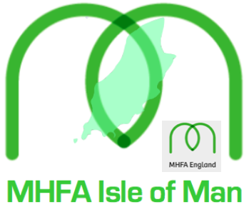
MANX MINDS - MHFA ½ Day Mental Health Aware
Course Application

Name:

Home address:

Telephone/mobile: Email:

MANX MINDS - MHFA ½ Day Mental Health Aware | Venue: | Please ‘X’ to show your seminar session choice:
- Thursday 11th February  Morning: 9a.m - 1p.m. | Ramsey Grammar School
2. Thursday 11th February  Evening: 6p.m - 10p.m. | Ramsey Grammar School
3. Saturday 13th February  morning: 9a.m. -1p.m. | Central Ramsey
4. Monday 15th February:  Morning: 9a.m - 1p.m. | Ramsey Grammar School
5. Monday 15th February  Evening: 6p.m - 10p.m. | Central Ramsey
6. Thursday 25th February  Morning: 9a.m - 1p.m. | Ramsey Grammar School
7. Thursday 25th February  Evening: 6p.m - 10p.m. | Ramsey Grammar School
8. Saturday 27th February  Afternoon: 1p.m. -5p.m. | Ramsey Grammar School

Why do you wish to complete this particular course?

Other well-being courses completed:

Other relevant information:

Dietary requirements /allergies:

The full payment for this course of £30 is required before any course application can be accepted. If you wish to secure a place on your chosen date please organise payment as soon as possible, as places will be allocated on a first come, first served basis (maximum of 20 delegates/session).

Payment by automated bank transfer is preferred quoting:
YOUR NAME & RGS

Please arrange transfer to: acc# 13217917 - sort code: 55-91-00

(If automated payment is not possible cheques should be made payable to: “MANX MINDS” and posted to -
Manx Minds, 1, Barrule Park, Ramsey, IM8 2BW)

— Thank you.

All information will be held in the strictest confidence in accordance with the
Manx Minds Privacy Policy which can be accessed via our website: www.manxminds.com

