Exam Reporting and Student Support Results Days 2019

Key Dates
CIE IGCSE 13/08/19
CIE IA Level 13/08/19
Other A Levels 15/08/19
Other Level1/2 qualifications 22/08/19

Key Stage 5 (Year 13)
UCM will provide results for any students who have completed collaborative school courses in Year 13 to schools before the 13/08/19 (ie BTEC Level 3 etc).

CIE I A Level Results are available online to pupils on 13/08/19.

Teacher support will be available from schools on 15/08/19 when other Level 3 results are released. DESC Careers Adviser appointments will be available for the following week by phoning the Job Centre number 687014.

In addition DfE Careers Adviser interviews/advice is available throughout the Summer at different venues across the Island on set days/times:

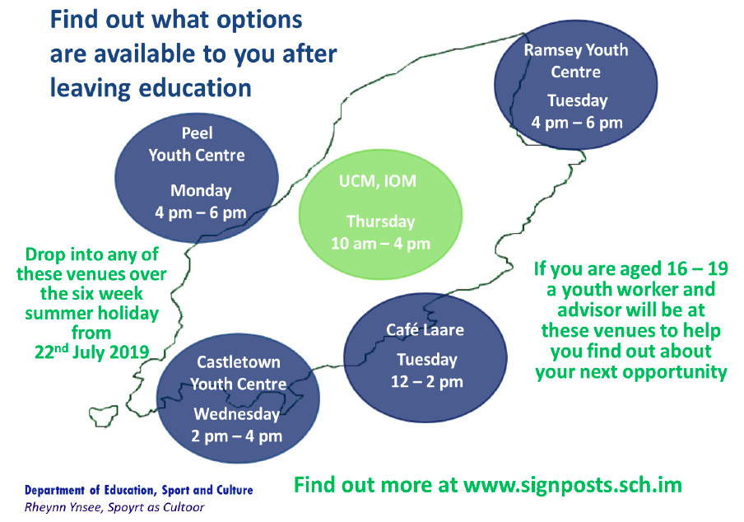

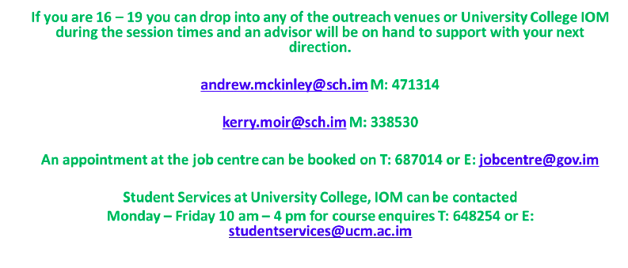

The JobCentre
Nivison House
31 Prospect Hill
Douglas
Isle of Man
IM1 1ET

UCM is providing opportunities to talk through options at UCM every Thursday throughout the Summer. On these days there will be staff from each programme area available to discuss any places still available on UCM Higher Education courses starting in the Autumn Term 2019.

Appointments can be made via the UCM General Enquiries Number on any day 648 200.

Key Stage 4 (Year 11)
UCM will provide results for students who have completed courses whilst at school in Year 11 to schools before the 13/08/19 (ie BTEC, City & Guilds etc).

CIE IGCSE Results will be available online to pupils on 13/08/19.

CIE IGCSE outcomes will give a partial picture of attainment for most students so structured school support will be in place as usual on 22/08/19 when all other qualification results are also available to students.

In addition to teacher support from that school there will also be a member of staff from UCM Student Services present in each school on 22/8/19 and DESC Careers Adviser appointments will be available through the Job Centre number 687014 for the following week.

UCM is providing opportunities to talk through options at UCM every Thursday throughout the Summer. On every Thursday there will be UCM staff from each programme area available to discuss places still available on courses (Level 1, 2 or 3) at UCM starting in the Autumn Term 2019. Appointments can be made by phoning the UCM General Enquiries Number 648 200.

In addition DfE Careers Adviser interviews/advice is available throughout the Summer at different venues across the Island on set days/times:

The JobCentre
Nivison House
31 Prospect Hill
Douglas
Isle of Man
IM1 1ET

School offices are manned throughout the Summer so if parents wish to make an appointment to discuss results when teaching staff are next available then they can contact the usual school number.

School Contacts Results Days Summer 2019

School | Headteacher Contact | School Number | Results days contact for EIS
BHS | Adrienne  Burnett | 648700 | Pete  Wiles
CRHS | Keith  Winstanley | 693500 | John  Danielson
QEII | Sue  Moore | 841000 | Helen  Caley
RGS | Annette  Baker | 811100 | Will  Wood
SNHS | Chris  Coole | 648800 | Darren  McGuinness

UCM – DESC/ School Collaboration results contact for KS4 and 5 results

Date | Activity | SLT Contact for EIS & Schools | Email | Telephone Number
13/8/19 | IGCSE Results Day | Jo Pretty, Principle | Jo.Pretty@ucm.ac.im | via General enquiries  648 200
15/8/19 | KS5  Results Day | Jo Pretty, Principle | Jo.Pretty@ucm.ac.im | via General enquiries  648 200
22/8/19 | KS4 Results Day | Jo Richardson, Assistant Principle | Joanne.Richardson@ucm.ac.im | via General enquiries  648 200

