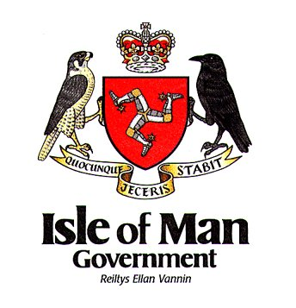

ENDOWMENT FUNDS APPLICATION FORM
FOR REQUEST OF FINANCIAL ASSISTANCE

Surname: Forename

Address/School:

Reason for Request:

Description of Request:

Benefits of attending if
funding is available:

Are you submitting this request for yourself, if no please explain: Yes No
…………………………………………………………………………………………………………………………………………………………………….
Total of funds requested: …………………………………
Have you part paid any of this request by yourself: Yes No if yes how much?......................................

Signature: Date:

Send completed form to: Department of Education, Sport and Culture, Hamilton House, Peel Road, Douglas, Isle of Man, IM1 5EZ

