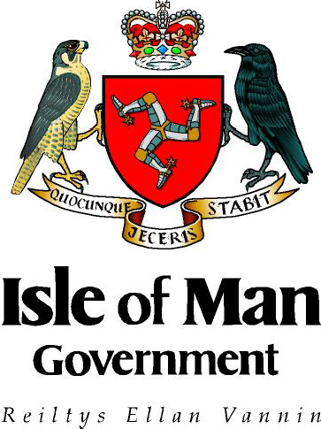

Drugs and Alcohol in Schools
-
Guidance Document

Department of Education, Sport and Culture
Rheynn Ynsee, Spoyrt as Cultoor

July 2019

Rationale
For the purposes of this document the word drug is used to cover:
‘A substance people take to change the way they feel, think or behave’ (United Nations Office on Drugs and Crime)
This definition includes all illegal and legal drugs including alcohol, tobacco and medicines.
The Department of Education, Sport and Culture does not permit the use of illegal drugs within schools’ sites, or the consumption of alcohol on school premises within school hours.
The consumption of alcohol at events held on school premises outside of school hours is permissible, however, this is subject to certain restrictions and conditions (see Alcohol and Drug Workplace Policy for the Public Service.)
For the purposes of this document the word ‘school’ is synonymous with any place where education staffs are employed during their normal working hours (e.g. University College Isle of Man, Youth & Community settings and other off site venues).

Requirements
Each school must have a written policy setting out their ethos and approach in relation to drugs within the wider context of physical and emotional health. This policy should be developed in consultation with stakeholders from the organization / learning community and disseminated throughout the establishment. Awareness raising and training is an important feature of any procedures that are implemented and the Police Liaison Officer is a key individual.

The head teacher or a designated senior member of staff will have responsibility for school drug policy development and review. This senior member of staff will also consider wider safeguarding implications for the student and the community prior to establishing a response for each incident.

Please note, by not reporting the matter to the police properly the potential for individuals themselves committing the offence of possession is very high! By not reporting incidents and thinking ‘in house’, there is a real risk of committing an offence.

The school policy will:
- Complement the guidance relating to medicines in schools and the two should be used together in schools.

- Clarify the school’s approach regarding drugs for staff, pupils, governors, parents/carers, external agencies and the wider community.

- Support the management of incidents involving drugs (including those on school trips) and the content, delivery and organisation of drug education. These may be in separate documents and should be readily accessible to all.

- Take account of current local and national policies and guidance on health, relationships and sex education and wider behaviour policies such as anti-bullying and child protection procedures.

- Clarify the support available to children and young people whose own drug use or that of family members may be causing concerns, including screening, referral or signposting to external agencies.

As part of school policy development:

- Each establishment should refer to the agreed protocols / flowcharts (developed in consultation with the police to assist in decision making - see below in appendix 2) for use when working with outside agencies to promote effective partnerships.

- Each school will have a named lead and person who is responsible for the planning of a drug education programme that is age appropriate and relevant. An overview of this should be publicised and readily accessible to parents/carers through, for example, the schools prospectus or website.

- The response to incidents involving drugs should not be considered in isolation but should be complemented by the overall approach to drug education and the values and ethos of the establishment. This may inform additional review of policy at times.

- Staff should be made familiar with the procedures to be followed if an intoxicated parent/carer is collecting students from school and driving under the influence so that the appropriate safeguarding response can be instigated.
Appendix 1 – Response to Drug Incidents
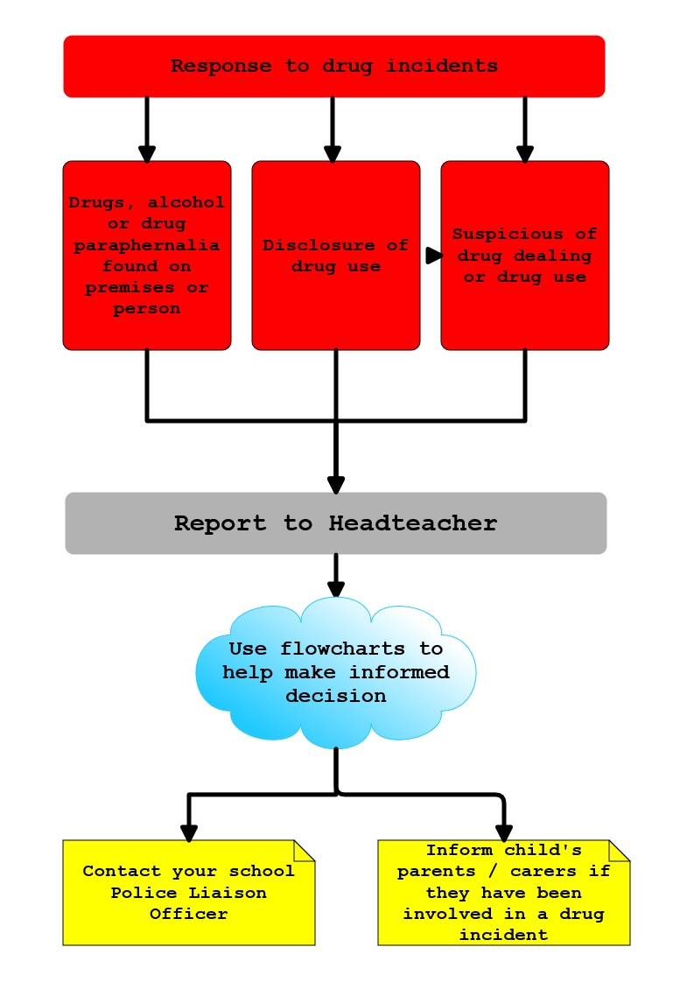

Appendix 2 – Guidance flowcharts. What to do if ….?

1. | Concerns raised about young person (change in behaviour / known to associate with substance misusers / rumours of possession / supplying).
2. | Young person has disclosed misuse of drugs / alcohol / solvents / legal highs or is said to have misused drugs / alcohol / solvents / legal highs.
3. | Young person has been found on school premises intoxicated due to drugs / alcohol / solvents.
4. | Young person is thought to be / rumoured to be in possession of suspected illegal substances / legal highs.
5. | Young person is in possession of alcohol or solvents.
6. | Young person is in possession of a small amount of a suspected illegal drug.
7. | Young person is in possession of a large amount of a Suspected illegal drug with possible intent to supply.
8. | Young person is seen by a member of school staff outside of school; drinking / drug-taking / under the influence of drugs or alcohol.

