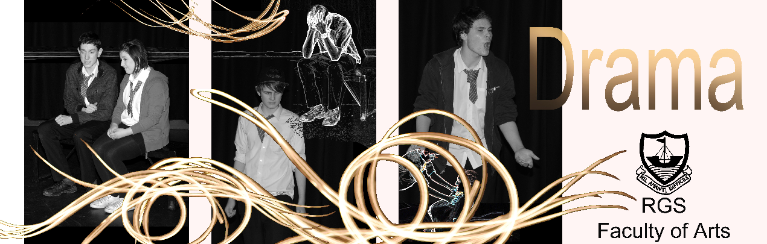

Drama Mission Statement

You ask my advice on acting? Speak clearly, don’t bump into the furniture, and if you must have motivation, think of the pay packet on Friday!’ Noel Coward.
Drama at Ramsey Grammar School is designed for students to develop skills not only within the Drama Studio, but beyond school life and in future employment. Students are able to develop skills that include engagement, communication and oracy, creative imagination, clarity of expression, autonomy, leadership, confidence and co-operation. Opportunities are embedded for students to be able to hone and develop performance talent, but equally important is to understand the purpose of the theatre they create. Methodologies of theatrical practitioners are introduced throughout the Key Stages to enable students not only to ‘re-enact’ but to shape their own ideas with a greater understanding of the need for style, intention, theatrical form and to learn to celebrate individual and unique perspectives.

Drama is essential in developing key skills (sometimes called ‘soft skills’). Drama facilitates young people’s ability to think creatively and critically, collaborate and problem-solve, as well as developing students’ emotional intelligence to communicate and appropriately – all the skills that employers are looking for.

Drama at Key Stage 3:
The aims of Drama at RGS at KS3 are to develop students’ knowledge and understanding of Drama as an art form, whilst also using Drama as a learning tool to investigate various issues, texts and ideas (many of which are cross-curricular). Such investigations will present students with the opportunity to develop their ideas through role-play and acting, as well as developing their confidence, the ability to work as part of a group and to be constructively critical.

Drama Through The Key Stages

‘I believe that the creative arts should be compulsory for all GCSE students – school children should take at least one creative subject until the age of 16 to help boost future talent in the creative industries.’
Bernardine Evaristo (Booker prize-winner)

Drama at Key Stage 3:
The aims of Drama at Ramsey Grammar School at KS3 are to develop students’ knowledge and understanding of Drama as an art form, whilst also using Drama as a learning tool to investigate various issues, texts and ideas (many of which are cross-curricular). Such investigations will present students with the opportunity to develop their ideas through role-play and acting, as well as developing their confidence, the ability to work as part of a group and to be constructively critical.

Drama at GCSE and Post-16 level:
The RGS Drama department follows the WJEC specification at GCSE and AS/A2 level.

The specifications foster candidates’ creativity, personal growth, self-confidence, communication and analytical skills through the acquisition of knowledge, skills, understanding and the exercise of the imagination. Students will have the opportunity to participate in and interpret their own and others’ drama. They will investigate the forms, styles and contexts of drama and will learn to work collaboratively to develop ideas, to express feelings, to experiment with technical elements and reflect on their own and others’ performances.

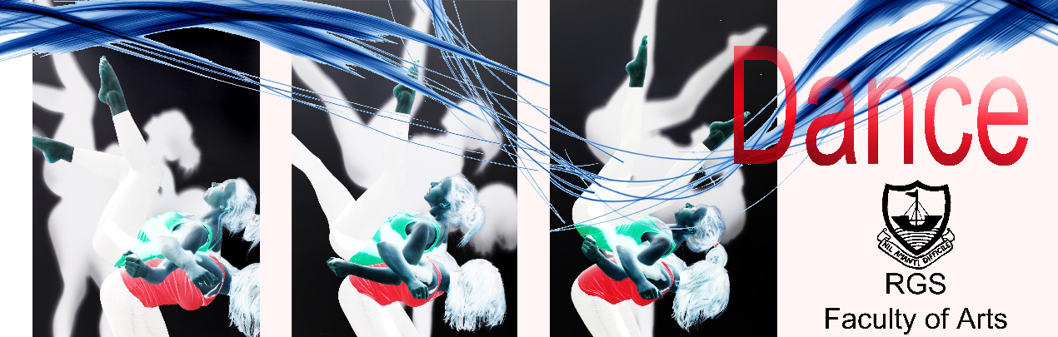

Dance Mission Statement

‘Dance is the hidden language of the soul.’ Martha Graham

Dance at Ramsey Grammar School is designed to give students an experience that will promote enjoyment of the subject, with schemes of work which are related to its historical, cultural, social and ethnic origins. Dance encourages creative expression through imaginative movement, whilst also developing performance skills and overall fitness.

Although Dance is taught as part of the Creative Arts programme at Ramsey Grammar School, however it features within the Physical Education descriptors of the National Curriculum:

- Perform dances using advanced dance techniques within a range of dance styles and forms.
- Analyse their performances compared to previous ones and demonstrate improvement to achieve their personal best.

