Marble pear tray bake
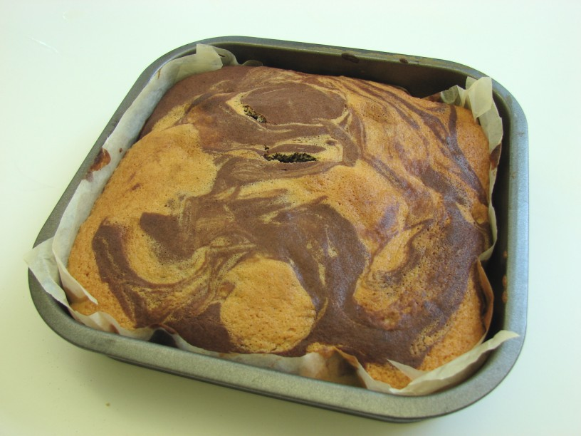
Ingredients
100g caster sugar
100g butter or soft baking spread
Complexity: medium
2 eggs
100g self raising flour
1 x 15ml spoon cocoa powder
1 x 5ml spoon baking powder
1 pear

Equipment
Baking tin (20cm square) or foil tray, weighing scales, mixing bowl, measuring spoons, electric hand whisk, small bowl, sieve, metal spoon, knife, fork, chopping board, spatula, cooling rack.
Method
1. Preheat the oven to 180ºC or gas mark 4.
2. Grease and line the baking tin or foil tray.
3. Cream the sugar and fat together, ideally using an electric hand whisk, until light and fluffy.
4. In a small bowl, beat the eggs with a fork.
5. Add the beaten egg, a little at a time, to the fat and sugar.
6. Sift the flour and baking powder into a bowl.
7. Fold the flour and baking powder into the mixture, a spoonful at a time.
8. Core and chop the pear into small pieces. Scatter pieces of pear into the lined cake tin.
9. Spoon half of the plain cake mixture into the tin.
10. Stir-in the cocoa to the remaining cake mixture.
11. Spoon the chocolate mixture into the baking tin and then swirl the two mixtures together to create a marble effect.
12. Place in the oven and bake for 20 minutes, until golden brown and springy to the touch.
13. Remove from the oven and allow to cool.
Top tips
- When lining the baking tin it is only necessary to line the bottom. The sides can be greased with oil.
- Instead of chocolate, use other spices and fresh fruit, e.g. mixed spice, apricots.

Food skills
- Weigh.
- Measure.
- Core.
- Chop.
- Cream.
- Beat.
- Sift.
- Fold.
- Stir.
- Bake.

This recipe is from the original Licence to Cook programme and is provided under the Open Government Licence.

