Orange, oat and sultana cookies

Ingredients
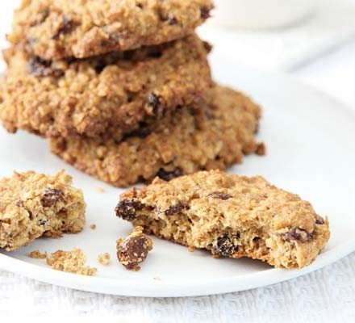
- 100g butter at room temperature
- 1 egg
- 1 ripe banana
- 1 tsp vanilla extract
- 100g light soft brown sugar
- Orange
- 100g wholemeal flour (or plain if you only have that)
- ¼ tsp salt (school)
- 1 tsp baking powder
- 100g rolled oats
- 25g desiccated coconut
- 50g chopped walnuts
- 75g sultanas or chocolate chips

Method
- STEP 1
Heat oven to 180C/160C fan/gas 4. Cream the butter and sugar together until well blended and smooth. Gradually beat in the banana, vanilla extract and egg. Add the zest. Mix well with a wooden spoon until thoroughly blended.
- STEP 2
In a large bowl, mix the flour, salt, baking powder, oats, coconut, walnuts and sultanas or chocolate chips. Stir the dry ingredients into the wet and mix thoroughly until a thick dough is formed. Line a baking sheet with parchment. Drop heaped tbsps onto the sheet, leaving a 5cm (2in) space around each one, and press down lightly. Bake for 15-20 mins until lightly browned. Cool.

