Coleslaw
Ingredients
¼ white cabbage
Complexity: low-medium
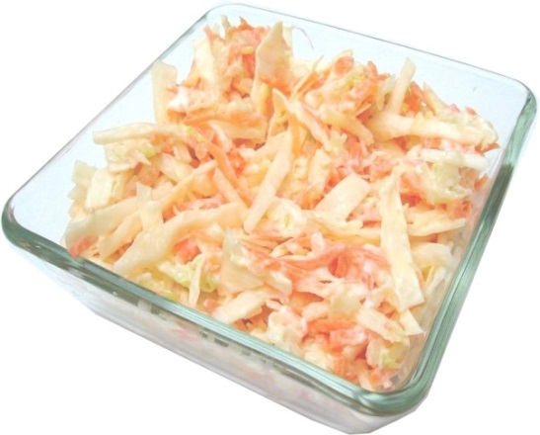
1 carrot
1 medium apple
2 x 15ml spoons of low fat mayonnaise

Equipment
Chopping board, sharp knife, vegetable peeler, grater, mixing bowl, measuring spoon, mixing spoon.

Method
- Prepare the vegetables:
  - shred the cabbage;
  - top and tail, then peel and grate the carrot;
  - core and grate the apple.
- Place the cabbage, grated carrot and apple in the mixing bowl and add the low fat mayonnaise.
- Mix all the ingredients together.

Top tips
- Instead of using only low fat mayonnaise experiment with different combinations of low fat mayonnaise mixed with low fat plain yogurt, fromage frais or crème fraiche.
- Try adding other vegetables such as onion or celery. Why not try making a super salad?
- You can use lots of different ingredients such as fruit, meat, fish, potatoes or rice.

Food skills
- Measure.
- Shred.
- Trim.
- Peel.
- Grate.
- Core.
- Mix.

