Cheese and Onion Pie

Shortcrust pastry
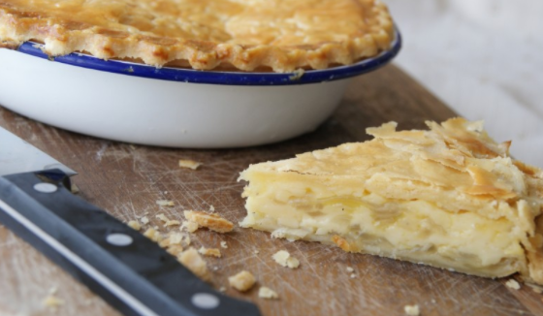
200g plain flour
100g butter

Filling
2 medium potatoes
15g butter
1 onion
1tbs plain flour
100ml milk
150g cheese
(Flavouring optional, mustard, cayenne pepper, salt and pepper)

Pie plate approximately 20 cm in diameter.

Method

Light the oven, 200 C. Grease the pie plate.

- Sieve the flour into a bowl. Add the margarine and white fat and cut into small pieces.
- Rub the fat into the flour using your fingertips, until the mixture looks like bread crumbs.
- Add the water a little at a time to mix to a firm, smooth dough.
- Chill the dough in the fridge.
- Get a large pan and add 1litre of water, turn on the hob and get the water boiling. Meanwhile peel the potatoes and cut into thin slices. Add to the water and boil for 10 minutes, drain in a colander.
- Grate the cheese and put this into a small bowl. Chop the onions into small pieces.
- Melt the butter in the pan, fry the onions for 5 minutes. Add the flour, stir, then add the milk slowly. Stir until thick then add the slices of potato and grated cheese and season well.
- Divide the pastry into two, one slightly larger than the other. Roll out the smaller piece and use it to line the plate.
- Pour the potato and cheese mixture into the dish and place the other piece of pastry on top of the pie, glaze with egg wash.
Bake for 30 minutes until golden brown.

