Homemade (Healthy) Doner Kebab
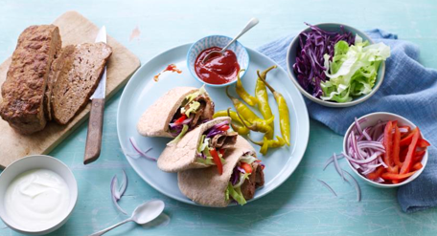

Ingredients
- 250g strong bread flour (to make the pitta bread, yeast in school)
- 400g/14oz lean lamb mince (if you prefer use chicken or make them vegetarian, your choice)
- 2 garlic cloves, crushed
These are the spices for the meat, all are available at school
- 1 tsp ground cumin
- 1 tsp ground coriander
- ½ tsp onion powder
- ½ tsp smoked paprika
- ½ tsp sea salt
- ½ tsp freshly ground black pepper

To serve – perhaps hummus, guacamole (have a go making your own, recipes available from school or BBC Good Food website)

Here are some suggestions for salad:-
- ½ iceberg lettuce, finely shredded
- ¼ red cabbage, cored and finely shredded
- ½ red onion, thinly sliced
- 1 red pepper, sliced
- 2 tbsp chilli sauce
- 4 tbsp low-fat plain yoghurt
- 2 tbsp pickled chillies (optional)

Method

- Preheat the oven to180C. Brush the oil over a 1kg/2lb 4oz loaf tin.
- Tip the mince into a large bowl, add the garlic, spices and seasoning and mix with your hands until smooth. Press into the loaf tin and bake for 20 minutes. Set aside until cool enough to handle.
- Meanwhile, make the pitta breads.
- Turn the meat out of the tin and slice the kebab lengthways into thin strips. Open up each pitta to create a pocket and pile in the salad ingredients and meat. Add chilli sauce and yoghurt, plus pickled chillies if using.

