Lamb keema

Keema simply means minced meat – any meat can be used for this recipe
Ingredients:
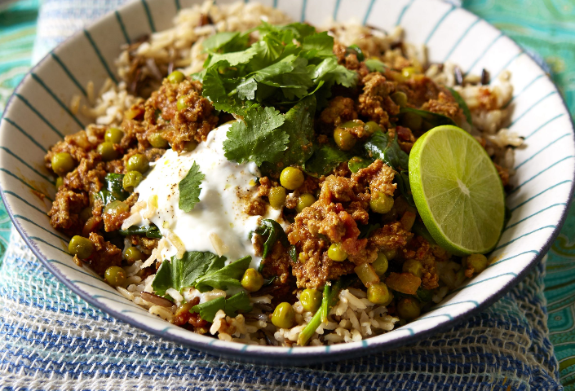
- 1 large onion, peeled
- 3 garlic cloves
- 2 green chillies, seeds removed
- 1 piece of ginger (thumb sized)
- 2 tbsp olive oil
- 400g lamb mince
- 2 large tomatoes (chopped)
- 2 tbsp natural yoghurt
- 2 small carrots, peeled and sliced
- 150 g frozen peas
- 2 tbsp garam masala
- 1 tbsp turmeric
- pinch of cayenne pepper
- squeeze of fresh lemon juice
- bunch of coriander, chopped
Method:
First, we prepared the paste. In a food processor we chopped the onion, garlic, chillies and ginger, then we fried it with spices on a very hot pan, to make it fragrant and aromatic.
- Peel the onion, garlic and ginger, remove seeds from chillies. Place them all together in a food processor’s bowl and chop finely.
- In a deep, large pan heat the oil and add the chopped ingredients. Fry them for 2 - 3 minutes over a medium - high heat until fragrant. Add the spices (garam masala, turmeric and cayenne) and fry for 1 more minute.
- Add the lamb mice and fry, stirring continuously to prevent any lumps, until browned.
- Dip in the tomatoes and yoghurt, add the carrots, season with salt and black pepper, mix well, reduce the heat and simmer for about 30 minutes, stirring from time to time. If the dish is getting too thick add a splash a water.
- Once the meat is cooked, stir in the peas and chopped coriander, add a squeeze of lemon juice and cook for 5 more minutes.
- Serve with basmati rice or naan bread with minted yoghurt and mango chutney.

