Chocolate Cookies

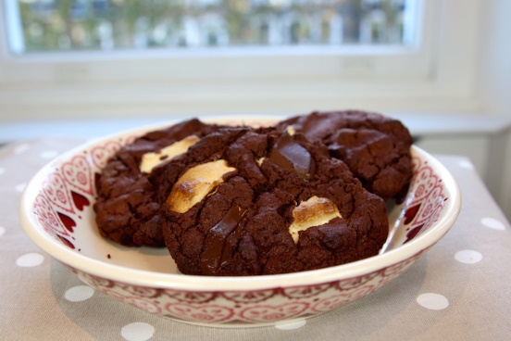

To make 10 (rather large) cookies you will need:
200g butter
300g caster sugar
1 large egg
275g self-raising flour
75g cocoa powder
a little dash of milk
a large bar of milk chocolate
a large bar of white chocolate
a large bar of dark chocolate (this is totally optional - only add if you are a dark choice fan. Or add Daim bars instead for a toffee crunch!)

Method:
- Pop your oven on to 180 C. Grease 2 trays
- Cream together your butter and sugar
- Crack in your egg
- Stir in all the dry ingredients (Add a dash of milk if your mixture is looking dry)
- Break up all of your chocolate and throw it in, using your hands to get it into the dough
- Pick up a 10 small handfuls of cookie dough and place them onto your trays
- Pop them into the oven for 15 minutes (I have found this to be the perfect baking time. When you get them out they will not look cooked, it is vital you know this, as it will be very tempting to leave them in for longer and then they'll be hard and overcooked once they are cool.
- Take your cookies out after 15 minutes and leave them to cool for about 5 minutes.

