Beef and mozzarella meatballs

Ingredients
Complexity: Medium-high
450g beef mince
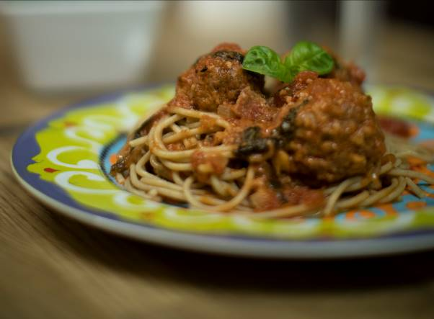80g Parmesan cheese
100g mozzarella cheese
3 garlic cloves
½ x5ml spoon dried chilli flakes
2 x 15ml spoons tomato puree
1 egg
½ x 5ml spoon Worcestershire sauce
1 onion
20g fresh basil leaves
100g streaky bacon
200ml reduced salt vegetable stock
1 x 400g can chopped tomatoes

Equipment
Chopping board, vegetable knife, large mixing bowl, mixing spoon, heat resistant silicone spoon or wooden spoon, small mixing bowl, fork, large oven proof dish, red board, large frying pan, foil, oven gloves.

Method
- Pre-heat the oven to 180°C or gas mark 4.
- Place the beef mince in a large mixing bowl.
- Prepare the ingredients for the meatballs:
  - grate the Parmesan cheese, reserving 1/3 to use later;
  - grate the mozzarella cheese;
  - crush two of the garlic cloves;
  - crack the egg into a small bowl and whisk with a fork.
- Add prepared ingredients to the beef mince, along with the tomato puree and Worcestershire sauce.
- Stir the ingredients until thoroughly combined.
- Using your hands, form the mince mixture into 12 equal meatballs and place them in an oven proof dish. Thoroughly wash and dry your hands after touching the raw meat.
- Prepare the ingredients for the sauce:
  - peel and dice the onion;
  - crush the remaining garlic clove;
  - tear the basil leaves;
  - cut the bacon into small pieces on a red board thoroughly washing and drying your hands afterwards.
- Add the bacon and onions to frying pan and fry for four minutes.
- Add the garlic to the frying pan and cook for a further minute.
- Pour the vegetable stock into the pan. Stir and bring to the boil.
- Pour in the chopped tomatoes.
- Sprinkle over the basil leaves and stir.
- Remove from the heat and pour the sauce over the meatballs.
- Sprinkle the remaining parmesan on top.
- Cover with foil and place in the oven using oven gloves.
- Cook for 35 minutes.
- After 35 minutes remove the foil and cook for a further 10 minutes. Remember to use oven gloves.
Top tips
- Use a reduced fat or lighter cheese to reduce the fat content
- For a smoky flavour why not try smoked paprika, cinnamon and cumin instead of chilli?
- Serve with a selection of roasted vegetables - cook a tray of peppers, onions, cherry tomatoes and courgettes in the oven at the same time as the meatballs.

Food skills
- Grate
- Crush
- Whisk
- Stir
- Form and shape
- Peel
- Dice
- Cut
- Fry
- Boil
- Simmer
- Bake
- Weigh
- Measure

