Jambalaya

Ingredients
Complexity: Medium-high
400g chicken or pork
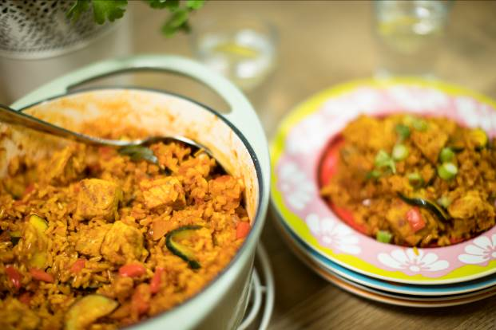1 onion
2 garlic cloves
5 spring onions
½ red pepper
100g button mushrooms
1 Courgette
oil (school)
1 x 5ml spoon mild chilli powder
2 x 5ml spoon ground turmeric
225g easy cook rice
Stock cube
1 x 400g can chopped tomatoes
Ground black pepper
3 Whole cloves

Equipment
Chopping board, vegetable knife, garlic crusher, large saucepan with a lid, heat resistant spoon or wooden spoon, measuring spoons, measuring jug, plate

Method
- Remove any visible fat from the meat and chop into strips.
- Prepare the remaining ingredients:
  - peel and dice the onion;
  - peel and crush the garlic cloves;
  - slice the spring onions into circles, reserving some green tips for garnish;
  - deseed and dice the red pepper;
  - quarter the button mushrooms;
  - halve the courgette and slice.
- Pour the oil into the pan and allow to heat.
- Add meat to pan, stir and allow to brown.
- Remove browned meat from the pan, and place on a clean plate.
- Add the onion, garlic, chilli powder, turmeric and rice to the pan.
- Stir well and cook until the rice turns opaque.
- Add the stock cube to 450ml of boiling water add that plus the tomatoes.
- Sir well and turn up the heat to boil.
- Simmer for 20 minutes.
- Add the meat, whole cloves, spring onions, red pepper, mushrooms and courgettes and stir well.
- Cook for a further 10 minutes, or until the liquid is absorbed. Stir occasionally.
- Sprinkle with the reserved green tops of the spring onions and serve.

