PIZZA PINWHEELS
Dough
500g Strong Bread Flour
1 teaspoon of yeast (school)
1 level teaspoon of salt (school)
1tbsp olive oil (school)
Filling
1 tin of tomatoes / passata or pizza base spread
200g cheese
Optional
Peppers
Pepperoni
Tuna
Sweetcorn
Mixed herbs/basil/garlic

- Light the oven, 180 C. Oil a baking sheet.
- Put the flour, yeast and salt into a bowl.
- Put 300ml of hand hot water into a measuring jug. Be very careful when measuring out your water!!!! Add 1 tablespoon of oil.
- Pour into the flour and mix to a soft dough. Add a little more water if necessary. Knead for 5 minutes.
- Roll out onto the work surface.
- Prepare topping ingredients. Spread tomato mixture – not quite to the edge. Add other prepared ingredients and arrange. Sprinkle cheese on last.
- Roll up from the nearest long side, pinch the edges if the filling tries to escape. Slice the roll into 12 equal pieces. The easiest way to do this is to slice the roll in half, then in half again so you have 4 equal pieces. Slice each of these pieces into 3 pinwheels.
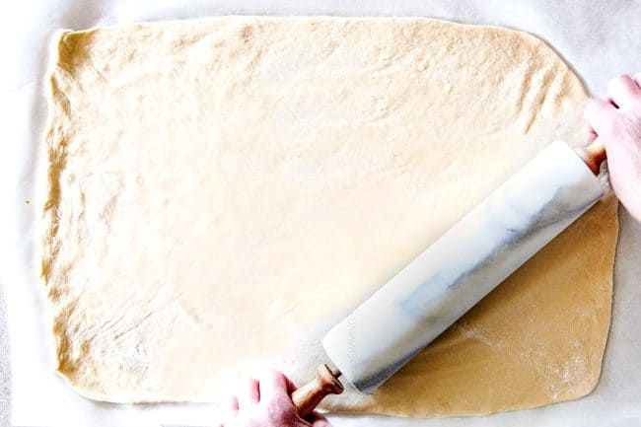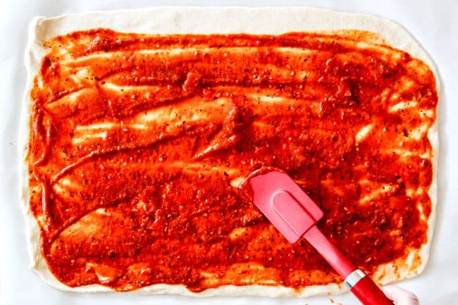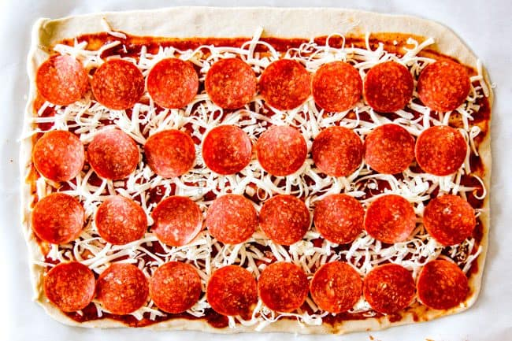

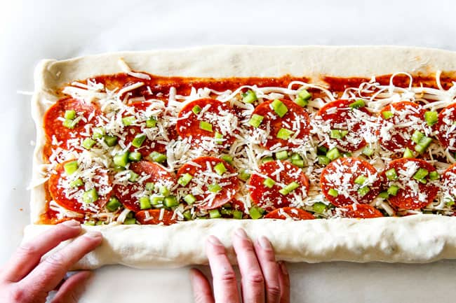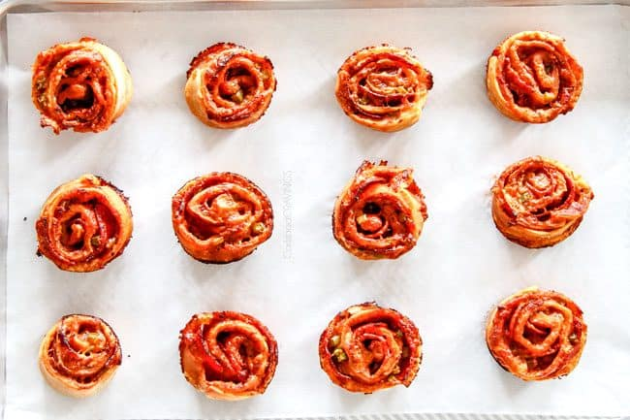

- Place each pinwheel, cut side up, on prepared baking sheet. Bake at 200 C for 25-30 minutes or until dough is golden. Remove from oven and let cool for 5 minutes before removing pinwheels from pan to a wire rack. The Pizza Pinwheels will be a little soft at first but will firm up as they cool. Garnish with fresh parsley.

THEN EAT!

