Yr 7 Food and Nutrition Ingredients list
(Classes with Mrs Butler-Smith, room 173)
Please bring a container each week plus foil or cling film if needed. Where possible spices or unusual ingredients will be supplied by school. Please ask for an alternative recipe rather than not bring ingredients if you don’t like the food. You can always adapt/modify ingredients to suit tastes. These dishes are developed to improve high skill techniques, presentation and encourage healthy eating apart from a couple thrown in for the sweet tooth. Remember – it’s all about balance!
1 | Introduction to course.  Healthy Eating / Eat well Plate  Demo: Healthy Drinks (students get involved making drinks) – ingredients supplied.  Understand health and safety in the Food Room. Food Room expectations. | Objectives for this rota are to develop understand Healthy eating and to develop basic practical skills, while considering balanced diets.
2 | HEALTHY DRINKS  CHOOSE ONE OF THE FOLLOWING:  Orange juice:  3 to 4 oranges  Smoothie:  Soft fruit of your choice.  Eg. Any of the following: Grapes, strawberries, raspberries, blueberries, banana, mango etc.  Milkshake  300 – 500ml Milk and fresh fruit of your choice:  Eg. 1-2 Bananas, 6-10 strawberries, 6-10 raspberries, etc.  Drinking yoghurt:  2 to 3 heaped tablespoons natural yoghurt.  Fruit of your choice. Eg. 1-2 Bananas, 6-10 strawberries, 6-10 raspberries, etc.  BRING in a container to take your drink home in. | Skills:  Basic knife skills  Working with electrical food equipment  Washing up and cleaning  Knowledge:  Eat well plate. Team work.  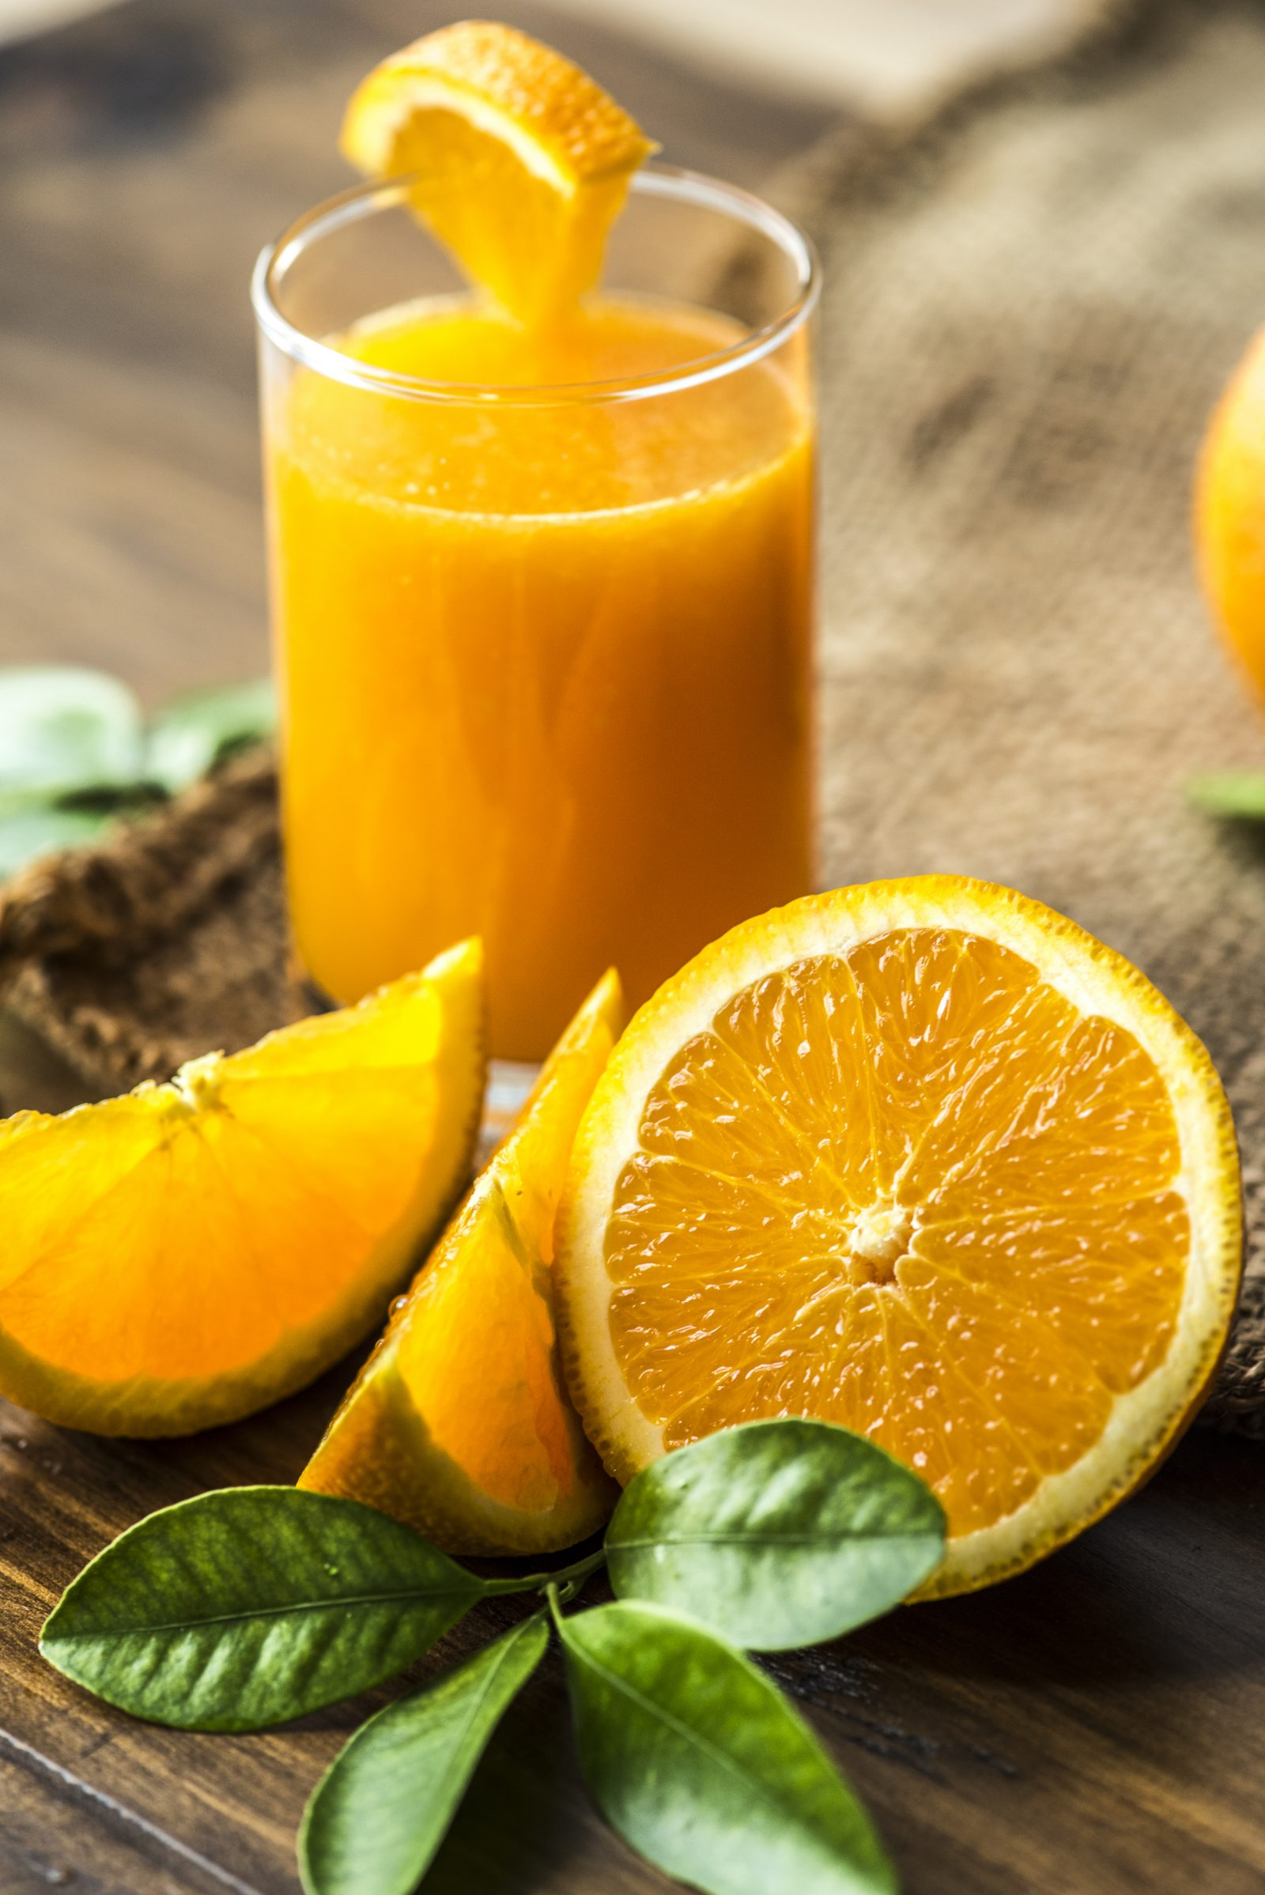  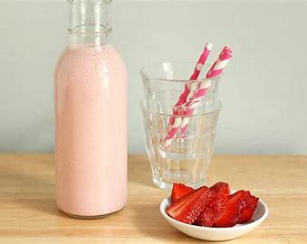  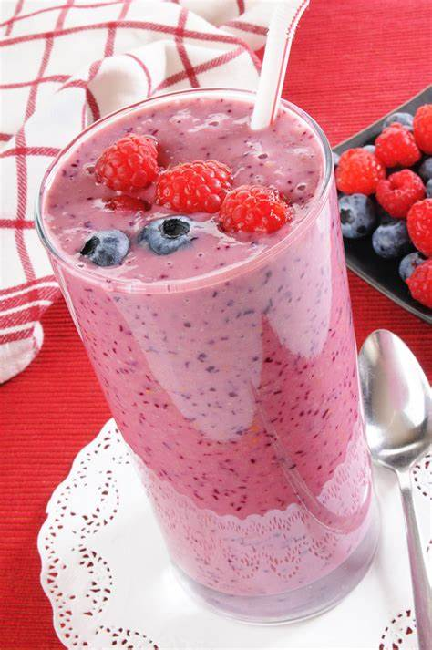  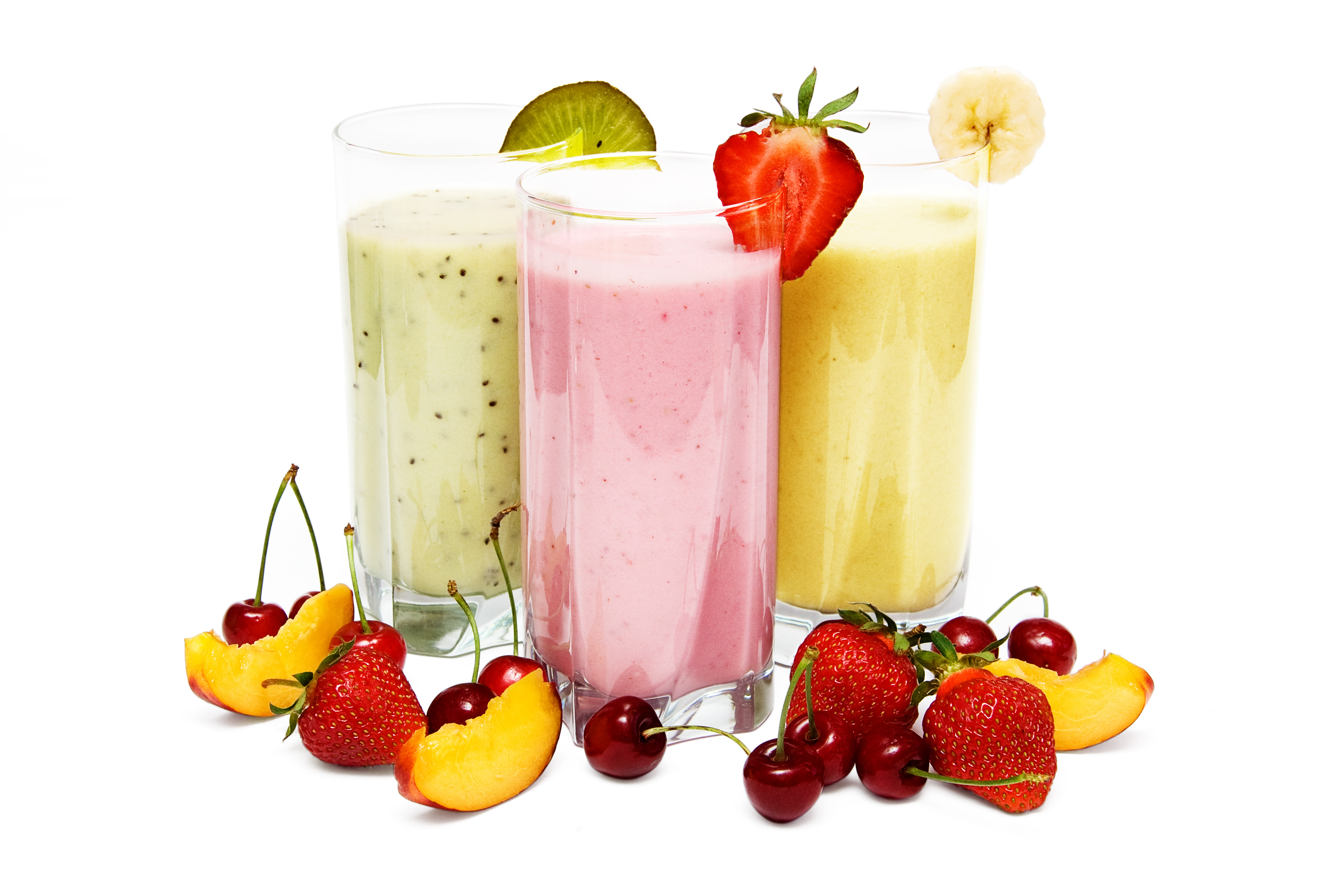
3 | FRUIT CRUMBLE  500g Fruit  125g sugar  100g plain flour  50g margarine  OVEN PROOF DISH eg pie plate. Foil to cover before taking home | Skills:  Rubbing in method, how to use a peeler, preparation of fruit, baking  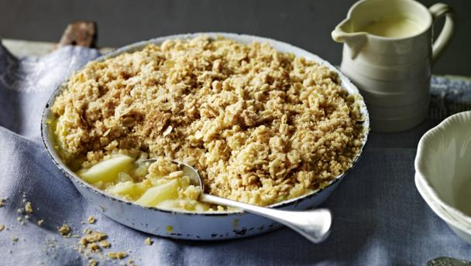  Knowledge:  Healthy Eating.
4 | BOMBAY POTATOES CURRY  500g new potatoes  1 x 15ml spoon oil (school)  1 large onion  1 x 5ml spoon turmeric (school)  1 x 5ml spoon cumin powder (school)  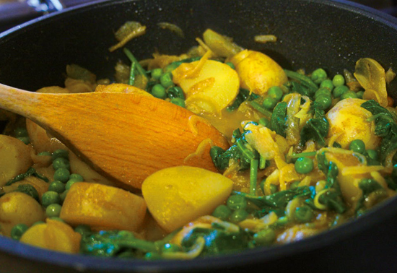  1 x 5ml spoon coriander powder (school)  ¼ x 5ml spoon dried chilli flakes (school)  100g frozen peas  1 handful baby spinach  BRING IN AN OVENPROOF DISH, foil to cover and a TEATOWEL | Skills:  Cooking on the top of the hob,  preparation of vegetables/knife skills)  Knowledge:  Indian cooking. Use of spices
5 | ROCKBUNS  200g Self Raising Flour  75g block margarine  75g sugar  75g dried fruit eg. Raisins, sultanas  - egg  BRING IN A LARGE CONTAINER TO TAKE THEM HOME IN | Skills:  Rubbing in, making a dough, shaping, baking.  Knowledge:  Rules to work with pastry, understanding of product shaping. Planning of product presentation.  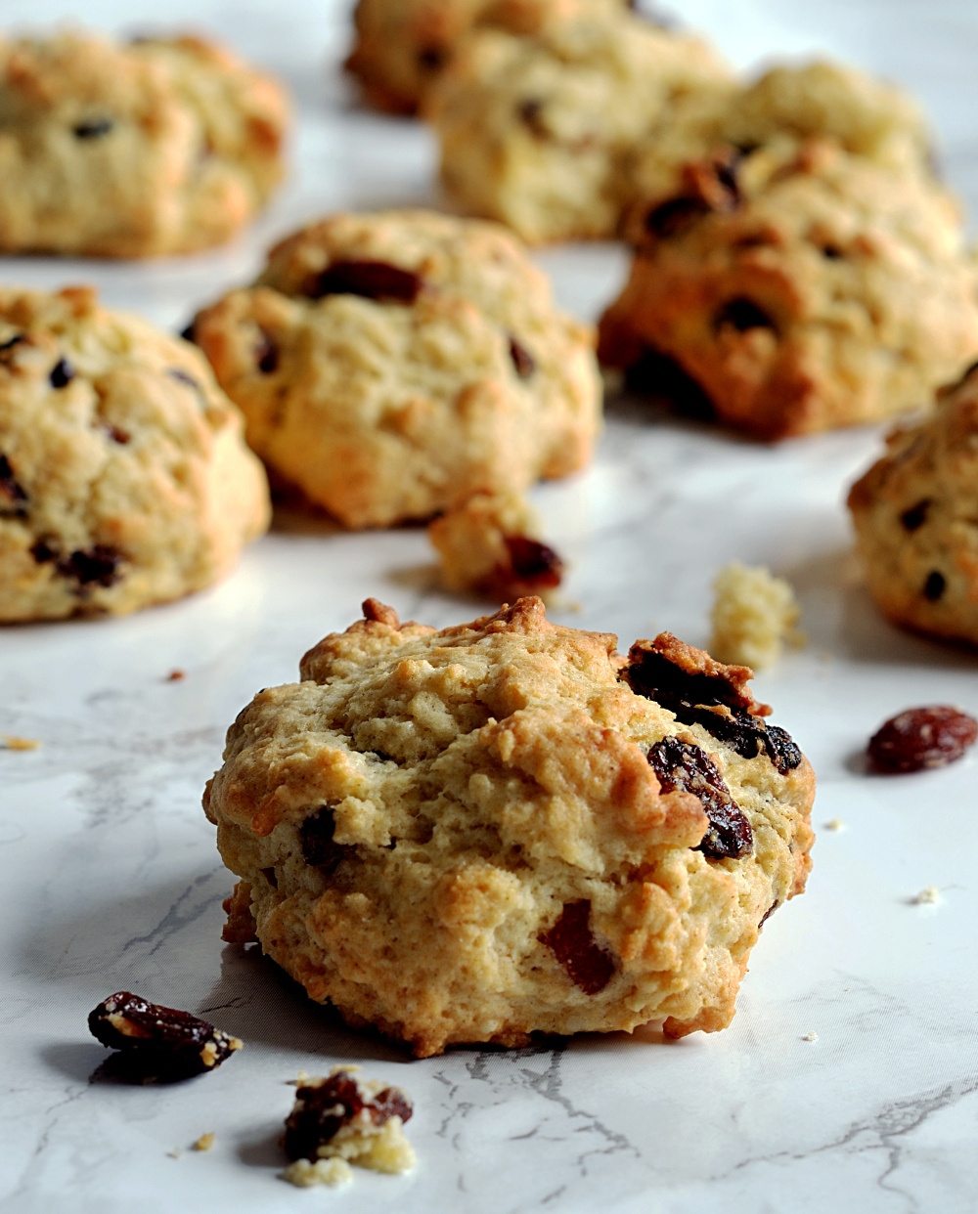
6 | TOAD IN THE WHOLE  250g (or a pack) of sausages  140g Plain Flour  2 egg  175ml /½ pint milk  Pinch of salt (school will provide)  1 tablespoon oil (school will provide)  BRING IN AN OVENPROOF DISH, foil to cover and a TEATOWEL | Skills:  Knife skills (vegetables)  Smooth mash potato  Layering savour dish  Knowledge:  Healthy eating  Thermofan ovens vs convection ovens.  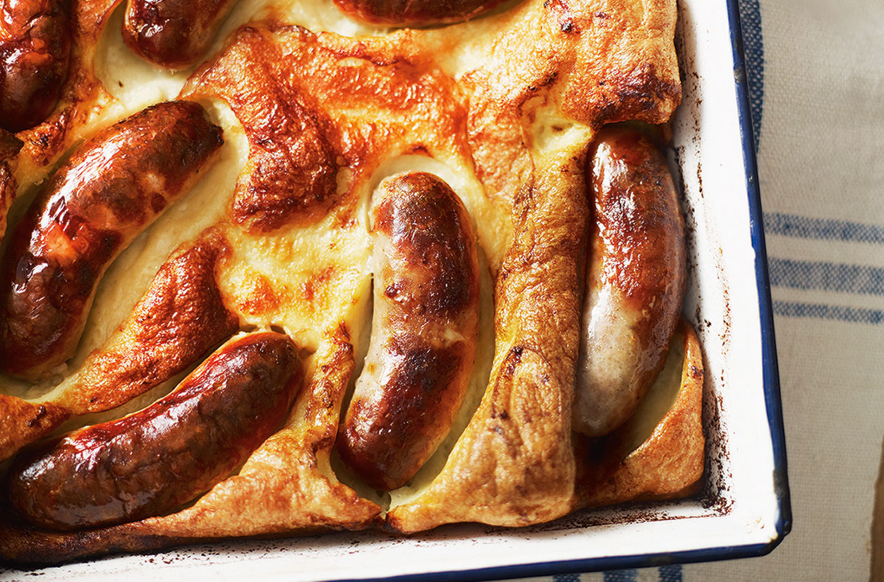
7 | RICH BONNAGE MUFFINS  170g soft plain flour  80g block margarine or butter pinch salt  pinch mixed spice (school)  Pinch nutmeg (school)  5ml bicarbonate of soda  80g soft brown sugar  350g mixed dried fruit  5ml black treacle  150ml buttermilk or milk  12 paper muffin cases  CONTAINER to take your MUFFINS home | Skills:  Rubbing in Method  Knowledge:  Traditional Manx recipe dating back to 1727. (shape changed to muffin)  Traditional ingredients – smart use of all ingredients made at the time.  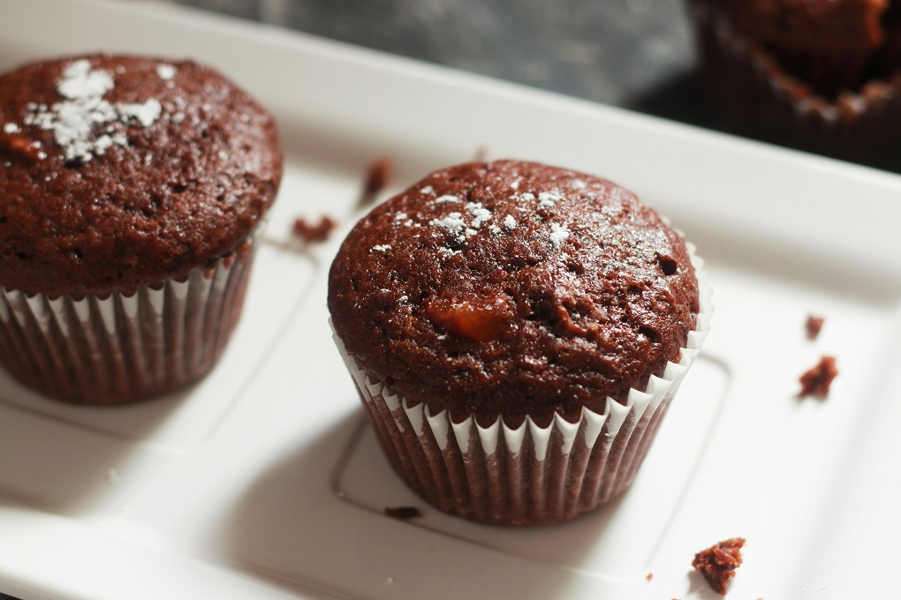
8 | HOME MADE PASTA (School will provide ingredients)  100g plain flour (or strong flour)  1 extra-large eggs | Skills:  Doughs, pasta making and shaping, cooking pasta)  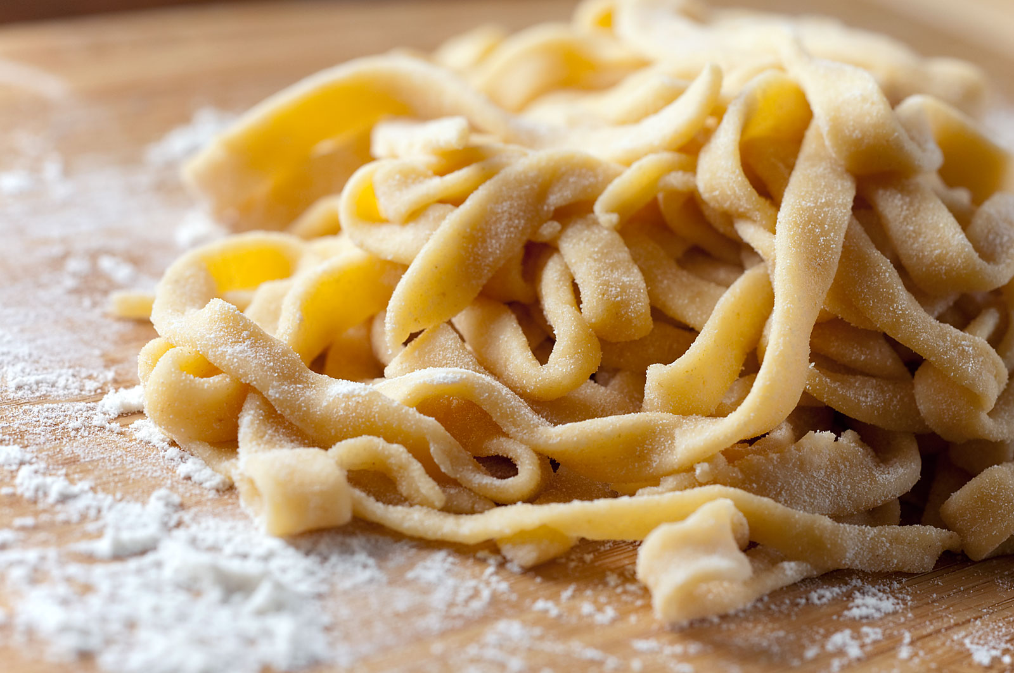  Knowledge:  Pasta making
9 | NO CRUST CHEESY TUNA QUICHE  3 eggs  50g butter, melted  60g plain flour  250ml milk  2 tablespoons spring onion, chopped  Parsley chopped  Salt (school)  Black pepper (school)  1 tin tuna fish, drained and flaked  Or 150g Cooked sausages or bacon  170g cheddar cheese, grated  (small tin sweetcorn, drained – optional)  BRING IN AN OVEN PROOF DISH, FOIL TO COVER AND A TEATOWEL | Skills:  Cooking pasta, knife skills, grating, cheese, assembling dish, oven baking savoury dish.  Knowledge:  How to cook a product on top of hob as well as in the oven.  Designing your own recipe to suit your needs.  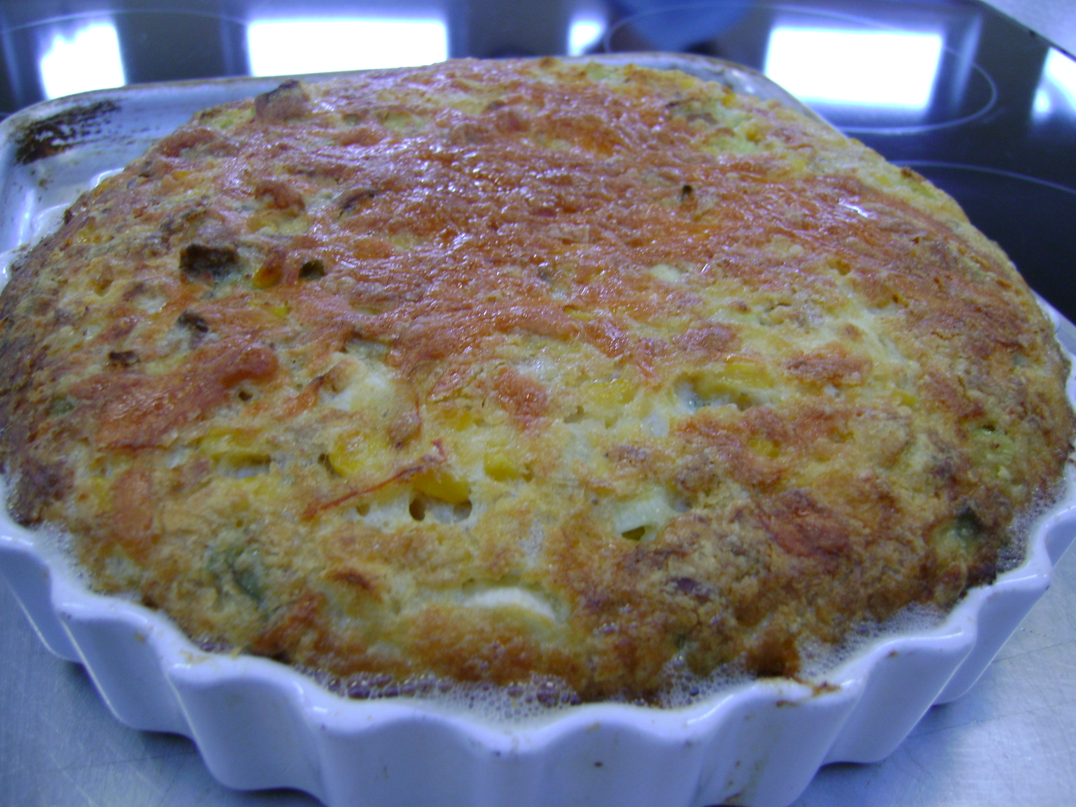  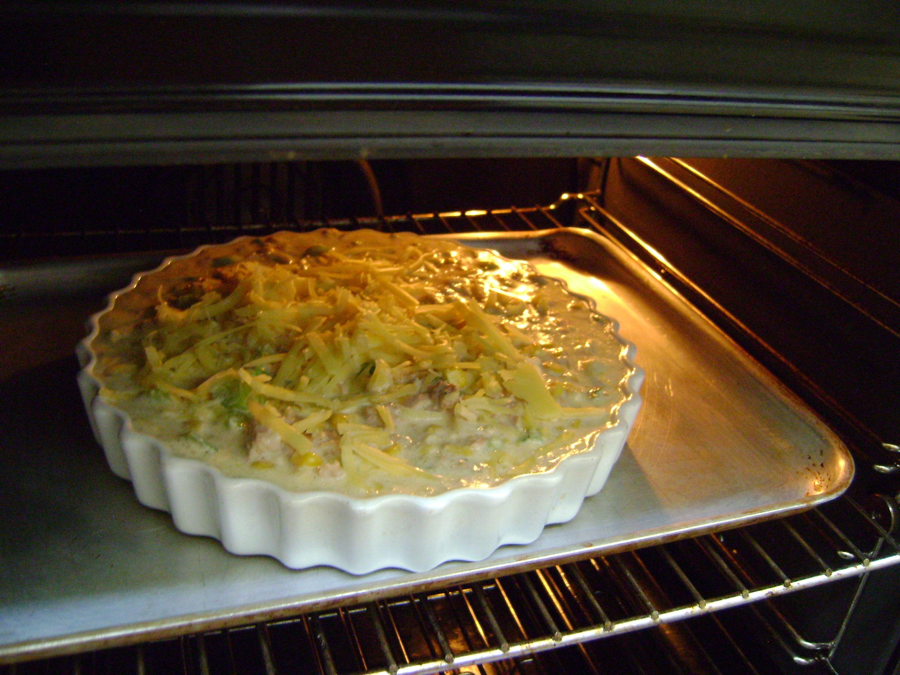
10 | Thai Pork bites.  1 garlic clove  2.5cm ginger root  1 x 15ml fresh coriander  2 spring onions  ½ lime  225g lean pork mince  1 x 15ml soy sauce  1 x 15ml grape juice  1 x 5ml honey  1 x 15ml sweet chilli sauce | Skills:  shaping mince, Sauce making  Knowledge:  Safety when working with meat. Storage of food  