Yr 9 Food and Nutrition Ingredients list
(classes with Mrs Butler-Smith, room 173
Please bring a container each week plus foil or cling film if needed. Where possible spices or unusual ingredients will be supplied by school. Please ask for an alternative recipe rather than not bring ingredients if you don’t like the food. You can always adapt/modify ingredients to suit tastes. These dishes are developed to improve high skill techniques, presentation and encourage healthy eating apart from a couple thrown in for the sweet tooth. Remember – it’s all about balance!

1 | Introduction to course.  Demo Swiss Roll and Food Photography. | Objectives for this rota are to develop the high skill levels in Food production, and presentation techniques while considering balanced diets.  3D drawing of a food product.
2 | SWISS ROLL  3 eggs  75g castor sugar  75g self raising flour  Flavouring of your choice  FILLINGS: of your choice  extra sugar for rolling up  extra 1 tablespoon of flour  BRING in a 20cm diameter container to take it home in. | Skills:  Whisking method (True Sponge ie no fat or added raising agent), lining a rectangular baking tray, rolling hot baked cake, presentation.  Knowledge:  How cakes can become a part of a healthy eating diet. No fat, adding fruit.  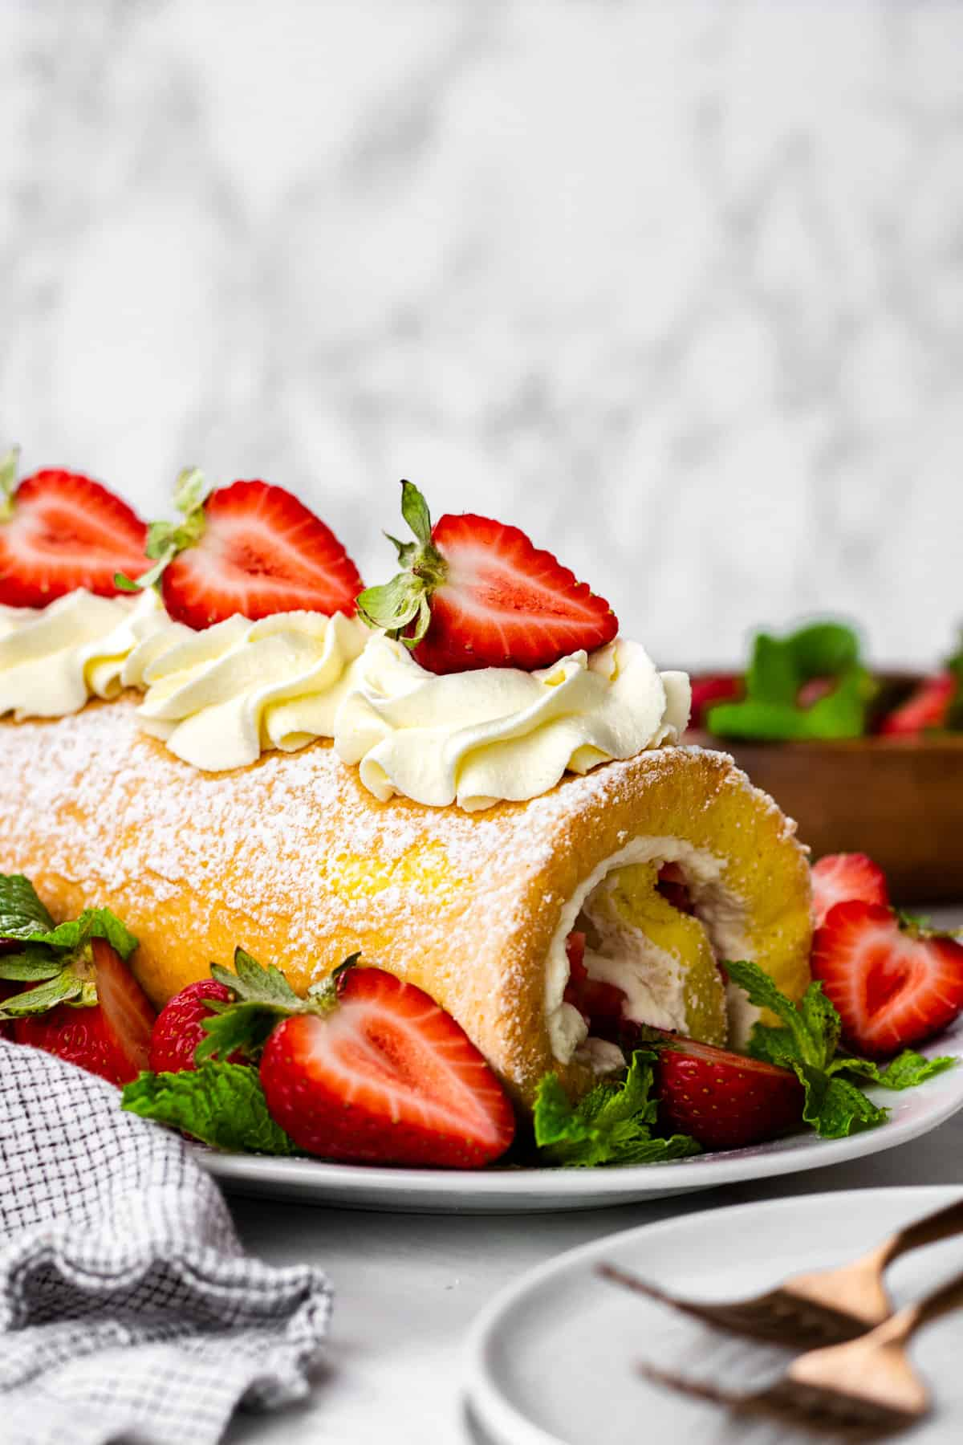
3 | Tomato, bean and pasta Soup  1 onion  2 celery sticks  1 clove of garlic  5ml oil (school)  2 large cans chopped tomatoes  5ml mixed herbs  1 can cannellini beans  50g small pasta shells  600ml water (1 reduced salt stock cube, optional)  A few fresh basil leaves (school)  Black pepper to taste (school)  30g Parmesan cheese, grated on finest grater. (optional)  BRING A WATERTIGHT CONTAINER to take soup home in | Skills:  Knife skills, modification of recipes, presentation.  Knowledge:  How to modify recipes, balanced diets.  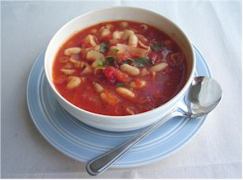
4 | ROUGH PUFF PASTRY  225g plain flour  ¼ level teaspoon salt (school)  150g block fat (either 150g butter or block margarine or 75g margarine & 75g lard)  1 teaspoon lemon juice  Extra 100g flour for rolling  Rough puff pastry will be frozen until next week  You will bring in your filling for the following week | Skills:  Puff pastry making  Knowledge:  Rules for making pastry. Planning of fillings and shaping of pastry.  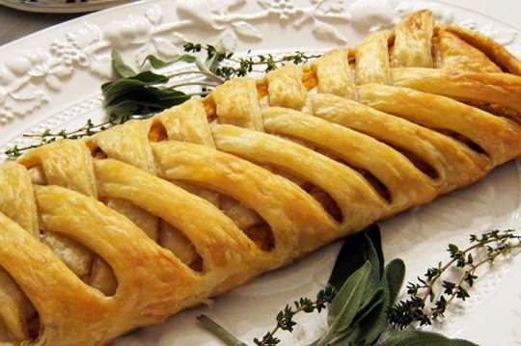  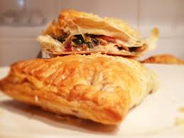  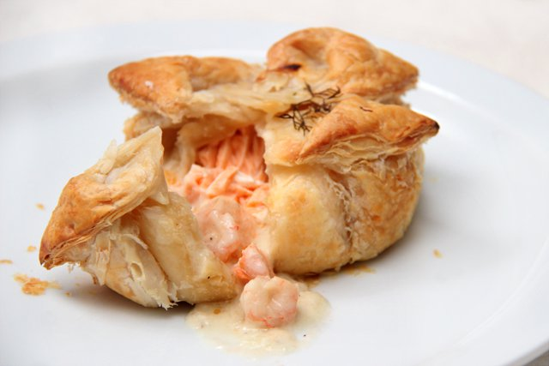
5 | Fill ROUGH PUFF PASTRY  Filling of your choice  Eg. Sausage meat (for sausage rolls)  Cooked apple (for apple turnovers)  Meat and vegetable stew (cold for meat & veg pie)  Curry mince or meat (curry turn over)  Chicken pie filling (chicken plat)  Or filling of your choice.  CONTAINER to take your pastries home in. | Skills:  Puff pastry making, baking and shaping, presentation skills  Knowledge:  Rules to work with pastry, understanding of product shaping. Planning of product presentation.
6 | Shepard’s Pie  200g lean minced beef, lamb or pork  1 onion  1 stock cube – beef or vegetable  125ml water (school)  15 ml flour  100g fresh or frozen vegetables eg carrots/mixed vegetables  500g potatoes – about 4 medium sized  15g margarine or butter  30ml milk  2.5ml salt and Pepper (school)  BRING IN A LARGE OVEN PROOF DISH and tea towel to carry home | Skills:  Knife skills (vegetables)  Smooth mash potato  Layering savour dish  Knowledge:  Healthy eating  Thermofan ovens vs convection ovens.  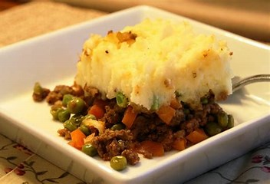
7 | Chelsea Buns  130ml water (school)  30g margarine or butter  25g sugar  1 egg  250g plain flour  2ml salt (school)  10g instant dry yeast (fast acting) (school)  Rich yeast dough to be frozen until next week. It will be proved before your lesson ready to use.  You will bring in the filling and icing ingredients for week | Skills:  Working with yeast.  Rich dough as opposed to plain yeast dough.  Knowledge:  Yeast: living organism which produces CO² to make product rise.  Kneading  Proving  Shaping
8 | Shape Chelsea Buns and finish  Filling for Chelsea Buns  25g margarine  25g sugar  5ml cinnamon (school)  75g fruit cake mix (mixed dried fruit)  Icing for Chelsea buns:  150g icing sugar about 40ml water (school)  Bring in a container to take them home | Skills:  Working with, shaping, proving and baking yeast doughs.  Presentation  3D drawing of product  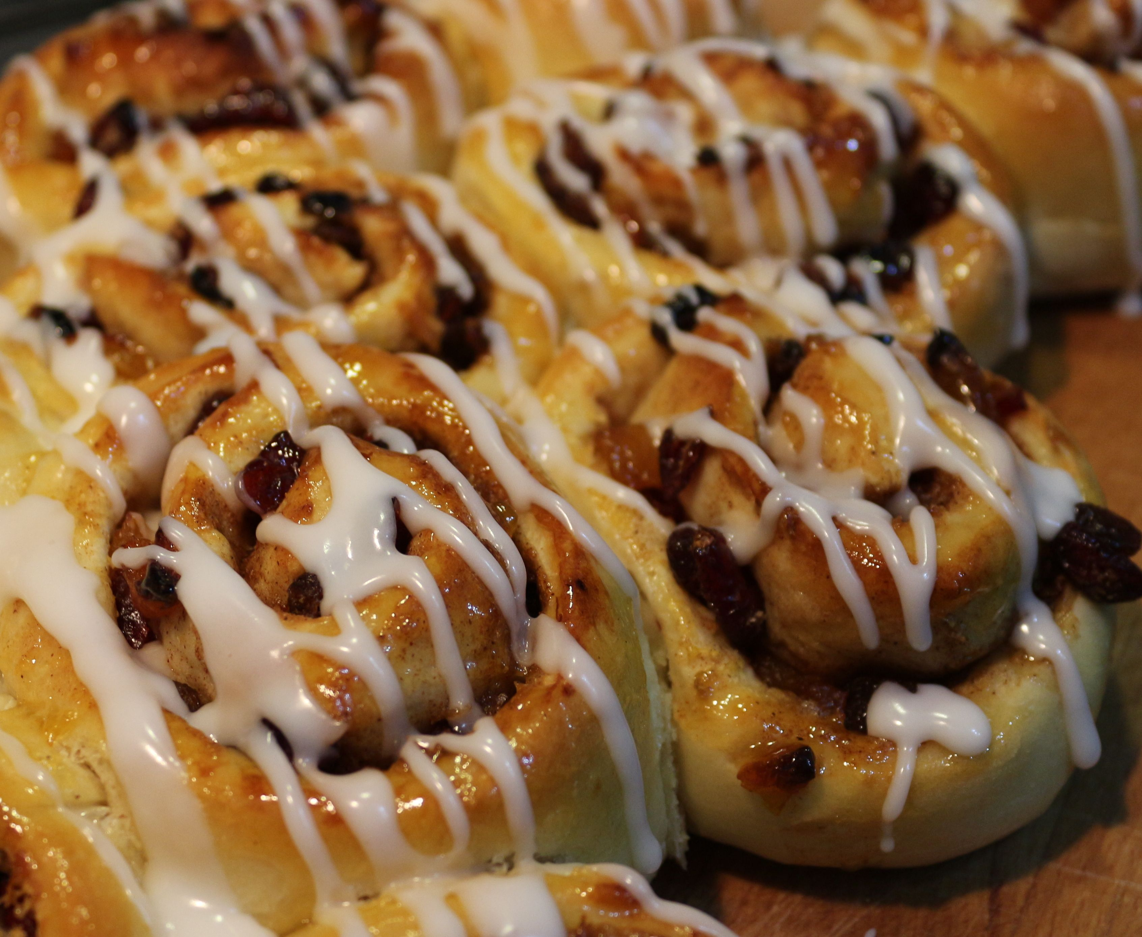  Knowledge:  Yeast baking.
9 | Classic Baked Cheesecake  15 digestive biscuits  10ml unsalted butter melted,  180g granulated sugar  10 ml plain flour (2 tsp)  600g cream cheese  5ml finely grated lemon zest (from about 1 lemon)  5ml vanilla extract  85ml double cream  1 large egg yolk, at room temperature  1 large eggs, at room temperature  For the strawberry topping  1 1/2 pounds strawberries, washed, hulled, and cut into large dice  1 cup granulated sugar  1 teaspoon finely grated lemon zest (from about 1 medium lemon)  1 tablespoon freshly squeezed lemon juice  2 tablespoons water, if needed  23cm loose bottomed baking time, pie plate or foil quiche dish. Foil or cling film to cover. | Skills:  High protein products.  Working with egg to make product both set and rise.  Fruit for finishing. Glaze, fruit coulis, gel etc.  Knowledge:  Types of cheesecakes.  Function of ingredients.  Presentation  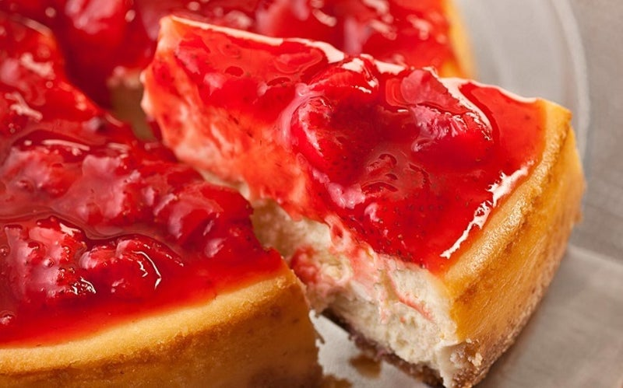
10 | Student’s free choice.  - Product chosen must be able to be made in a double lesson (check your recipe and timing to ensure this).  - Bring in a printed copy of the recipe (you can email it to Mrs Butler-Smith for printing if you wish to.  - You must be able to follow the recipe yourself i.e. understand what you need to do. | This is possibly the last lesson you will be doing a food practical in school, so this will be fun. Enjoy your last Food practical.

