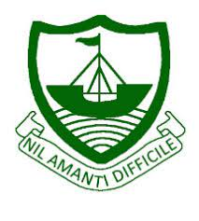
RGS Newsletter
Friday 7th January 2022 – Issue 14

Headteacher’s Award Winners

This week once again we held our Headteacher’s Friday Tea Party. The Headteacher’s award winners were invited along to share their experiences and the reasons for their nomination for this prestigious award. They were chosen by the staff at RGS over all other students in their year group to be recognised as students of excellence. They were nominated for many reasons, but these included participation in extracurricular activities, excellent manners, musical achievements, exemplary behaviour, being supportive to others, kindness, resourcefulness, resilience, hard work, attainment and aspiration. A truly inspirational group of young people who really do embody our way of being here at Ramsey Grammar School. We are so proud to have these students as a part of our school community. Well done to them all.
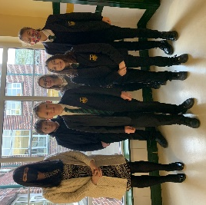
- Year 7 – Isla Rousseau
- Year 8 – Oliver Dowty
- Year 9 – Bob Radcliffe
- Year 10 – Lainie Sharpe
- Year 11 - Lottie Stennett
- Year 12 – Mia Dunwell
- Year 13 – Jessica Wild

Headteacher’s Message

It has been wonderful to have the children back in school and I have been impressed with their focus and enthusiasm in lessons this week. It has been a very busy start back after our Christmas break. We have been under extreme pressure in terms of staffing due to winter illness over the course of the week and have done all that we can to ensure that all children can continue their face to face learning here at Ramsey Grammar School. A number of you have contacted me to ask if we will be sending year groups home as other schools on the island are doing. We will do everything in our power to keep the students learning in person with us. Be assured that if we do have to send a group home it will be after exhausting all other possible ways of managing staff absence. We thank you for your support and understanding with this. I would like to publically thank my staff who have been going above and beyond this week to support the smooth running of the school and the continuation of face to face learning.

You will all have seen my letter to you all at the start of the week regarding the updated government guidance around Covid-19. We thank you all for your ongoing support with this matter. If you would like the most up to date information on this matter the best place to look for this is on the government website here - https://covid19.gov.im/general-guidance/
- Know Before You Go – Lateral Flow Testing – We encourage students and all staff to test at least twice a week using free LFD test kits and to ‘know before you go’ to protect themselves and others. If they receive a positive test result they are advised to follow the latest Public Health advice.
- Face Coverings on School Sites - Staff, students and all visitors are expected to wear face coverings particularly when gathering in communal areas moving around school premises (indoors).

We were deeply saddened to have had to cancel the celebration assemblies with parents due to the new government guidance issued. We are running the celebration assemblies remotely and screening them to tutor groups next week to ensure that the students are all celebrated as they should be to the school community after all the effort they have put in. Certificates will be handed out by tutors during the screened assemblies for students to take home.

I have some good news to share, we welcome Mrs Brown from the social sciences team back to the school after her time on maternity leave. We are very happy to have you back with us once again.

After a rigorous and extensive interview process last term, we are very excited to announce that we have two new members of the senior leadership team joining us on secondment for the remainder of the year. We welcome Mrs Corrin and Mr Davies onto the senior team as Associate Assistant Headteachers. They will be in post until July 2022. A warm welcome from us all to Mrs Corrin and Mr Davies.

Lastly, we have our Year 13 mock exams taking place over the course of the next two weeks and I just want to take this opportunity to wish all our students the very best. They have all worked so hard already and we just know you will do yourselves and us proud during these exams. My advice is to study smart, look after your wellbeing and do your best.

I wish you all a happy and restful weekend.

Kind regards

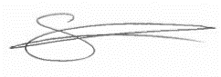
Sarah Findlater

Headteacher
Ramsey Grammar School

Parent App Reminder
Parent App is used to communicate live achievement points, behaviour points, links to the website and notes about upcoming events. This is one of the most important methods of communication. If you do not have Parent App set up, please use this link here to access instructions to set this up on your device. The new behaviour system is here for you as a reminder what a Level 1, Level 2 and Level 3 sanctions mean.
Mrs Corrin – Associate Assistant Head

Student Absences
A reminder to all parents that student absences can be emailed in to rgsabsence@sch.im at any time and these will be picked up first thing each school day. The other option of phoning in on the day is still in place, and the phone line opens from 8.30 am each day. The call should be made to the dedicated line 811 100 (Option 1). The full absence policy can be found online here. All notifications either via email or phone need to be received by the school before 10.50 am.

Department Update – Maths

Once again, a busy half term for the Maths team. We held our Year 11 Mocks and currently our students are getting individual feedback on their results and how to improve on their results. As usual, the Maths team will be holding a second mock exam with Year 11 in March/April time to help with the final push and to ensure all students are fully prepared for the exam in June.
At Key Stage three, our Year 7’s have been set and should all know what set they are in and with what teacher. There were some excellent results in the Half termly assessment that made all the Year 7 teachers think hard about where to allocate students. This is an ongoing process and changes can be m again at the end of half term. Our Year 8 and 9’s were working hard on their algebra and manipulation skills along with geometric and numerical skills.
Year 10 are well into the GCSE Curriculum and are realising that there is a step up from Key Stage 3 to Key Stage 4. Some of our higher groups are relishing the higher topics that are challenging them.
Our Year 12’s have completed their first number of in-school A-level assessments and are getting feedback on these also. This also includes our collaboration students doing Further Mathematics that complete lessons remotely at QE2 and CRHS.
Our Mathematicians of the month are…
- Year 7: - Grace Kelly and Oliver Druggan
- Year 8: - Ciernan Hughes and Noah Parks
- Year 9: - Thomas Forbes and Syan Misselbrook
- Year 10: - Adam Delooze and Ashton Marsh
- Year 11: - Sam Kimber and Alfie McConnell
- Year 12: - Ben Gelling
- Year 13: - Glenn Callow
Department Update – Social Sciences

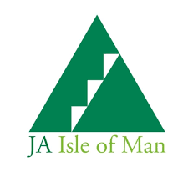
Recent weeks have seen a significant push on exam skills as a large number of students have been preparing for and sitting their mock exams. Year 11 mocks were completed just before Christmas and Year 13 are due to be sat from next week, this has been the focus of most lessons. Our Year 12 LIBF Finance and Btec Enterprise students are preparing to sit their public exams over the next couple of weeks. Our enrichment activities in Year 12, Charity Challenge and Junior Achievement, continue to progress well. Just before Christmas was the JA 'Pitch It' event, this provided some invaluable, constructive feedback to our student teams. We are very pleased to welcome back Miss Brown from her maternity leave and would like to thank Mrs Collins for admirably supporting our students over the past 12 months.

Department Update – Drama

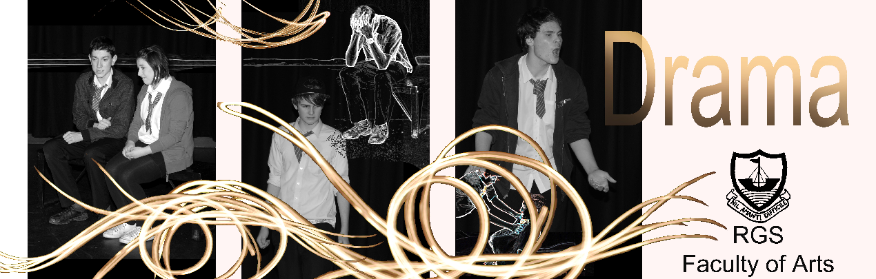

‘The most valuable asset a nation has is the creativity of its children.’ Alan Plater (playwright).

Happy New Year from the Drama Team!

Sometimes I’m asked by parents why Drama features on the secondary school curriculum, as they state that their child is not going to grow up to be an actor or work in the creative industries. Perhaps others can answer this more eloquently…

The American poet Dana Gioia summed it up very succinctly by stating: ‘The purpose of arts education is not to produce more artists, though that is a byproduct. The real purpose of arts education is to create complete human beings capable of leading successful and productive lives in a free society.’

The idea that the essential skills – sometimes called ‘soft skills’ – gleaned from Drama can help develop the whole student is underlined by Sue Woodroofe, Principal of the Grammar School at Leeds: ‘Far from being a ‘soft subject’, the teaching of Drama is essential in encouraging resourcefulness and creating independent thinkers who can be the entrepreneurs of the future. Not only that, but a multi-disciplinary education which includes culture alongside Maths, Science and Humanities is essential if we are to produce creative world-leading scientists, doctors, technologists and engineers.’

Maybe the final word should go to comedian Peter Kay? He said: ‘I’ve always believed Drama to be an important subject. It’s not just about play-acting; it’s about giving children confidence and ironing out their inhibitions. I realise that most of them may never go near a stage again once they’ve left school, but I guarantee that they’ll exude confidence for the rest of their lives as a result of being taught Drama.’

Good luck to our GCSE and A-level candidates who have assessed performances this term!

Senior School’s Shield Basketball Champions 2021/22
The final of the Senior Shield Basketball took place on Thursday 16th December at the National Sports Centre. The squad consisted of students in Year 9 through to Year 13 including; Jack Coates, Brayden Roche, Ben Smith, Owen Chestnut, James Dawson, Jake Richmond, Rhys Curphey, Althea Mallorca, Will Dalugdugan, Harry Eyres, Jake Kinrade and Harvey Garrett (missed final due to Covid).
The squad were undefeated after the round-robin league fixtures against the other high school teams on the Island and were therefore slight favourites going into the final. Their opponents were a strong and talented Ballakermeen High School who they narrowly beat in their group game encounter in a tense, tight affair.
Ramsey controlled the game from the tip-off. In a very competitive game against a superb opposition, every member of the team played solid defence and an exciting but intelligent offence. They lead by 14 points at half time and although BHS put them under intense pressure going into the final quarter they played with maturity, passion and poise to never let the opponents within sight of an upset. RGS ran out winners 78 points to 60. MVP was Jack Coates, however, credit should also be given to each member of the squad as it was a superb team performance. This is the first time in the history of RGS that we have won the Senior shield! This team has now won both the Inters and Seniors! Well done to all the squad on this historic achievement! 1,2,3…RAMSEY!!!

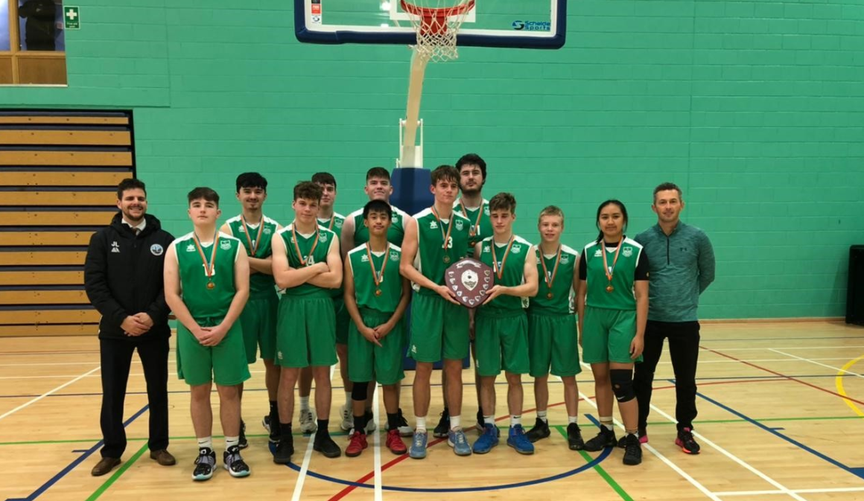
Pictured from left to right: Mr Leece (Coach), Jake Richmond, Owen Chestnut, Jake Richmond, Will Dalugdugan, Ben Smith, Jack Coates, Rhys Curphey, Brayden Roche, Harry Eyres, Althea Mallorca, Mr Guy (Coach)

Key Dates:
10th – 19th January 2022 – Year 13 Exams
17th January – RGSA Meeting
25th of January – Y11 Reports Published
26th January – Student Voice Questionnaire – Teaching and Learning
27th January – Junior Achievement Event – All About the Money
27th January – Live Screening - Leopoldstadt
28th January – Parent Voice Questionnaire

