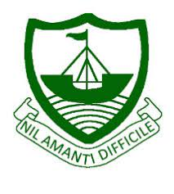
RGS Newsletter
Friday 8th October 2021 – Issue 4

Headteacher’s Award Winners - This week once again we held our Headteacher’s Friday Tea Party. The Headteacher’s award winners were invited along to share their experiences and the reasons for their nomination for this prestigious award. They were chosen by the staff at RGS over all other students in their year group to be recognised as students of excellence. They were nominated for many reasons, but these included house point levels, positivity, exceeding targets, overcoming adversity, determination, resilience, trustworthiness, kindness to others, smart appearance, being proactive, and peer support. A truly inspirational group of young people who really do embody our way of being here at Ramsey Grammar School. We are so proud to have these students as a part of our school community. Well done to them all.

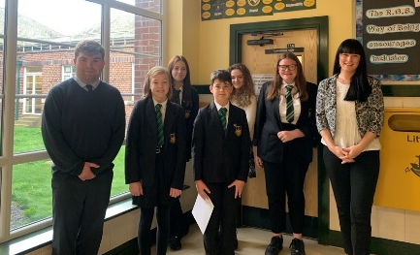
- Year 7 – Olivija Delivron and Neveah Galvin
- Year 8 – Ethan Walker
- Year 9 – Taylor Gardham
- Year 10 – Georgia Sutton
- Year 11 – Megan Caine
- Year 12 – Elisha Skillan
- Year 13 – Ryan Corfield

Higher Education Fair
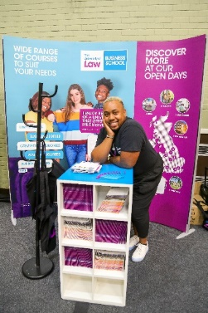
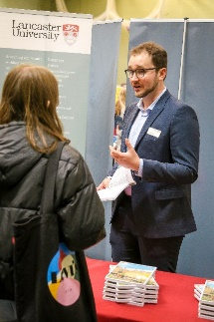
This week was the annual Higher Education Fair organised at Ballakermeen High School. 76 RGS students from Year 13 visited the fair and spoke with delegates from over 50 HE institutions. The world of work was also represented by companies such as MPES and PWC. Representatives from the University of Oxford and University of Cambridge gave talks and one-to-one tuition, helping RGS students to complete competitive applications. Sarah Crotty from the University of Central Lancashire, gave a talk on her university, as well as a more general presentation on choosing the right degree and university. She also helped the students to devise useful questions to ask the other representatives at the fair. Speaking with our students, there was a wide focus on different pathways with students speaking to Universities from all over the UK.

Mathematical Olympiad for Girls
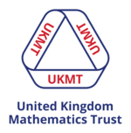
The Mathematical Olympiad for Girls is aimed at girls and young women across the UK and consists of five challenging problems. The aim is to encourage girls to tackle advanced mathematical problems as well as open young people's minds to the breadth and depth of mathematics. 10 girls from our A Level mathematics classes will participate in this on Thursday 7th October and compete against the top female A Level Mathematicians in the UK.

Black History Month
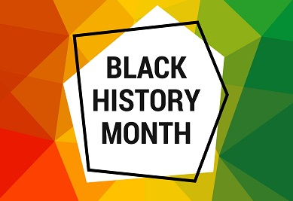
As you may have seen in the news and media October is Black History Month. We hope that a time will come when there is no need for Black History Month, but unfortunately there's a long way to go before we can safely stop needing to highlight racism is the past and link it to the present and future. With that in mind can you urge your students to read "Black & British: A short essential History" by David Olusoga, which is aimed at KS3 students and we have copies in the History Department. In addition you might want to show these clips which have been sent out by BBC Teach: https://r1.ddlnk.net/3YNL-1CF1D-27F9A7A5C9CAD0566YKNDP9669A46134E83634/cr.aspx. Mr Wilkinson particularly recommends "Small Axe" but, as the blurb says, it might not be recommended for younger students.

Y7 & Y8 Tutors Evening
Thank you to parents and staff for supporting our Year 7 & 8 Tutor Evening this week, we hope parents found it helpful to meet the tutors who will be supporting students all year. We have received some good feedback, a positive start for Year 7/8 students.

Parental Voice Survey – Teaching and Learning Focus
Please find a link here to our parental survey on Teaching and Learning. We would appreciate your views in order that they may be represented in our continuing evaluation of teaching and learning at RGS.

JA Kick Start
The 2021-22 Isle of Man Junior Achievement event kicked off this week. RGS have four wonderful teams, all competing against other schools on the Island to become the next JA company programme winners. Student's enjoyed a fantastic day out at the Comis Hotel and Golf resort, where they took part in a series of challenges to aid the growth of themselves and their businesses. This is the beginning of a 6 month process that will see them work alongside professional business mentors in the Isle of Man community, working on areas such as product development, digital marketing, managing finances, distinguishing a brand identity, sales and a whole range of transferable skills. The prize? A once in a lifetime trip to Estonia to represent the Isle of Man at the European Junior Achievement Finals. A massive thank you to the wonderful JA team for putting on such an amazing event today. You are an absolute blessing to the Island and our community.

Year 7 Life Matters
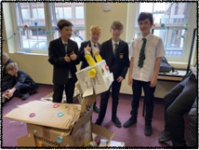
Last Tuesday the RMPS department teamed up with SUMT to deliver a fun and reflective day for Year 7 with our annual ‘Life Matters’ Day. The day began with students reflecting on what matters most to them - communities, themselves, the earth or relationships. They then went off to individual workshops that focused on these matters in greater detail. Activities ranged from team building activities to creating something from the natural world out of rubbish. Along with the philosophical reflection, students also had the opportunity to learn about and reflect on Christian values in relation to these four areas. A great day was had by all involved and we are excited to continue to explore issues like these in RMPS with the students in Y7 and beyond.

World Space Week
What a good time to acknowledge some amazing achievements of our past and present students at RGS.
This Year, World Space Week is dedicated to the theme of “Women in Space”. Last week we mentioned Reese Dalugdugan’s success in winning the Man Sat Scholarship. We have asked Reese to give us her top websites for budding ‘Space Cadets’ of the future: Reese’s recommendations (Click the links below):
- The SETI Institute, Unistellar, and The Planetary Society organize virtual events, observation challenges, contests and more to help inspire a new generation of female space explorers
- www.lovetech.im. - We inspire and empower girls to explore opportunities in STEM on the Isle of Man.
- Mission X: Train Like an Astronaut
- CanSat
- Astro-Pi
- Moon Camp Challenge
- https://www.nasa.gov/stem
- https://stellarium-web.org/ - online planetarium

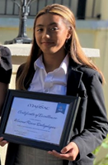
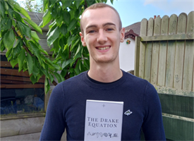
Jake Hanlon has just published a book on the Drake equation. The equation, which Jake has analysed, was formulated by American astrophysicist Dr Frank Drake in 1961 and uses different probabilities to predict how many extraterrestrial civilisations are in the galaxy. It is lovely to see a number of RGS teachers mentioned in his preface. We wish him all the best with his publication.(Left) Jake Hanlon with his book, The Drake Equation; (Right) Reese Dalugdugan accepting her Man Sat Scholarship certificate.

World Mental Health Awareness Week
Ramsey Grammar have been lucky to have ISLE LISTEN record an assembly for all students based on mental health awareness week. Students have been encouraged to make a pledge of what they can do to help their mental health. Students were then guided through ISLE LISTEN’s website so that they have another resource for support. Please feel free to watch the assembly which is on the school website and take a look at ISLE LISTEN’s website which is full of resources and signposts for support.

Department Update – Rural Science
It has been a busy start to the year at the school farm!
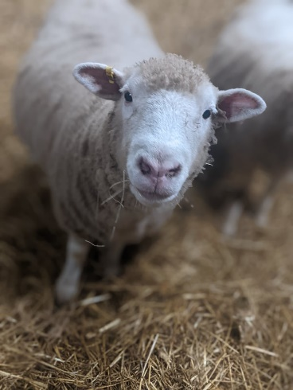
- Year 7 students have been learning how to be safe on the farm and have started to learn about the basis for all agriculture - Soil!
- Year 8 students have been learning all about sheep production and how we plan for the arrival of lambs.
- Year 9 have gone into more detail and are learning about how we can time the lambs to be born at the right time of year, as well as how to assess the health and welfare of the animals.
- Year 10 have made a tremendous start to their Level 2 BTEC Agriculture, following in the footsteps of our brilliant Year 11s who have enjoyed making up for lost practical time last year, and getting out on the farm.
- Year 12 & 13 are learning about Livestock Production.
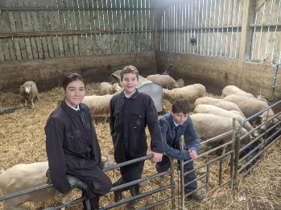
We are currently lambing our small flock of Dorset Sheep, Farm Club members have been carrying out the day-to-day care of the pigs, sheep and poultry with help from an incredible team of 158 volunteers to carry out daytime checks, and Staff doing overnight and weekend lambing checks. Farm Club is on every day from 8:30am –9am and after school, 3:40 – 4:15. It is open to all year groups on a rota – Students should see the “School Farm News” group to find out when it is their turn.

Our current Farm club team say they enjoy attending because :

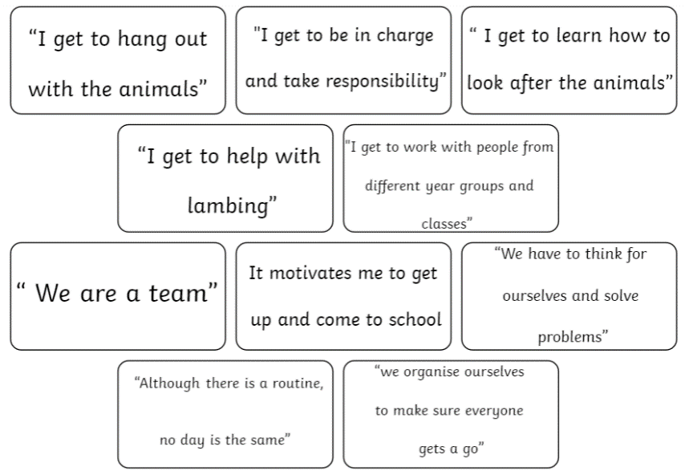
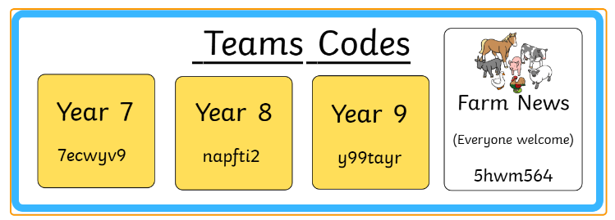

We are keeping our “School Farm News” page updated with news from the lambing shed, all students and staff are welcome to join and find out how you can get involved with the farm.
Department Update - Religious, Moral and Philosophical Studies
For those of you unsure what ‘RMPS’ is, we are the department formerly known as ‘RE’. For a very long time, as a department, we found ourselves constantly saying “we are Religious Education, but we cover so much more than that in our subject.” So, we finally made the decision to rename our subject ‘Religious, Moral and Philosophical Studies’. Students at RGS will study about the six major world religions here, but they will also explore moral issues such as prejudice and discrimination, crime and punishment and wealth and poverty as well as delving into philosophical investigations about the nature of reality and the world we live in. Here is a quick insight into what our students are currently studying in the RMPS curriculum:
- Year 7 - Students are currently exploring ‘Big Questions’. This week we are conducting a comparison of the Christian and Scientific explanations for the creation of the world and humanity. The next big Question will be ‘Does God exist?’.
- Year 8 have begun our study of the religion of Islam - they have explored key misconceptions about Islam and Muslims and are currently looking at Islamic beliefs and teachings about the Prophet Muhammad and the 5 Pillars of Islam.
- Year 9 - Students in Y9 have begun our ‘Introduction to Morality’ where we look at different thought experiments and explore religious and non-religious approaches to moral decision making. One famous thought experiment that has sparked a lot of debate is Philippa Foot’s ‘Trolley Problem.
- Year 10 have begun our first GCSE topic, exploring Christian beliefs about God and the nature of humanity - comparing scientific and biblical accounts of creation and humanity.
- Year 11 have completed GCSE Christianity and are now moving on to the ‘Good and Evil’ topic where they will explore religious and non-religious beliefs about war and peace, crime and punishment and the ‘Problem of Evil’.

Department Update –Modern Foreign Languages
All of our students from year 7 to year 13 have made a fantastique start to the new academic year in Languages. Last week we celebrated the European Day of Languages with an assembly for each year group along with some activities in Language lessons. In MFL we encourage our students to have fun with languages and to “give it a go!”

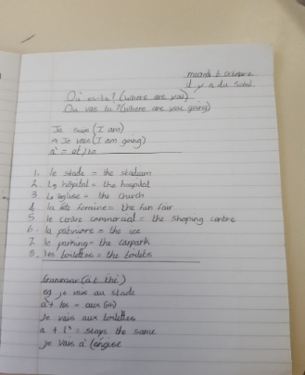
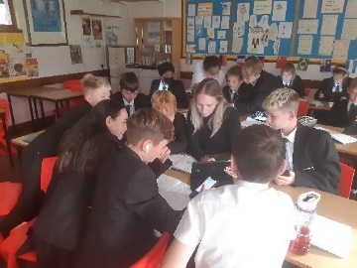
Year 7 French – this term students have learned how to have an introductory chat in French, asking someone’s name, age and birthday. They have enjoyed using their French-speaking skills in lesson. We have also introduced a new online resource for our students to practise their listening skills in school and at home. All of our students in year 7-11 have their own account set up on: SentenceBuilders.com. This is an excellent resource for our students and helps them to progress in their language study.
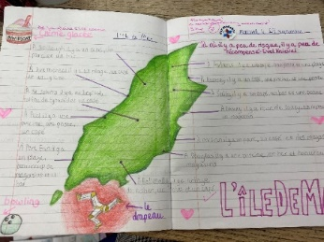
Year 8 French – this term we are learning how to describe our lovely Island and all of the attractions and things to do here. We are also learning how to give and understand directions in French, a very useful life skill indeed!

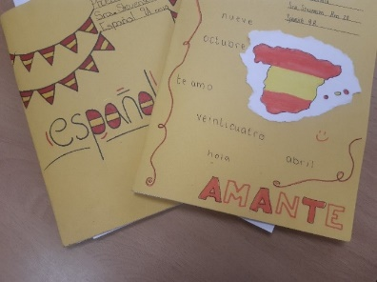
Year 9 Spanish
Year 9 Spanish students are learning about different types of food, how to give their opinions and talk about likes and dislikes. This is an extremely useful topic should they have the opportunity to go to a Spanish Speaking country. They are also learning how to read a menu in Spanish and order in a restaurant! We feel it is important to equip our young people with some real- life language skills!

Year 11 Spanish
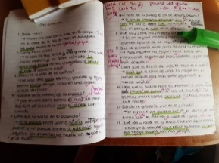
Our GCSE students have been working hard in Spanish preparing for our upcoming Mock exams. The students will take a speaking exam which will see them taking part in a conversation on a GCSE topic with their teacher. In order to prepare for this, students have been making excellent use of their 20 Key checklist. This is a list of language features which students are encouraged to include in their writing and speaking work to help them to progress with their skills.

Key Dates Next Week:
11-15th October – CAT4 Testing (Years 7, 8 & 10)
8 – 15th – Duke of Edinburgh Silver Award Expedition
Wednesday 13th October – Flu Immunisations (Year 7-11)
Wednesday 13th October – IGCSE English Resit
Wednesday 13th – Year 13 trip to UCM
Thursday 14th – Year 12 Geology Fieldwork
Friday 15th – Year 12 Geology Fieldwork

