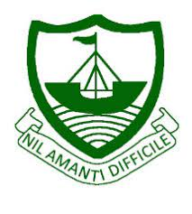RGS Newsletter

Friday 12th November 2021 – Issue 8

**Headteacher’s Award Winners**

This week once again we held our Headteacher’s Friday Tea Party. The Headteacher’s award winners were invited along to share their experiences and the reasons for their nomination for this prestigious award. They were chosen by the staff at RGS over all other students in their year group to be recognised as students of excellence. They were nominated for many reasons, but these included being a great friend, looking after others, excellent transition into the school, achievements in History, diligence, goal setting, perseverance, strength of vision and being a role model to others. A truly inspirational group of young people who really do embody our way of being here at Ramsey Grammar School. We are so proud to have these students as a part of our school community. Well done to them all.

* Year 7 – Callum Huxham
* Year 8 – Neo Storm
* Year 9 – Khloe Mundle
* Year 10 – Ryan J Kelly
* Year 12 – Karley Corkish
* Year 13 – Spencer Footer

**COP26**

The **Year 11** Assembly this week was based around the COP26 Conference currently taking place in Glasgow. Students were given an explanation of what COP26 is and what has been agreed so far.

What can we do to help?

* Eat less meat
* Travel by car and plane less
* Use social media

Avoid Fast Fashion

Reuse – don just recycle

Students have been asked to bring ideas for the year groups reps to discuss how they as a year group can support climate change.

**Year 10** Global Perspectives students have been given the exciting opportunity to take part in a Mock COP26 conference. The One World Centre will host the conference. The students have been given a country that they will represent. Each country will present a 1-minute impact statement to outline their country's position on climate change. During the morning, they will be asked to come up with solutions to climate change problems.

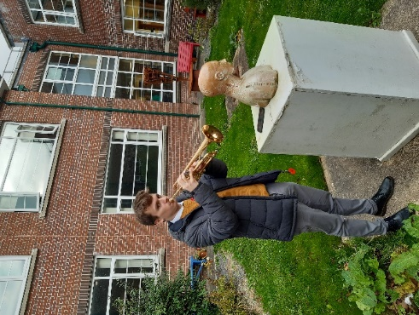**Remembrance Day**

Our amazing trumpeters Ivo Morrey, Oscar Bovenizer (pictured) and Henry Domer sounded the Last Post to signify the commencement of the two-minute silence, followed by the Reveille at the end. All played beautifully, Ivo in the East Building, Oscar the West and Henry went to Bunscoill Rhumsaa Junior Building. Well done to all concerned.

**Non-Uniform in Support of Hospice**

Over £730 was raised on the non-uniform day before half term which is great. Money raised will go towards the Splash campaign for IOM Hospice. The Big Splash will see a large pod of individually designed Dolphin sculptures placed around the Isle of Man for everyone to see and enjoy. At RGS we will forward to receiving two dolphins to participate in this exciting project.

**Sovereign Arts Foundation Student Prize 2021**

We are delighted that Zara Woodward is one of 20 finalists this year with her artwork now on display with the other finalists at the Promenade Methodist Church in Douglas (see the newspaper article below) The exhibition runs from 3rd – 26th November and you can vote for your favourite online [here](https://www.sovereignartfoundation.com/art-prizes/student-art-prize/isle-of-man/) or at the exhibition itself. We wish Zara the best of luck with her piece, pictured below.

**Year 7 Restart a Heart**

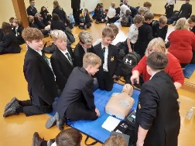Year 7 students were given training in CPR, Defibrillators and what to do in the event of choking. Students were thorough engaged and appreciated the opportunity to learn these valuable life-saving skills

Many thanks to the staff of Nobles Hospital who provided the training.

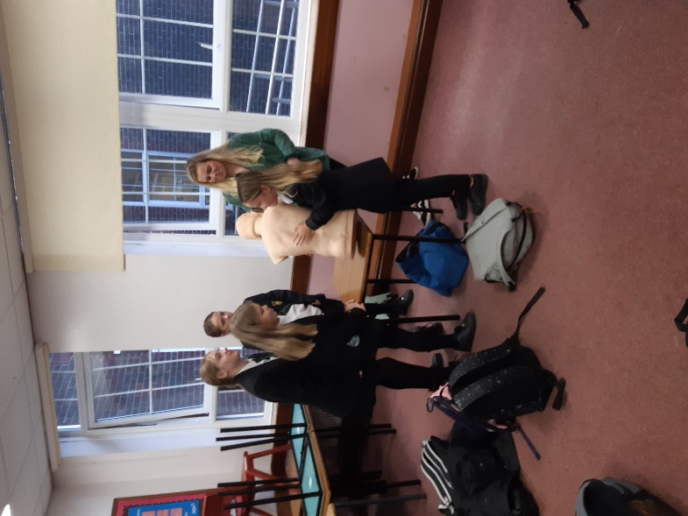

**Year 9 Health Fair**

Taking place on the 18th November. We look forward to visitors from the following organisations:

[](https://www.google.co.uk/url?sa=i&rct=j&q=&esrc=s&source=images&cd=&cad=rja&uact=8&ved=2ahUKEwjMq7ruzcLeAhWJ66QKHZWVCacQjRx6BAgBEAU&url=https://www.gracepointwellness.org/poc/view_doc.php?type%3Ddoc%26id%3D41255%26cn%3D1310&psig=AOvVaw28mlDt6K3tKUgzb4S2jNVp&ust=1541691316228330)A picture containing logo

[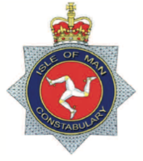](https://www.google.co.uk/url?sa=i&rct=j&q=&esrc=s&source=images&cd=&cad=rja&uact=8&ved=2ahUKEwi8x7fczcLeAhUnPewKHYsgDh0QjRx6BAgBEAU&url=https://en.wikipedia.org/wiki/Isle_of_Man_Constabulary&psig=AOvVaw1Io7xRTLE-arsp3umn6CTa&ust=1541691276938010)

* Anti-social behaviour (Police)
* Class A drugs (Room (Police)
* Active Travel
* Stop it. (Quit 4 U)
* Current trends, attending a GUM clinic
* Just Another Game? Motiv8
* Consent (room 15) (Health education officer)
* Time to relax (dance studio) Mrs Corrin

**Maths Symposium**

The Annual Maths Symposium took place on Friday the 22nd of October. Students from St Ninians High School, QEII and Ramsey Grammar School took part in the activities on the day. The day began with a Lecture by Dr Ian Wright, Consultant Orthopaedic Surgeon at Nobles hospital and the man in charge of all the Covid data used by the Government to aid in making the decisions that occurred throughout the pandemic.

Dr Wright gave insights on how decisions were made during the crisis and how the island came within hours of building a nightingale hospital at the NSC. However, after looking at the data Dr Wright was confident that the availability of beds in the ICU at Nobles was enough to cope with the pandemic. The biggest worry was the production of oxygen for patients at the hospitals but that addressed and the island was deemed to have enough resources.

The afternoon activities were done in teams made up of school groups and was a tight affair. Give points separated the top two teams at the end and unfortunately the Ramsey Grammar team of Ben Gelling, Oscar Bovenizer, Joe McDonough and Ivo Morrey (pictured) just missed out on the top prize. The winners on the day were St Ninians High School. Well done SNHS.

A big thank you goes out to all the staff that helped on the day and those who generously covered lessons for staff involved.

We will reclaim the top prize next year!

**Department Update – MFL**

MFL - Our year 7 students are really getting to grips with their Spanish conversation skills. They can now introduce themselves and use adjectives to describe their own and others personality traits. Meanwhile in Year 8 students have been learning how to describe themselves and family.

Here are some Year 8 students playing ‘Mentioroso/a’ (Liar Liar) They read a phrase out loud and their partner has to guess if they are reading what is written or whether they have changed part of the sentence. In Year 10 Spanish we are learning to talk about ourselves and others and looking at how we can expand our answers to include idioms, various tenses and a variety of opinions, whilst in Year 12 we are learning about families under the reign of Franco compared to the majority of family types there are now in Spain and around the world.

**Department Update - RMPS**

Over the past few weeks many debates have been going on in RMPS classrooms at RGS. Y7 classes have been looking at various arguments for and against the existence of God as well as looking at what it means to be theist, agnostic and atheist. Y8 have been continuing their exploration of Islam, most recently examining the issues Muslims in Britain face, including having to deal with islamophobia. Y9 have begun to explore the topic of prejudice and discrimination, looking into issues to do with racism, homophobia and antisemitism amongst many others. Y10 and Y11 continue their studies with WJEC GCSE short course, with Y10 looking into Christian approaches to morality and Y11 exploring the world of crime and punishment. As always, we thoroughly enjoy when students get involved in the debates we have in our subject, and it is a privilege to listen to and learn from the great minds we have at RGS.

**Covid Guidelines**

Please note that we are currently following Government guidelines in regard to Covid 19, click on the link [here](https://covid19.gov.im/general-information/back-to-school-safely/frequently-asked-questions-regarding-covid-19-and-the-return-to-school/) for more information

**Key Dates:**

Tuesday 16th November – Year 9 Health Fair

Friday 19th November – Live Screening Relaunch – Riverdance 25th Anniversary Show

Wednesday 24th November – Year 9 JA Learn to Earn

Week Commencing 29th November – Year 11 Exams