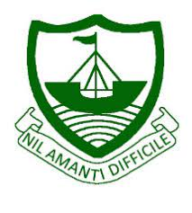
RGS Newsletter
Friday 26th November 2021 – Issue 10

Headteacher’s Award Winners

This week once again we held our Headteacher’s Friday Tea Party. The Headteacher’s award winners were invited along to share their experiences and the reasons for their nomination for this prestigious award. They were chosen by the staff at RGS over all other students in their year group to be recognised as students of excellence. They were nominated for many reasons, but these included being a good friend, support of others during the cross-country event, kindness, overcoming adversity, taking on additional work, contribution to the school community, amazing effort to improve grades, inner drive to achieve well, acting with determination and grace when under pressure and taking on additional responsibilities. A truly inspirational group of young people who really do embody our way of being here at Ramsey Grammar School. We are so proud to have these students as a part of our school community. Well done to them all.
- Year 7 – Katherine Black
- Year 8 – Megan Lord
- Year 9 – Sophie Wood
- Year 10 – Ffinlo Corkill
- Year 11 – Wilma Dalugudan
- Year 12 – Eleanor Prince
- Year 13 – James Dawson

Coop Community Funding
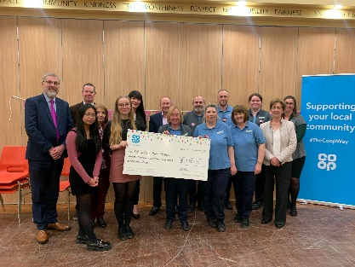
We were delighted to have the representatives of the Coop into the school last week to pass over yet another amazing Coop Community Fund cheque. This cheque was for an astronomical £19, 018.74. This funding has been awarded to the school to support the development of our audio-visual equipment within the school. Watch this space to see the improvements that we will be making! While the Coop representatives were with us we took them on a tour of the new and improved SS&S area of the school and spoke with them about the Leia and Accelerated Programs we have launched within the school which is where the last donation was grateful spent. We are so very lucky to have such wonderful community support from the Coop and are forever grateful.

Year 9 Health Fair
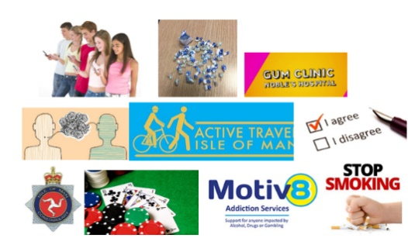
Last week we hosted another very successful, Year 9 Health Fair, held annually. This involved a range of 8 different health-related sessions which the students took part in. The sessions included: Time to relax, Stop it (smoking), Consent, Active Travel, anti-social behaviour, class A drugs, GUM and Gambling.

Feedback from the visitors delivering the health fair said that the Year 9 students participated brilliantly during the morning and were very well behaved with one specific comment ‘the students were an absolute credit to the school’. Students gave great feedback about the morning that they found it useful, enjoyed it and learned new things. Here were a few of the specific comments ‘the visitors spoke to us, so we understood’, ‘I found all the topics very interesting’ and ‘I know understand a lot more about the topic.

Department Update – Maths
This half term has been a busy one for the Maths team. We received the results for the Mathematical Olympiad for Girls, which this year had a record number of students from Ramsey Grammar. Congratulations to Arabella Ayen, Mia Dunwell, Nerys Otto, Ezra Daniel, Abbie Mellor and Millie Smith. This Olympiad is taken up by 10% of all A-level mathematicians in the UK so well done girls.

The results from the Maths Symposium are in and the team of Joe McDonough, Oscar Bovenizer, Ben Gelling and Ivo Morrey came second out of 20 teams. The prize went to Saint Ninians High School, but the boys were a very close second.

Our Year 11 students are busily preparing for the Mock exams which are taking place this half term. Numbers at after School Maths club has increased with a large number of Year 11’s turning up for extra support. Remember Year 10’s you can also avail of the after-school club if you require extra support.

Our Key Stage 3 students have been covering a lot of algebra and shape space and measure this half term and our Year 7’s have been busily getting ready for our end of term assessment as we move into sets after Christmas. In the final week of this half term, we have lots of themed activities planned for our groups so plenty of opportunity for some creative work to be shown.

Each month we are celebrating two students from each year group that have worked particularly hard and contributed well in maths that month. October winners were;

- Year 7: - Jess Musgrave and Jimmy Glover
- Year 8:- Aoibh Nash and Abbie Pattison
- Year 9: - Cameron Bazley and Sophie Wood
- Year 10: - Ryan Jones and Harriet Skelding
- Year 11: - Dixie Yardley-Scott and Lottie Stennett
- Year 12: - Will Taylor
- Year 13: - Reese Dalugdugan

Department Update – Social Science

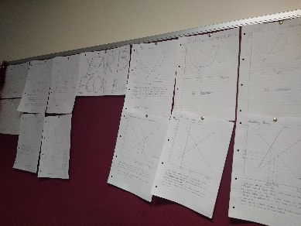
Much of the focus across the Social Sciences in recent weeks has been upon preparation for examinations. Year 13 Global Perspectives completed their public exam in October and Year 11 students are busy preparing for their mock exams in early December. Furthermore, Year 13 students are working towards their mock exams in the New Year. As a result, this can a very stressful time for students therefore staff are investing a great deal of effort in ensuring everyone is as well prepared as possible. As part of their preparations, Yr13 Economists Jack Coates and Eoin Gordon have created a Diagrams Wall in the 6th Form area.

A really positive event in recent weeks was the Year 10 COP26 Mock Summit, with our Global Perspectives students representing various countries around the world. It was fascinating, and somewhat enjoyable, to see Malawi getting particularly angry at both Saudi Arabia and Australia for their lack of action. I am sure you have read the write-up of this event provided by Mrs Davies in last week’s newsletter.

Department Update – Drama
‘Drama is life with the dull bits cut out.’ - Alfred Hitchcock. Year 10 Drama students have recently been looking at Devising drama. Devising is a group collaboration in response to a stimulus, leading to the creation of a piece of performance. A stimulus is anything that excites the imagination and sows the seeds for a piece of drama. It could be a poem, a song, an object, a picture, a newspaper or web article.
Having devised some pieces based on stimulus provided by the Drama department, on Friday Year 10 brought in their own pieces of stimulus to base an original piece of theatre on. Items included a bank card, a pack of playing cards, a gas mask, and an old key. Working collaboratively in satellite groups, the students brainstormed initial ideas about plot, character, themes and – as Bertolt Brecht is their influential practitioner – a message for the audience to take away from the performance.

As well as developing their drama skill set and meeting the assessment objectives of the GCSE Drama specification (Unit 1), the Devising Unit will also help develop students’ employability skills. These include Communication and inter-personal skills (collaborate, noticing, empathy and listening); Working under pressure to deadlines (perseverance, planning and managing distractions); Being self-motivated (absorption, perseverance, imagining, managing distractions); Team working (collaboration, empathy and listening, interdependence) and Negotiating skills (empathy and listening, questioning, reasoning). The students are still working on the assignment, but I will keep you updated with regard to the outcomes and final performance pieces…

Year 13 Academic Review Day
A reminder that we will be holding the Year 13 Academic Review Day on 2nd December. With mock exams set for the second week in January, this is a crucial time for students to review their current progress and present their academic plan for the coming months. Families of Year 13/14 students are invited to attend a short meeting with their tutor in which they can listen to feedback from the student’s teachers and see if they are on track for their short and long-term goals. The deadline for appointments was 25th November, so please double-check that you have confirmed a time with their tutor. Please contact us if you have any queries.

Student Librarians – thank you to the students below who give their time each lunchtime to help in the school library. We are very grateful for their valued support.
Jacob Crowe | Theo Milward
Eleanor Corrie | Daisy Divers
Beck Parker | Jake Faragher
Cameron Pressford | Chloe Meadows
Abigail Campbell | Bella Kerruish
Izzy Callow | Georgia Kerr
Emily Gale-Hasleham | Piper Withington
Phoebe Margrave | Phoebe Davison
Ciara Fromm | Adam Brooks

Library Quiet Space Club – Due to student requests via our student council representatives, we will be relocating the games club that currently takes place in the library at lunchtime and maintaining the library to a quiet space to work and read during this time from now on.

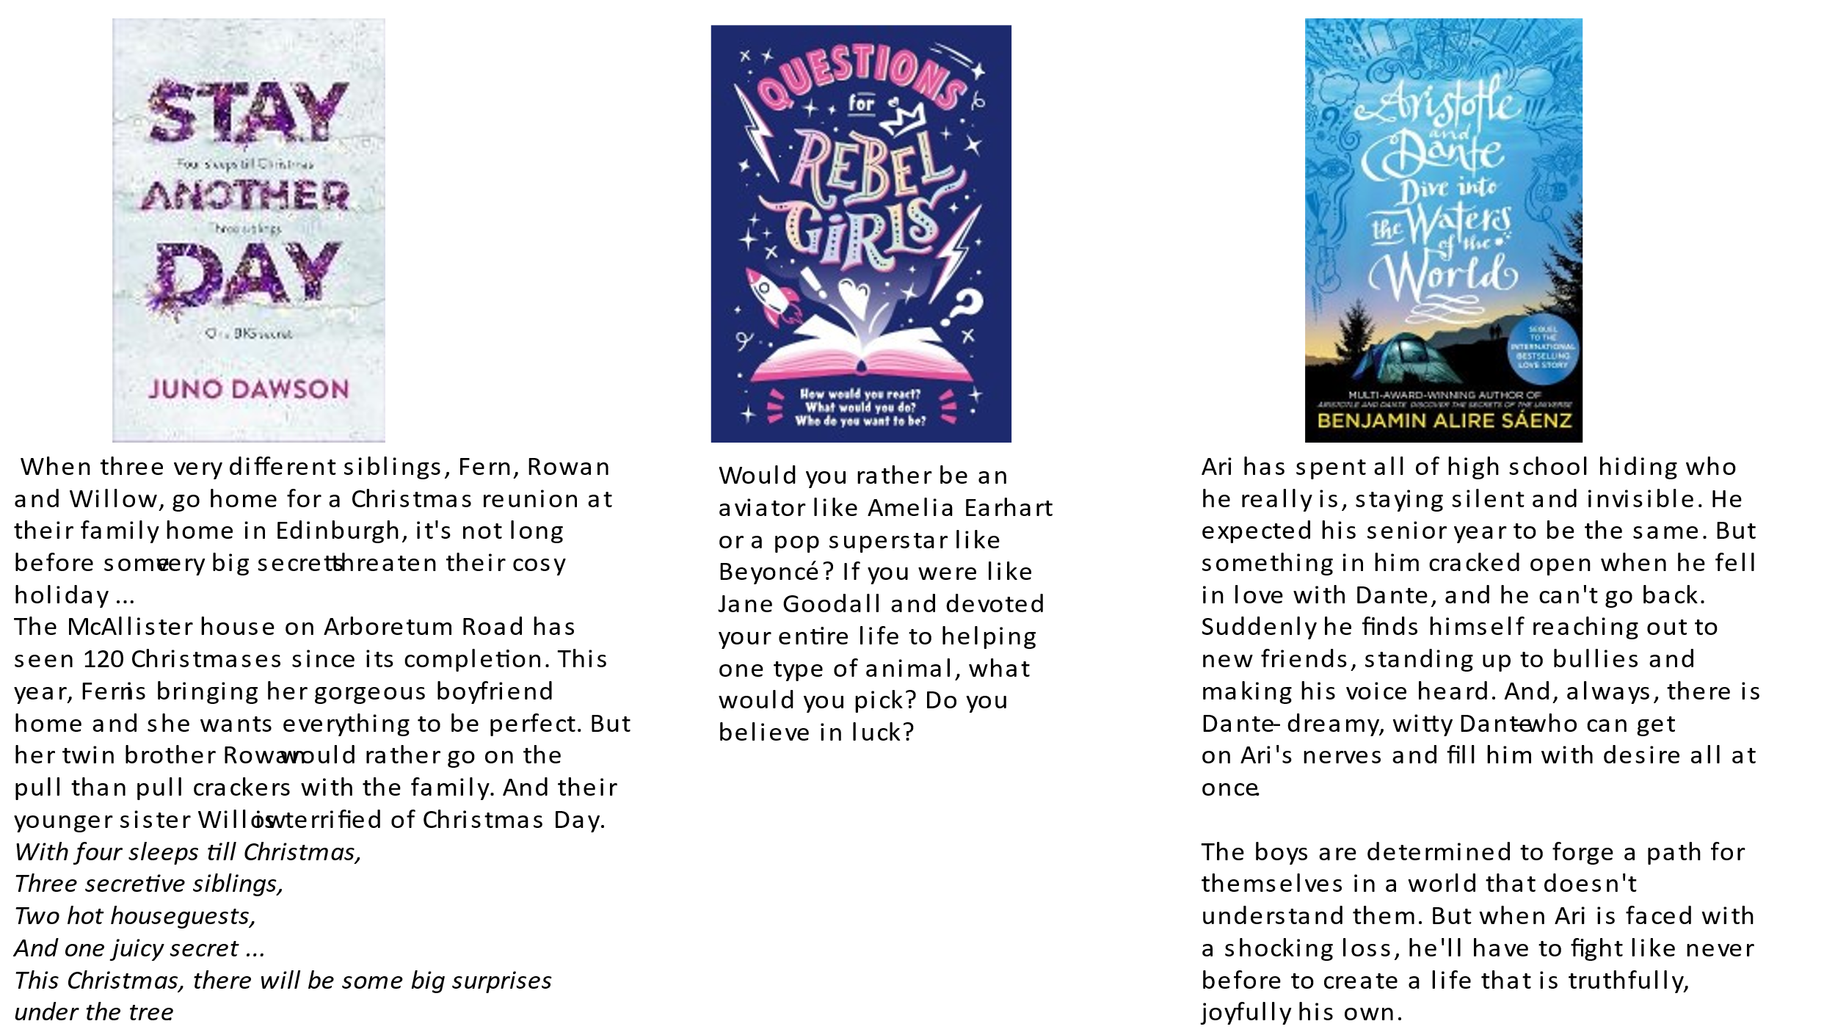

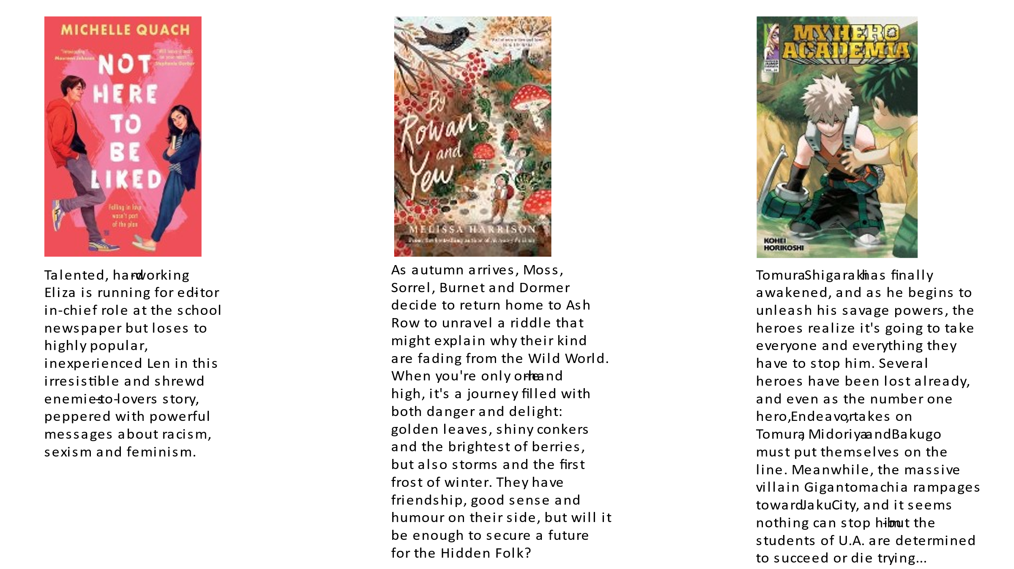

Key Dates:
- Week Commencing 29th November – Year 11 Mock Exams (until Friday 10th December)
- Thursday 2nd December – Year 13 Review Day
- Friday 3rd December – Non-uniform
- Thursday 9th December – Live Screening – The Nutcracker (Royal Ballet)

