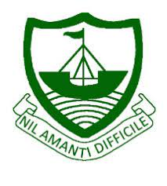
RGS Newsletter
Friday 7th January 2022 – Issue 14

Headteacher’s Award Winners

This week once again we held our Headteacher’s Friday Tea Party. The Headteacher’s award winners were invited along to share their experiences and the reasons for their nomination for this prestigious award. They were chosen by the staff at RGS over all other students in their year group to be recognised as students of excellence. They were nominated for many reasons, but these included kindness, compassion, partaking in musical performances, excellent effort, being a caring friend, considering others and cooking genius. A truly inspirational group of young people who really do embody our way of being here at Ramsey Grammar School. We are so proud to have these students as a part of our school community. Well done to them all.

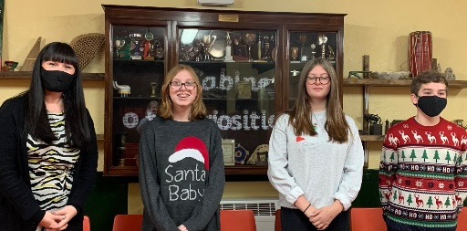
- Year 7 – Charlotte Maloney
- Year 8 – Daniel Cross
- Year 9 – Jess Beastall
- Year 10 – Lily Smissen
- Year 11 - Harry Eyres
- Year 12 – Lexi Forbes
- Year 13 – Lucy Gilmore

Headteacher’s Message

As we come to the end of our first term of the academic year we are so proud of all that our young people have achieved. Having had a full-term with minimal disruption despite the situation increasing in seriousness on the island we feel very grateful indeed. We thank you for your diligence and support when it comes to government guidance. We have done all that we can to mitigate the risks within our setting whenever we can. The children have shown maturity, resilience, and determination to focus on their studies and get back into normal school life once again.

We have had so many amazing events this term; New student induction events, Y10 Maths and English evening, Y7 Managing Change Day, Y7 Life Matters day, Comic Book Dress Up Day, Duke of Edinburgh evenings, Junior Achievement Kick Start Event, Year 7 and 8 Tutor Evening, Maths symposium, Y11 Review Day, Y9 Health Fair, Global Perspectives Mock COP26, Y9 Junior Achievement Learn to Earn, Y13 Academic Tutor Day, Non-Uniform Cruise Day, Y12 Politics Mock United Nations Security Council Day, Y7 English Showcase, the Carol Service, Christmas extravaganza performance, prize giving, weekly headteacher’s award tea parties, numerous external speakers in assembly and so much more! It really has been wonderful to get the school back to the enriching experience that it should be, both inside and outside of lessons. We end the term with Christmas songs ringing in our ears, tinsel around our necks and well wishes from our school community.

I would like to thank all of our families from the bottom of my heart for all that you are doing to support our students, and indeed staff, to ensure that our young people lives are richer, more positive, happier, more driven, focused and full of care and consideration. It takes a village to raise a child and we so value working with you all

I wish you a very happy holiday. Enjoy some rest, friends and family as much as you can.

Kind regards

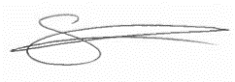
Sarah Findlater

Headteacher
Ramsey Grammar School

Year 7 Myths and Legends English Showcase

Year 7 students completed their course on Myths and Legends by presenting their learning in a method of their own choice. There have been some fabulous entries to showcase and staff, students and teachers all thoroughly enjoyed visiting and seeing what has been going on. Thank you to all families who have given our year 7s space and support to be able to produce some excellent work.
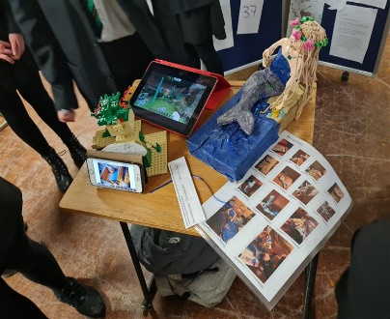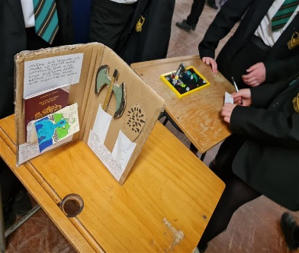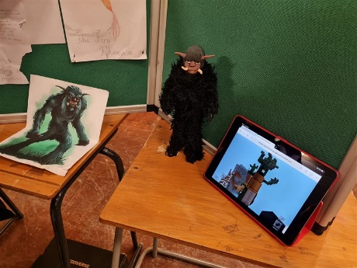

Year 10 Media Studies Visit

We were lucky enough in Media Studies this week to have a visit from Siobhan Fletcher at IOM News. Siobhan spoke to the students about how a newsroom on the Isle of Man runs, introducing them to some key technical terminology and sharing the practices of journalists. The Media Studies class have been producing their own newspaper this half term, focusing on understanding the conventions of newspapers and how they represent people and events.

Department Update – Art

Jessica Wild is a Y13 student who has recently been accepted into Edge Hill University for Primary School Teaching. She is currently working on her Art Unit 1, Natural Forms. She is focused on illustration, illustrative techniques and floral subject matter. Her work is technically very strong, with a clear love of colour. We would like to wish Jess all the best in her teacher training and hope on day she will bring her passion for Art to many children in her classes.
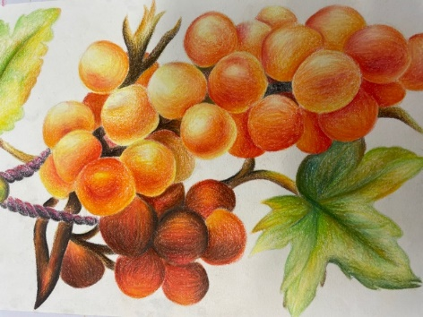
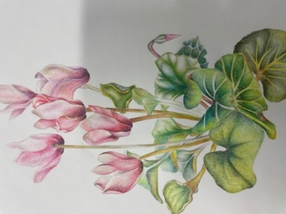
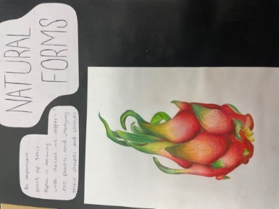

Artwork by Jess Wild Year 13

Spirit of Normandy/Young Historian Awards

The Spirit of Normandy Award was close to Hector Duff's heart and every year we enter the competition.
Year 10 had a special assembly last week where we remembered some of their achievements in Year 9 History, where their "Tell Me" Project work was acknowledged.

We invited Hector’s son and daughter-in-law to the ceremony, but unfortunately, they couldn't make it. They did however pass on their congratulations to the students. Picture 1 - Winners of the Young History Competition. Picture 2 & 3. Spirit of Normandy Winners. Picture 4. Winners who originally received their prizes at Awards Evening.
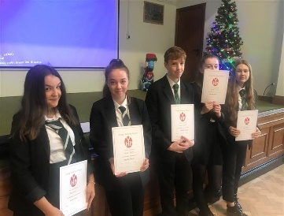
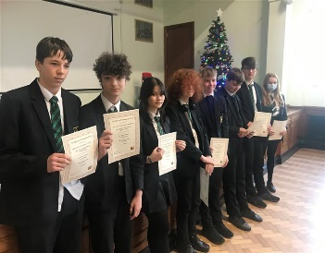
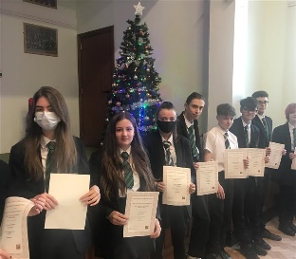
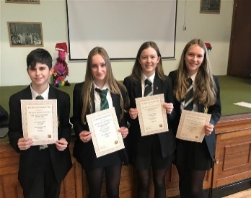

Geography Department Update

Year 12 recently undertook a day of Fieldwork looking at the Corrany river from its source high in the valley to its mouth at Cornaa. Year 7 students have been looking at traffic along Lezayre Road, making a note of traffic concerns and potential parking issues.

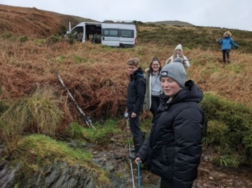
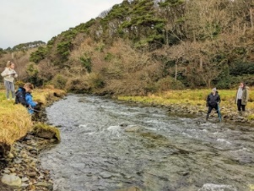
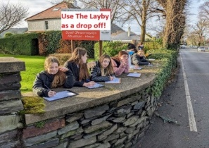

Year 7 & 8 Star Geographers for this term are:
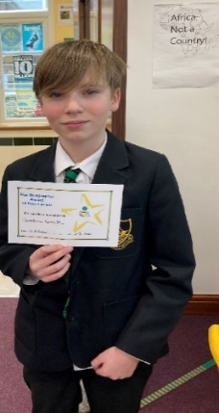
7A | Amelia Collister | Zac Woodward
7B | Resa Brown | Stanley Kinnish
7C | Alex Smith | Sam Faragher
7R | Liv Quayle | Christian Kneen
7S | Wiktoria Urbanska | Freddie Mooney
7V | Holly Bashforth | Lucy Harvey
8A | Sophie Lyness | Nuala Sharpe
8B | Cameron Pressford | Sam Footer
8C | Daniel Cross | Ciara Fromm
8R | Aoibh Nash | Saskia Clague
8S | Megan Lord | Pheobe Davidson
8V | Oliver Dowty | Isla Caine

Department Update - RMPS
Recently our Year 8 classes have moved on from learning about Islam, to the Indian religion of Hinduism. Hinduism is a vibrant and exciting religion, full of mythology and symbolism and we are always very excited to explore it in our subject. In particular we have spent time learning about the Hindu concept of God, called Brahman and the deity Ganesh the elephant headed God.
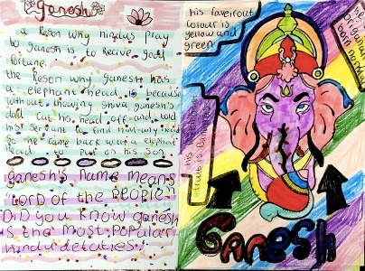
Students have created some fantastic information cards on Ganesh, using what they have learnt and some extra research. These examples are just a few of many that we will be putting up as part of our Hinduism display - the students really have excelled!
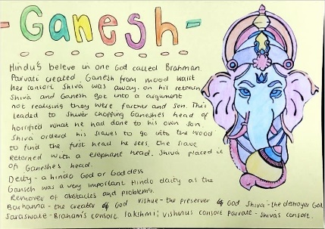

Parental survey results - Theme Communication:
217 families responded to the survey. The numbers of responses per year group were as follows.
- Year 7 -69
- Year 8- 59
- Year 9 -45
- Year 10- 39
- Year 11- 35
- Sixth form - 37
Results of the survey:
Parent App - 64% of families who responded have parent app. Parent app is used to communicate live achievement points, behaviour points, links to the website and notes about upcoming events. This is one of the most important methods of communication. If you do not have parent app set up, please use this here to access instructions to set this up on your device. The new behaviour system is here for you to understand what L1, L2 and L3 sanctions mean.
Live Notification - 95% of families who responded are happy to receive live notifications of behaviour and achievement points via parent app.
School Emails - 99% of families who responded receive e-mails from school which can include the newsletter, letters, school reports and sanctions. If we do not have your correct e-mail address, please let us know via RGSenquiries@sch.im.
Weekly Newsletter - 94% of families who responded receive the weekly newsletter via e-mail. If you do not receive the newsletter, please let us know via RGSenquiries@sch.im . We will review the content and how often the newsletter is sent home to families.
Other responses:
Planners- are still to be used and signed from home. We use them to write down homework, log when students use the toilet and use a sticker to inform a student if they have received a behaviour point. That way the student is aware of why they have received the behaviour point and it is a reminder about the sanction. If you child does not have a planner please contact school via RGSenquiries@sch.im. If your child receives a behaviour point, we are trialling a new system whereby they will receive a sticker in their planner to notify them about this and remind them they will need to attend a reflection session.
Parents evenings/Academic review days- these will be reviewed in the New Year and the result of this will be shared with you all.
Sports fixtures/Clubs lists & cooking ingredients- Sports fixtures & clubs will be on the website, links will also be on the parent app. We are working with the technology department to provide a link to the cooking ingredients required.
Revision guides/programmes of study - In the New Year, we will aim to ensure that these are available to view on the website.
Thank you so much to everyone who responded to the survey, as always, we value your feedback.
Mrs Josie Corrin
Senior Rugby Shield
It has been a few years since the RGS senior rugby team played in the Senior Rugby Shield final, last winning it in 2016. With a squad as strong as we have had in a few years but with a higher ratio of Year 11’s playing, things look like they could be on the up. Having won 3 of the 5 league games we claimed a home semi-final against St Ninians High School. The game was strongly contested, unlike the first match, SNHS put up a much-improved performance, but RGS came away with a 26-5 win.
The final was played under lights at Ballafletcher against the old enemy Castle Rushen. They had defeated us earlier on in the league when RGS had a depleted team due to injuries and some off-island commitments. There was an air of anticipation with a full squad available for the final, and indeed it was RGS who struck first within 5 minutes to score the first try. RGS then became the architects of their own downfall by making simple mistakes and giving away silly penalties. This gifted CRHS two easy tries, who then created a well-worked opening for a third try giving them a 17-5 lead at halftime. In the second half, both teams continued to make errors, both conceding silly penalties, leading to 3 yellow cards for each side.
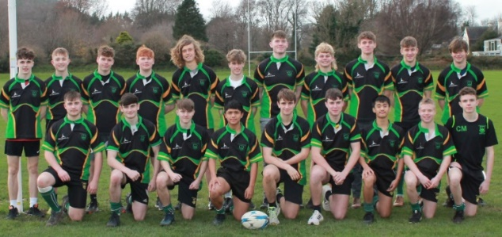
The score remained the same until about 15 minutes left when the extra CRHS man advantage paid dividends leading them to score a well-worked try. With the game out of reach, all the RGS subs were used and although CRHS ran a few more tries the lads never gave up, as has been their trait this year, and had the last say by scoring right at the end to lose 41 -10.
The whole squad commitment and effort has been superb this term and they thoroughly deserved their place in the final. In the end, we were beaten by a squad that had quite obviously had more time to train together.
Mr Ideson
Key Dates:
Tuesday 4th January – Spring Term Commences
Tear 7 Reports issued this week
Wednesday 5th January – Years 10, 11 and 8 Celebration Assemblies
Thursday 6th January – Years 7, 9 and Sixth Form Celebration Assemblies
10th – 19th January 2022 – Year 13 Exams

