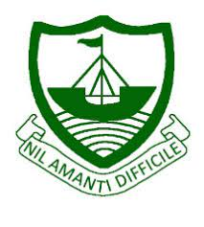
RGS Newsletter
Friday 21st January 2022 – Issue 16

Headteacher’s Award Winners

This week once again we held our Headteacher’s Friday Breakfast. The Headteacher’s award winners were invited along to share their experiences and the reasons for their nomination for this prestigious award. They were chosen by the staff at RGS over all other students in their year group to be recognised as students of excellence. They were nominated for many reasons including manners, hard work, contribution to the school, musical abilities, focus on studies, being a role model, positive attitude and helping others.

- Year 7 – Grace Kelly
- Year 8 – Sophia Shimmin
- Year 9 – Katie Foster
- Year 10 – Rio Kelly
- Year 11 – Felix Galbraith
- Year 12 – Nerys Otto
- Year 13 - Martha Done

Headteacher’s Message

We are very happy to let you know that we will be moving to have fewer Covid-19 linked restrictions in place from Monday within the school. We will be happy to start face-to-face Year group assemblies, swimming and inter-school sports once again. We will proceed with caution and open up what we can within the current guidelines from the government, keeping sensible and necessary mitigations in place at all times of course. We thank you all for your support with what has been a challenging few weeks in terms of illness and staffing and very much hope that we are over the worst of it now.

You may have seen in the press that we are currently advertising a Deputy Headteacher role for the next academic year. This role will be replacing our long-standing Deputy Headteacher, Carol Bamford who has stepped down to begin her phased retirement. Carol has been an amazing member of the senior leadership team and we are so happy that she has chosen to remain teaching for us in the Maths department. We will be conducting interviews over the next month and will announce the successful candidate as soon as this has been decided upon. We will also be advertising an Assistant Headteacher role shortly, this is a new role within the school that sees us expand our Senior Leadership Team. An exciting time for the school indeed.

I wish you all a wonderful weekend.

Kind regards
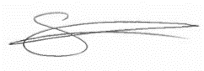
Sarah Findlater
Headteacher
Ramsey Grammar School

School Calendar
We have updated the school calendar and have uploaded it to the RGS website. Currently, we do not have an application that will allow a live calendar function on our website, so the list will be updated periodically and reuploaded. Please bear with us and keep checking back. We will of course endeavour to announce any updates in the relevant places, as well as here in the Newsletter so that Parents/Carers are kept abreast, but please do check back from time to time.

RGS Library Update
We have recently added many new fiction titles to tempt our readers, and the Library is open every lunchtime for browsing, working and reading, and to return or take out books. In our magazine section, we have at the moment: Top Gear, Rugby World, MBR (Mountain Bike Racer), Bike, BBC Wildlife, The Phoenix and FourFourTwo – which this month carries a feature on the Isle of Man Football team! It has been lovely to see so many students taking books home and reading in their own time. Now that so many students have been logging books out to read, we kindly ask that if you find you have RGS Library books in your home, we would be very pleased to have them returned so that others might enjoy them too.

Department Update – Geography
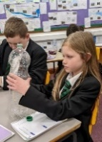
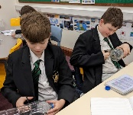
This term Year 7 are learning about the weather. Each student will upcycle a plastic bottle into a ‘Rain Gauge’ and record the rain over a week and compare their results to the forecast. Year 8 Have been studying population both globally and on the IOM. Year 9 Are currently investigating large corporations like NIKE. Understanding where our stuff comes from and who makes it with what consequences Year 10 Will be starting to explore global migration patterns and Year 11 Are looking at global food and water issues. Year 12 Have been looking into population control in India and River flood management. Year 13 have just got their Paper 1 results with 6 students gaining an A and 8 students achieving a B.

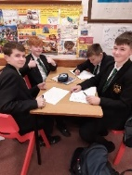
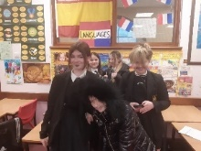
Department Update – Modern Foreign Languages

Year 7 French:
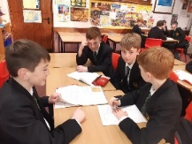
Students have been learning how to talk about families in French. This week we combined our acting skills together with the French we had learned and got into our own weird and wonderful families in the class. There were some excellent examples of French language and plenty of comedy! Some groups even brought in their own props and used make up to enhance their performance! Well done Year 7!
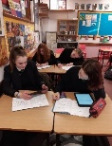
Year 9 are busy writing a profile in French about themselves and the Isle of Man to share with our partner school in France. Communicating with students of their own age is a really exciting process for them and they are enjoying using their language in a real-life context. Our profiles will be sent this week and our year 9s are very excited about receiving a letter from their new pen pals in the near future!
Our Year 8 students produced some excellent “WANTED” posters last term in Spanish. Students were able to describe the criminals they were searching for in excellent Spanish. Do we have some future international investigators in our midst at Ramsey Grammar School?
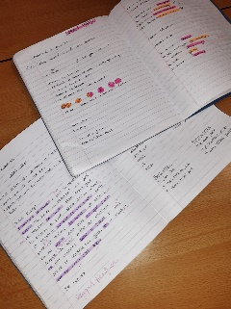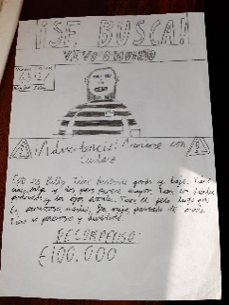

Department Update – Rural Science
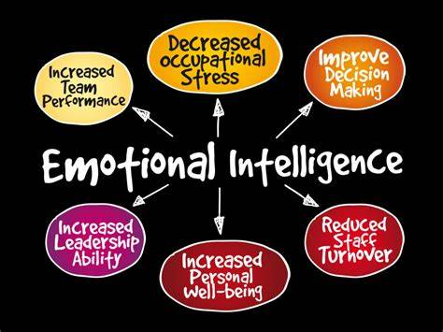
School farms have had an important role in schools across the British Isles for over 100 years, from students learning how to produce food for themselves and community to school farms today, which offer students not only the opportunity to find out how food is produced, but also offers opportunities for academic study, links across subjects, and the chance to develop soft skills, or Emotional Intelligence Quotient (EQ) whilst studying a more vocational subject.
Ramsey Grammar School has had Agricultural and Environmental lessons in one form or another since the 1940s. Rural Science is a core subject for all KS3 students, with all students in Years 7, 8 and 9 all receiving a lesson a week in Rural Science. Around a third of students opt for a Level 2 BTEC in Agriculture, and we are a hub for teaching Level 3 BTEC & SQA Level 6 Agriculture - with students from two other secondary schools travelling to us to take advantage of the specialist staff and facilities available on site.
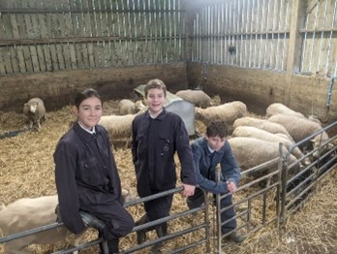
We pride ourselves in not only supporting the local farming community by raising awareness of current issues, but also giving students from all backgrounds the opportunity to gain experience working on our farm. RGS students are ambassadors for our local farming community, and we have received much praise from parents, local farmers, past students and organisations both on and off island. Including Winning the School Farms Network "Best Secondary School Farm" in 2017, and "School Farm Leadership" in 2021, which was entered by schools all over the British Isles.
Education outside of the traditional classroom environment is not a new concept (LOTC, 2009). School farms are becoming more valued and recognised by Governments. Through their website, “Growing Schools” (Saunders et al, 2011) in 2005, the U.K. Government issued a report highlighting that “outdoor learning supports academic achievement” by developing reflective and inquisitive thinking and problem-solving skills in real life situations. This is also supported by the London Sustainable Development Commission (2011).
Working with animals gives opportunities to develop resilience and adaptability. Animals are unpredictable and don’t adhere to lesson plans. Identifying risks and hazards becomes second nature, as working on a farm is inherently dangerous, so constant immediate risk assessments are required not just by teachers, but everyone. Rarely have students carried out the tasks set on the farm before, and the satisfaction of completing tasks that are genuinely needed, allows students to experience pride in overcoming uncertainty. Harvesting crops that they have grown and cared for from seed, or helping a lamb be born gives a real-life sense of achievement of something that genuinely matters and would not have been successful without them. Students work as part of a team, where nobody is doing exactly the same task. I rarely assign roles to students, and instead, let them negotiate roles. Through this, they develop and demonstrate skills in communication, negotiation, and fairness.
The benefits of school farms are plentiful and diverse. Some pupils will discover they have a talent for practical skills, which cannot be replicated within a traditional classroom, others might use the school farm as a way of growing their own self-confidence, developing empathy skills, or learning to work as part of a team, as well as the more obvious development of practical skills, theoretical knowledge and applying that knowledge to real-life situations to develop a deeper understanding.
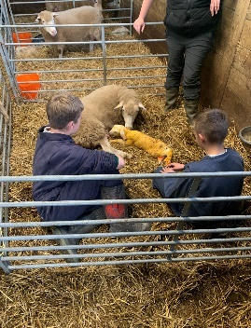
Development of these skills can be observed in use within a more formal classroom context too. All students benefit from their lessons in KS3, but students who may not take advantage of traditional classroom settings, get to experience success regularly. These students often excel in Rural Science/Agriculture, and the positive experiences outside the classroom are translated into written work in the classroom. Having had a taste of success, most students become determined to succeed and written work is of a much higher standard. One school in the UK stated “Working with large animals really switches disaffected students on. In a visit by the Shadow Minister for Education to the school farm he asked one of our young men if he minded working with the animals when the weather was bad, the response – ``it's the only reason I come to school!” (Saunders et al, 2011)
So, alongside the academic studies in Rural Science and Agriculture lessons, the development of the skills essential to employability and further education such as Critical Thinking, Communication, Listening and Interpersonal Skills are considered equally important to providing Ramsey Grammar School Students with the best opportunities to be successful in whatever they choose to do after leaving compulsory education.
What are we learning about at the moment?
Year 7
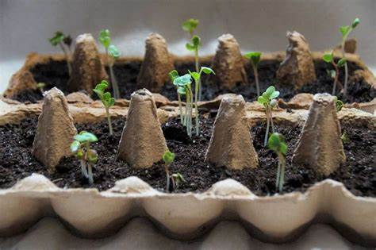
Germination - After initial theory lessons, students will be using the knowledge gained to grow their own crops. Sowing the seeds this term and continuing with their care until the Summer.
Chick Development - A whole half term project on the development of the chicks, taking measurements, fair tests, outliers, evaluating their own work, drawing graphs and data analysis. Developing their transferable scientific and mathematical skills, as well as developing their Interpersonal skills or fairness, teamwork and empathy.

Year 8
Poultry Production - Following on from their Natural Hatching, Artificial Hatching lessons, students will be rearing their Chicks.
Crop Production - Students are developing SMART action plans to enable them to take the lead in sustainably growing their chosen crops. Demonstrating their understanding of Nutrient requirements, recognising deficiencies, Compost Production, and fertiliser options and application. Developing Teamwork, Responsibility and application of scientific knowledge

Year 9
Maximising Productivity - Using their knowledge gained in year 7&8, year 9 are discovering how science is used to maximise yield. This includes glasshouses, hydroponics, genetic modification and rearing livestock. Students will also use their animal handling skills developed in years 7 and 8 to start working with the piglets. This develops their teamwork and communication skills, as well as giving opportunities to apply their productivity knowledge gained in classroom-based lessons, to identify areas for improvement. Rural Science and Agriculture lessons are all planned around the seasons and lambing and Farrowing times are no exception. The birth of the piglets is an integral part of the assessments in Years 10-13 Students weigh them weekly and interpret data, calculate feed conversion ratios, using this data to help monitor animal health and efficiently rearing young animals. These students are also continuing their studies in Animal Biology, Soil Science and the importance of maintaining up-to-date records on a farm.

Department Update – RMPS
This past week has been a busy one for the RMPS department as we delivered the Key Stage assembly for World Religions Day 2022. It is a day that is aimed at celebrating diversity and culture - something which underpins our rationale and philosophy as a department. This week some of our Y9 classes have been discussing the French senate’s proposals to ban the wearing of hijabs in sports competitions and whether they believe it to be discrimination or not. Meanwhile Y11 have begun to unpick the moral maze of the death penalty as part of their GCSE studies. In RMPS we strongly believe in assessing moral dilemmas from all angles and it is great to see the next generation approaching issues with such open minds and objectivity.
Key Dates:
25th of January – Y11 Reports Published
26th January – Student Voice Questionnaire – Teaching and Learning
27th January – Junior Achievement Event – All About the Money
27th January – Live Screening - Leopoldstadt
28th January – Parent Voice Questionnaire
31st January – (No Events)
01st February – Staff Voice Questionnaire
02nd February – (No Events)
03rd February – (No Events)
04th February - (No Events)

