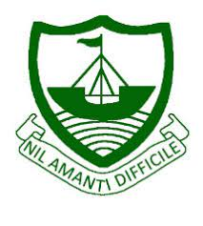
RGS Newsletter
Friday 19th November 2021 – Issue 9

Headteacher’s Award Winners

This week once again we held our Headteacher’s Friday Tea Party. The Headteacher’s award winners were invited along to share their experiences and the reasons for their nomination for this prestigious award. They were chosen by the staff at RGS over all other students in their year group to be recognised as students of excellence. They were nominated for many reasons, but these included being a great friend, looking after others, excellent transition into the school, achievements in History, diligence, goal setting, perseverance, strength of vision and being a role model to others. A truly inspirational group of young people who really do embody our way of being here at Ramsey Grammar School. We are so proud to have these students as a part of our school community. Well done to them all.
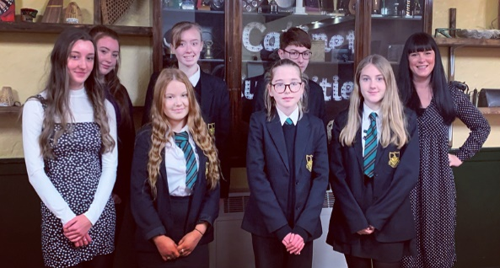
- Year 7 – Daisy Liddle
- Year 8 – Holly Salter
- Year 9 – Kieran Kelly
- Year 10 – Jasmin Torr
- Year 11 – Abigail Radcliffe
- Year 12 – Lara Butler
- Year 13 – Amber Walsh

Year 11 Mocks
Mock exams run from Monday 29th November until Friday 10th December. You should have received a mock timetable by email, if you have not received one please speak to Mrs Beaumont the exams officer. Please remember mobile phones and smart watches are not allowed in the exam hall. Make sure you prepare as thoroughly as you can using revision resources suggested by your teachers. Remember GCSEpod is also a fantastic revision tool. This is a fantastic opportunity to find out what you know now and what you need to work on before the summer. Good luck - Mr Wood
Parent Voice – Academic Review Day and Reporting
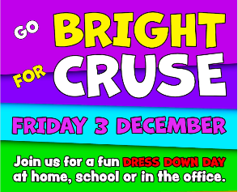
We would like to gain parental opinions in relation to Academic Review days and Reports. Currently reports contain colour-coded teacher judgements on characteristics we promote with our students and Current Assessment grades which reflect the grade each student has achieved at the end of each half term. Using the SIMS mobile app there is an opportunity to supply families with more regular attainment data and we wish to seek your views on this. The benefits of Academic Review days are highlighted in educational research. There is significant evidence that a student’s understanding of their own strengths and areas of development has the greatest positive impact on their attainment. These are skills we aim to develop in the review day process. If you would like to feedback and affect our future direction in terms of reporting and review days, please complete this short questionnaire. We appreciate you taking time to help us develop our systems.
Non-Uniform – In Aid of Cruse - We are holding a non-uniform day on Friday 3rd December in support of CRUSE. This is an amazing charity who offer support to students and families when they experience bereavement in the family. They come into school to speak and meet students, visit the family home and organise amazing events to help in their time of grief. We are encouraging students and students to wear something bright and donate £1 to the charity.

ISLE LISTEN Support Events - Lots of staff attended an information session run by ISLE LISTEN. The focus was how to support students who worry a lot and appear nervous in lessons and around school. Staff welcomed the session and left with lots of valuable tips. If you would like to see what ISLE LISTEN offer, please look on the school website here. They have lots of tips for parents and they are holding a parent information evening at RGS in February 2022. They will be holding several other sessions around the island and at their office in Douglas which is by B&Q.

As always, if you have any concerns about your child or you feel your child needs extra support, please do not hesitate to contact the school via RGSenquiries@sch.im.

Celebration Assemblies
During the week of 4th - 7th January 2022, Celebration assemblies will be taking place for all year groups in the West Hall. Students will be nominated by teaching staff and their Heads of Year/Form Tutors. They will receive certificates for various reasons: effort and attainment across all subject areas, demonstrating the RGS Way of Being and for the most amount of House Points in their year group. We look forward to seeing as many parents as possible and rewarding students for their hard work during the first term.

Cross Country Starting - The PE department are looking forward to the start of cross-country next week. Students will need to bring some old trainers (which will get muddy), a carrier bag for their trainers, a towel/cleansing wipes.

Global Perspectives - Mock COP26
As previously mentioned, Year 10 Global Perspectives students were given the exciting opportunity to take part in a Mock COP26 conference. The One World Centre hosted the conference supported by Mrs Collins and Mrs Davies.

Students were given a country that they had to represent and were asked to present a 1-minute impact statement to outline their country's position on climate change. During the morning, they were asked to come up with solutions to climate change problems. Freya Butterworth commented that ‘Although it was scary standing up and talking in front of my friends, I really enjoying discussing the problems of climate change. It was great fun!’

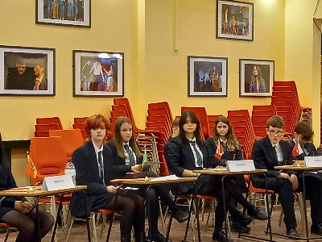
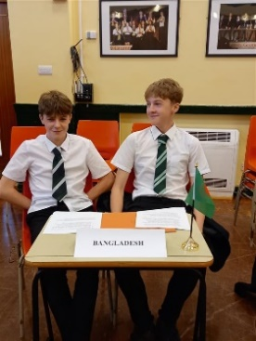
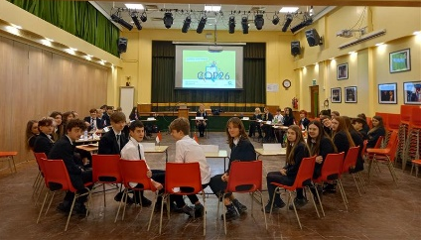

The students all made pledges at the end of the morning on what they could do to help climate change on an individual, school, and island level.
Department Update – English

At the start of November, our Year 8 students took part in the annual inter-school poetry slam competition sponsored by the One World centre. Students began writing these poems at the end of Year 7 as part of the curriculum.

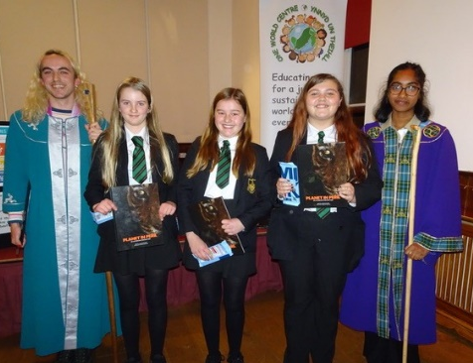
At the start of Year 8, we held our class competitions, then each class sent through 3 teams. Once we had the names, we arranged for a guest judge, our Headteacher, Mrs. Bell and Mrs. Nickson to judge our school finals. This left us with our final three teams which we sent through to the actual Poetry Slam competition. All three teams did exceptionally well and we are incredibly proud to say that we WON for the third year in a row.

Our winning team consisted of Maeve Morrey, Abbi Pattison and Sophie Christian, whose poem was titled ‘Oh my Days’. The competition was stiff, as all involved produced spectacular poems and performances, however, Maeve, Abbi and Sophie triumphed above the rest.

Well done girls!

Department Update – History
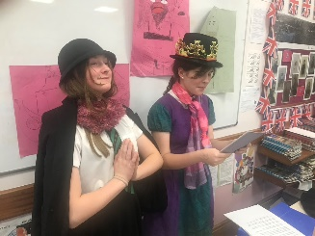
Year 7 students have looked at our development unit, Discoveries, that looks at world history from Neolithic times to the moon landings and beyond. Students have explored many historical skills with special focus on making inferences. Our highlight was making a human timeline and looking at the timeline in the history corridor.

Year 8 students have looked at our depth study on the Tudors and the political, social, economic and religious changes that took place. Students have focussed on source analysis.
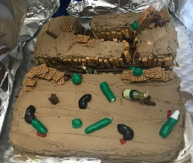
Our highlight was turning the classroom into a church in c1530. Ciara our Catholic Priest (speaking in Latin) and Maddie the Deacon.

Year 9 students have looked at the causes of WWI and are now looking at life in the trenches and key events. Students have looked at factors such as cause & consequence. Shortly they will be looking at the role of women during WWI and the actions of the suffragist movements. An excellent example of amazing work can be seen to the left here in the Trench cake by Annabel, Lily and Isobel.

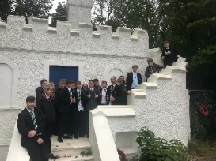
Year 10 - IGCSE students have been introduced to key individuals and events in Weimar Germany 1918 – 1933. They are now looking at the Rise of the Nazis and how German people were fooled by Hitler. Our highlight was watching a presentation that transports Nazi Germany to 21st century IOM.

Year 11 - Year 11 students are finishing their coursework on Tourism c1850 – 1914. They have now started to look at various aspects of the Cold War, such as the Cuban Missile Crisis and Vietnam etc. Our highlight was a trip to Douglas to look at tourist sites, organised by Miss Tedds. You will see in the image to the left our Year 11 students looking at evidence of Cunningham’s Camp in Douglas.

Year 12 - A Level students have been introduced to the complex character that is Winston Churchill through primary sources and have improved their essay writing skills by looking at the complex issues behind the Russian Revolution. Our highlight was analysing Churchill’s relationship with his generals on the whiteboard.

Year 13 - Students have continued working on their coursework either linked to the Cold War or Woman’s suffrage. They have also started to look at histography by looking at the French Revolutionary Wars and Napoleon. Pleasingly many students intend to study history at university. Our highlight was looking at Napoleon’s career. Does he deserve to be called great?

Key Dates:
- Wednesday 24th November – Year 9 JA Learn to Earn
- Week Commencing 29th November – Year 11 Mock Exams (until Friday 10th December)
- Thursday 2nd December – Year 13 Review Day
- Friday 3rd December – Non-uniform
- Thursday 9th December – Live Screening – The Nutcracker (Royal Ballet)

