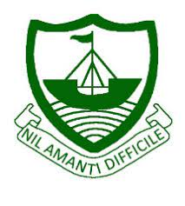
RGS Newsletter
Friday 3rd December 2021 – Issue 11

Headteacher’s Award Winners

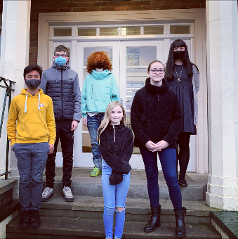
This week once again we held our Headteacher’s Friday Tea Party. The Headteacher’s award winners were invited along to share their experiences and the reasons for their nomination for this prestigious award. They were chosen by the staff at RGS over all other students in their year group to be recognised as students of excellence. They were nominated for many reasons, but these included Excellent attitude, kindness, making others happy, supporting others, excellent behaviour, achievement in exams and subject achievements. A truly inspirational group of young people who really do embody our way of being here at Ramsey Grammar School. We are so proud to have these students as a part of our school community. Well done to them all.

- Year 7 – Maisy Ayres
- Year 8 – Megan Lord
- Year 9 – Kieran Percival
- Year 10 –Quinlan Kewley
- Year 11 – Justin Hughes

Department Update – Science

The Science Department is excited to announce the arrival of a petrological microscope, vey kindly donated to our geology programme by the Department of Earth and Environmental Sciences at the University of Durham.
Geology teacher, Dr Spencer, said, “Our A-level students have to be able to describe photos of rocks as seen in the sorts of prepared specimens we can use with these microscopes – it is so helpful for them to actually look for – and find – these features for themselves”. It’s been lovely to hear the enthusiastic comments from the students (and visiting staff!) who have tried the microscope out in the last couple of weeks – a whole new world has opened to them, and the year 13s have also been able to look at my specimens of the rocks from the Castletown area which they explored on their fieldwork excursions last year. We hope to use the microscope not just for our A-level programme, but also to expand its use to lower year groups when we get our Geoscience club underway next year.

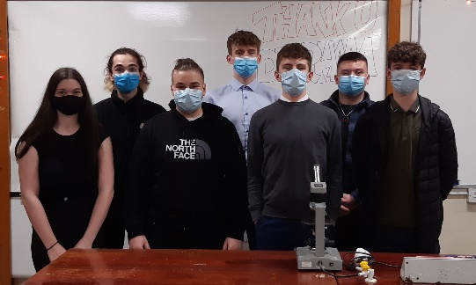
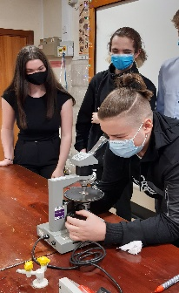

Some fantastic practical skills on show in science this term as seen below.
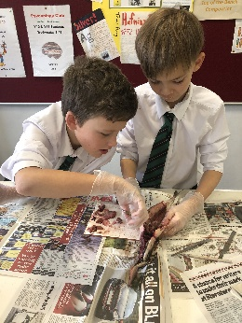
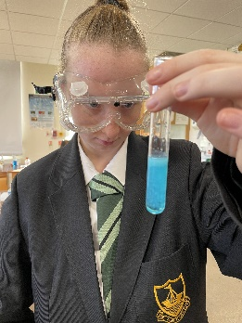
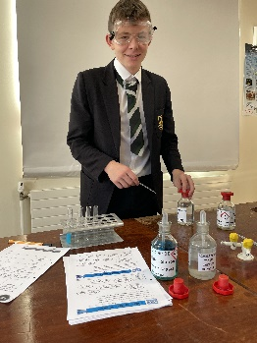
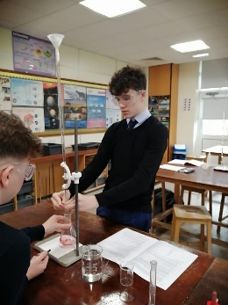

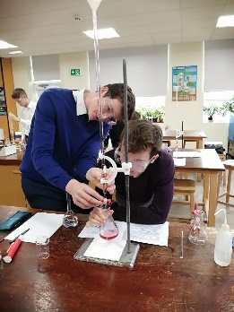
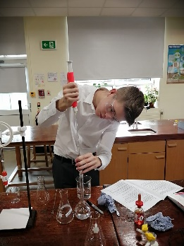
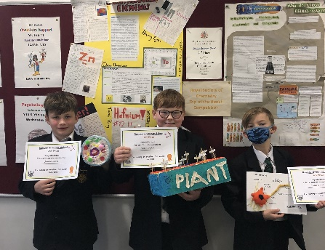

Small animal club – We have three new members of the RGS Science Department guineapigs
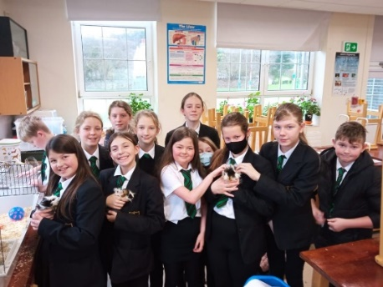
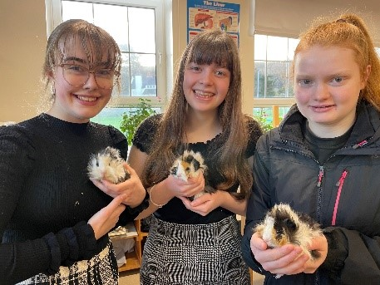

Department Update – Music

The school choir are busy rehearsing for the Carol Service to be held on Wednesday 17th December and the 3fm Carol Competition. Sincere thanks and congratulations to the following students for brilliant performances at the Young Musicians' Forum concert recently.

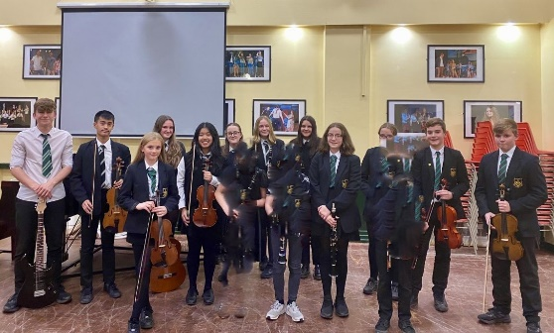
- William Dalugdugan
- Wilma Dalugdugan
- Chloe Kinley
- James Cook
- Ffinlo Corkill
- Daniel Cross
- Francesca Lord
- Sophie Corlett
- Maisie Corlett
- Erin Corkill
- Lilly-Rose Scally
- Annabelle Clague
- Leon Everden

Congratulations also to the following students who were successful in their recent instrumental exams with the IOM Music Service.

Year 9 | Lilly-Rose Scally | Grade 2 Clarinet with Merit
Year 13 | Ben Corkill | Grade 2 Drum Kit with Merit
Year 8 | Ava Harrison | Grade 2 Clarinet with Distinction
Year 8 | Nuala Sharpe | Grade 2 Clarinet with Distinction

Department Update – DT & IT

As the holidays rapidly approach, students in Design and Information Technology have been busy working on their designs and creating some fabulous Christmas dishes in Food,

Year 8 Computing – Students have been planning and creating magazine using publisher software. There has been some excellent design work going on across the board with many students taking pride in their work.

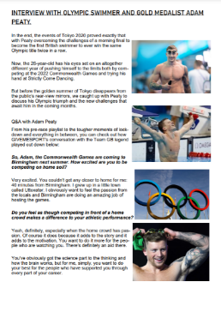
Textiles students have been finalising their designs ready for their cushions.

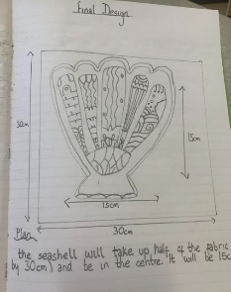
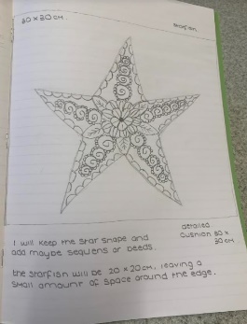
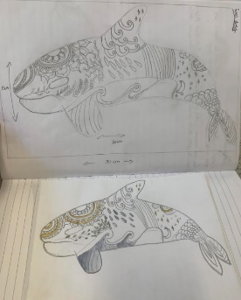

And in Food? Well Christmas wouldn’t be Christmas without gingerbread houses. We made a whole village of them!

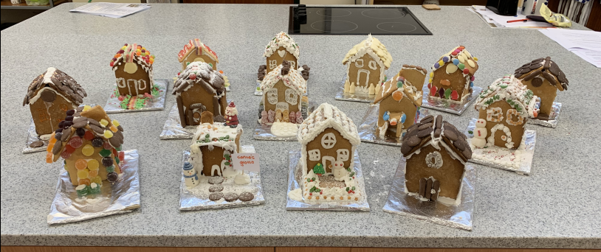

Interschools Cross Country success!
Ramsey Grammar School students had a very successful afternoon at the Inter-School’s Cross Country this week. All our students were a credit to the school and performed brilliantly. Stand out performances were:
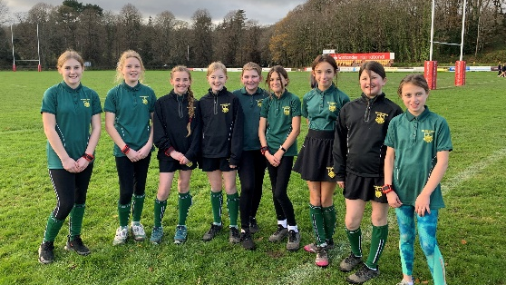
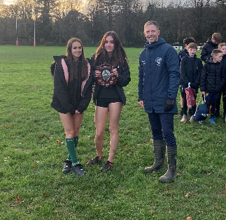
Harry Stennett - 1st
Sam Perry - 1st
Photos
Junior Girls’ Champion
Year 7 Girls
Intermediate Girls
Senior Girls
Senior Girls Champion
Lucas Stennett 2nd
Catherine Perry - 2nd
Charlie Swales - 2nd
Maddy McMullan - 2nd
Lucy Ormsby - 2nd
Abi Clayton - 3rd

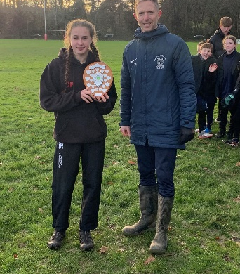
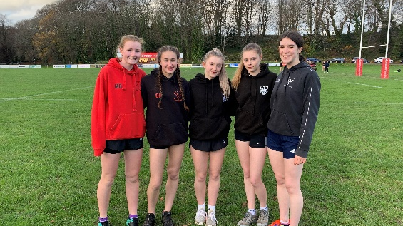
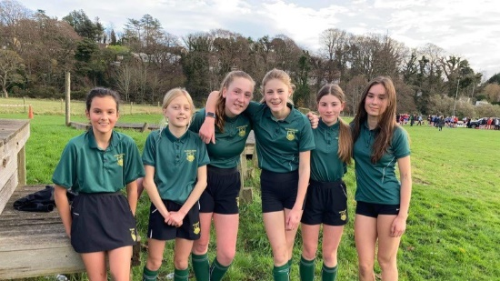

Key Dates:
- Tuesday 7th December – Flu Vaccinations Drop-in (East Hall) 3 pm – 6 pm
- Thursday 9th December – Live Screening – The Nutcracker (Royal Ballet)
- Friday 10th December – Year 7 English Showcase (West Hall) – 2.30 pm
- Monday 13th December – Year English Showcase (West Hall) – 2.30 pm
- Monday 13th December - IGCSE Parent Meeting – West Hall – 6.30 pm

