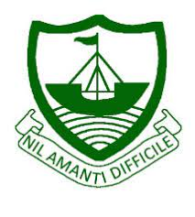
RGS Newsletter
Friday 22nd October 2021 – Issue 6

Headteacher’s Award Winners
This week once again we held our Headteacher’s Friday Tea Party. The Headteacher’s award winners were invited along to share their experiences and the reasons for their nomination for this prestigious award. They were chosen by the staff at RGS over all other students in their year group to be recognised as students of excellence. They were nominated for many reasons, but these included positive attitude, contribution, advocacy, diligence, determination, extra curricular activities, leadership skills, organisation, leadership skills and representing the school. A truly inspirational group of young people who really do embody our way of being here at Ramsey Grammar School. We are so proud to have these students as a part of our school community. Well done to them all.
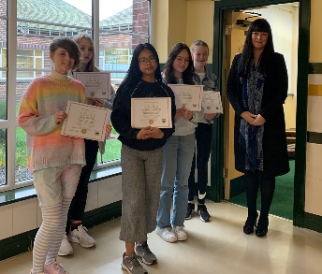
- Year 7 – Zoe Osborne
- Year 8 – Phoebe Margrave
- Year 9 – Sophia Pearson
- Year 10 – Eve Lincoln
- Year 11 – Olivia Cowley
- Year 12 – Neo Dixon
- Year 13 – Arabella Ayen

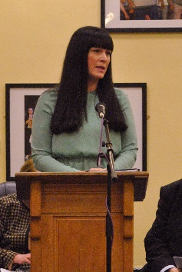
Prize Giving – We had a wonderful Prize Giving event this week in school. We took the time to celebrate the children’s achievements last year. The winners were presented with cups, shields, trophies and vouchers in recognition of their efforts. Mr Bevan, Chair of Governors, opened the event and congratulated all the students on their achievements. Mrs Findlater, our Headteacher, addressed the students and expressed how proud all of the staff and families are of the very special young people who we were celebrating. She highlighted how significant all of these achievements were in light of the turbulence they have all experienced over the last year due to the pandemic. We were wowed by wonderful Key Stage reviews from Amy Gelling, Elly-Jane Crellin, Lexi Forbes, Oscar Bovenizer, Arabella Ayen and Millie Smooth who spoke with maturity and passion about all that our young people have achieved this year. We were also entertained by a wonderful trumpet performance from Oscar Bovenizer and a beautiful hard piece by Arabella Ayen. A wonderful event, although different from previous Prize Givings due to the current restrictions. We thank our families for their understanding.

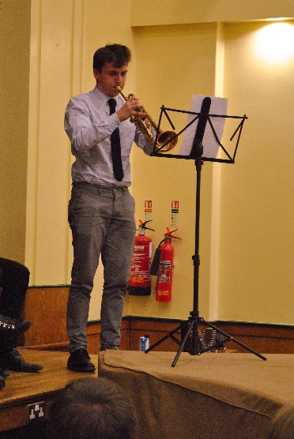
The prize giving in the format that the senior team decided to go ahead with, allowed us to bring the students together across the school years for the first time in a long time while also keeping them appropriately distanced with all possible mitigations considered and implemented. We would have been unable to do this if we also had visitors and families join us. We discussed many, many options and reviewed what was most important to us about prize giving which was that we celebrate the successes of our young people. Not an easy choice but one that we had to make.

Because we recognise that families will have missed the opportunity to come in to celebrate successes at our Prize Giving, we have brought in termly formal Year group Celebration Assembly events that families of those who are being celebrated are invited to. These will happen at the end of each term. This allows us to bring our families in to celebrate successes safely by only hosting one year group (or two in the case of the sixth form) at a time. We will celebrate academic achievement, effort, house points and students embodying our ways of being in these events with the final event of the year being a slightly extended event with additional awards being presented then. We look forward to celebrating lots more over the course of this year.

Uniform
Please do help us to maintain the dress code by ensuring skirts are not too short, tights and trousers are not ripped and blazers are worn at all times. With increased ventilation of learning spaces likely to be a necessity over the winter months we will be encouraging all our young people to have a warm coat and/or extra layers available for next half term, as well as the correct uniform.

Library Update - A New Life for Our Old Books?
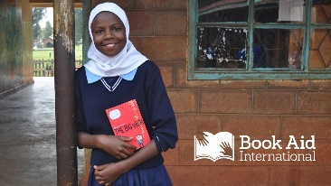
All schools are left wondering what to do with their text books when the curriculum or the exam board changes. At Ramsey Grammar School, we’ve come up with a solution: Book Aid for Africa. Book Aid for Africa (BAFA) is a registered UK charity that is committed to promoting excellence in education in different parts of Africa. BAFA collects new or fairly used educational/reference books and fiction for use in primary and secondary schools and for students in higher and further education that will consequently enrich, improve and change the lives of countless young people over coming years.

RGS 6th form students Aalin Penketh and Ellie Baldwin joined up with the School Librarian to gather, process and pack 26 boxes of donated and no-longer used books onto a pallet for delivery to BAFA’s UK collection depot.

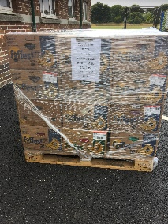
With help from local shipping business Mezeron Limited and their regular UK haulier, we were able to send books and materials to Book Aid for Africa which will end up equipping a large school of pupils aged 3-18 in Ethiopia. Mezeron’s Steve Walton generously not only waived the freight charge for this charitable exercise, but their UK haulier also kindly agreed to deliver the pallet to Sunderland free of charge! The local Co-op were able to provide all the strong boxes for packing (old banana boxes) and all those involved were delighted to know that their support for this charity will genuinely enhance the lives of many learners in developing countries, at the same time providing a ‘green’ solution here in the UK. BAFA was grateful for all the boxes of books, adding that every single resource was suitable for shipping off to their new home in Ethiopia. As a school, we are hoping to be able to support this worthwhile charity again in the future.

Rural Science – Lambing Update
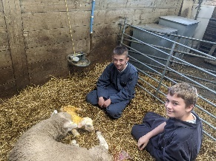
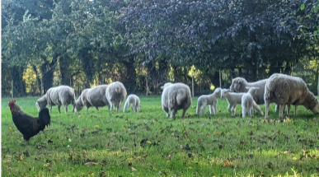
So far we have had 4 lambs. The first two were born on a Saturday which meant the students didn't get to see them until the following Monday. However, we didn't have to wait too long as another lamb was born after school that day during Farm Club and lots of staff and students came to see the birth. Our Headteacher, Mrs Findlater, came along to share the experience. She was very impressed with the knowledge and maturity of the student who were present for such a special event. The lambs received their ear tags and had their tails ringed by Year 11 and Year 12 and were put altogether in a pen with their mums so that the lambs could play.

Farm Club Student Report
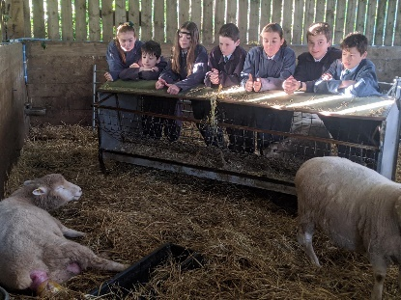
In Farm club we do a wide variety of jobs, like in the mornings we make the animals beds, feed them breakfast and let them outside for the day. In the afternoon there is a bit more time, and we get to hang out with the animals. On Friday morning we were really lucky to see another birth! Miss Arthur had been in to check at 5 am and at 8 am, but nothing was happening - the ewe waited for us to come come to Farm Club!
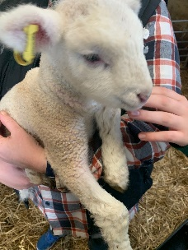
We went to get wheelbarrows to muck out the pigs and there she was! Miss Arthur said that we could miss first lesson to watch the birth - it was great to see the 4th lamb being born. That was a week ago, and today the lambs are big enough to go outside in the sunshine. The abandoned cockerel who lives there was very excited to have his sheep friends back again and came running to see them. We still have 7 ewes still to lamb, but they should be born after half term so that we can see them and help again!

Department Update – Dance

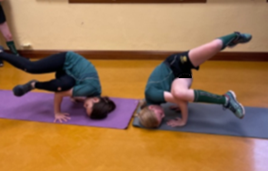
Meanwhile, in Dance Mrs Corrin writes: “It’s been a busy and energising half term. In Years 7&8 Dance lessons are based on the RGS Way of Being: respect, kindness, fairness, community (working together), trustworthiness and fairness. In Dance it’s essential to be kind and to work together and the students have been a pleasure to teach! I lead three or four warm-up routines and then we have a focus on working together in groups. Year 7 groups have been looking at Matilda: The Musical and some brilliant routines have been devised. The students had a great time working on these and lots of Achievement points were awarded.

Year 8 groups have worked on some street dance routines. They all attempted some street dance skills and these were incorporated into their routines, which have been really inventive and all groups worked really well together.”

Department Update – Drama
‘I believe that the creative arts should be compulsory for all GCSE students – school children should take at least one creative subject until the age of 16 to help boost future talent in the creative industries.’
Bernardine Evaristo (Booker prize-winner)
It’s been a busy half-term in the Drama department. Mrs Dunne has been working with Year 11, who continue to study and workshop their GCSE set text: ‘1984’ by Orwell and adapted for the stage by Icke and MacMillan. Students are approaching the text practically – from the perspective of an actor, director and designer – in order to write about the play from a Drama perspective in the written paper to be held in May 2022.

In Key Stage Three, Year 7 classes have been developing their drama skills – including Still Images, Thought Tracking and Performer as Resource – using local stories such as the sinking of the Ellan Vannin, the Snaefell mining disaster and The Terrible Tale of Chicken Charlie (a Manx ghost story). Year 8 groups have been studying the history and development of drama in order to ‘experience and learn about the nature and history of drama in different periods and cultures.’ (From the Arts Council Guidance on Drama Education). Year 9 continue their exploration of the contrasting theatre practitioners Stanislavski and Brecht.

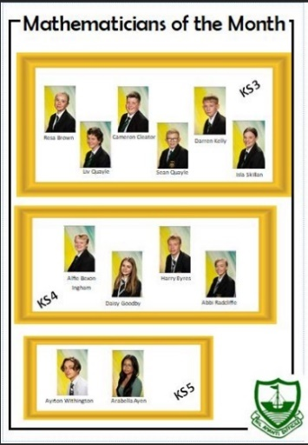
Department Update – Maths
This half term we are honoured to have Dr Ian Wright coming to be the Keynote speaker at the annual All Island Math’s Symposium. The Maths Symposium has Year 12 students invited from all the secondary schools to attend a lecture and then immerse themselves in problem-solving tasks. Dr Wright is a Consultant Orthopaedic Surgeon at Nobles hospital and in his spare time he dabbles in Maths. He completed a Maths Degree in 2012, all the while keeping up his day job. Dr Wright worked on Modelling of Covid 19 for the IOM Government. So a lot of the presentations you will have seen delivered by the Chief Minister and the Minister for Health will have been based on the work of Dr Wright. The title of his lecture is Pandemic Maths: - Covid-19 modelling, stats, and probability.
Each month we are celebrating two students from each year group that have worked particularly hard and contributed well in maths that month. September winners were;

Department Update - Social Sciences - Business
Year 10 have been continuing their look at types of business ownership, from sole traders to plcs. They have also begun investigating stakeholders, measuring business size and business growth. In the coming weeks, they will commence the Human Resources aspect of their GCSE course.

Year 11 have been completing the Production aspect of business, covering issues such as quality management, methods of production, economies of scale and stock control and are close to commencing their look at External Influences, investigating topics such as inflation, unemployment and exchange rates. Thoughts are also slowly moving towards Year 11 mock exams in late November.

A level students in Year 12 have continued their study of leadership with Mr Shimmin, covering theoretical models such as the Blake Mouton Grid, Tannenbaum Schmidt Continuum and Hackman and Oldham’s Model of Job Design. Other lessons, with Mr Foley and Mr Hindle, have been investigating factors that affect demand and costs within business and are working towards commencing the Finance aspect over the coming weeks. A recent case study has been ‘Mere’, a hard discounter from Eastern Europe that aims to significantly undercut both Aldi and Lidl in the UK grocery market, maybe one to keep an eye on?

Our Business Enterprise group in Year 12 has recently visited some local businesses with Mr Wilson to develop their understanding of entrepreneurship and are preparing for their January assessment in Business Environment with Mr Foley.

The Yr 12 LIBF Personal Finance group has been continuing to prepare for their January assessment with both Mr Davies and Mr Foley, focusing upon a range of finance issues that affect wider society.
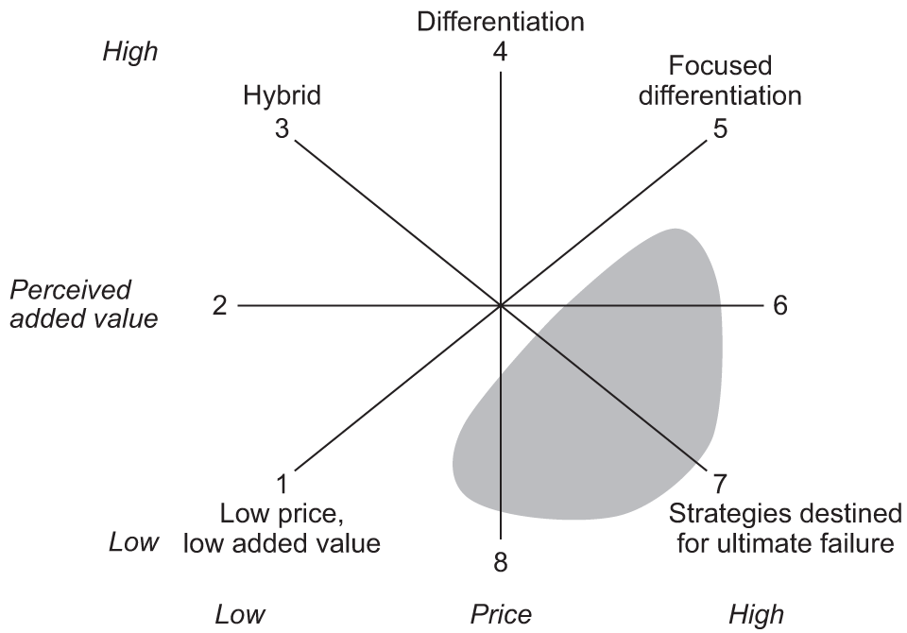
Year 13 A level students have been making further progress in investigating some of the more complex theoretical models focusing upon strategy, including Bowman’s Strategic Clock, Ansoff’s Matrix and Porter’s Generic Strategies. Mr Shimmin has also been introducing some real-life case study examples to relate to these theories, such as Ryan Air, Google, Amazon, Starbucks and HMV. Mr Hindle and Mr Foley are continuing with financial ratio analysis and are moving towards some alternative measures of business success with Elkington’s Triple Bottom Line and Kaplan & Norton’s Balanced Scorecard.

Department Update - Social Sciences - Economics
The Year 12 Economists are well underway with an understanding of the price mechanism and how the interaction of demand and supply efficiently allocates resources within a market economy. Mr Hindle has also introduced the concept of elasticity, measuring the responsiveness of both demand and supply to a change in price. Current issues such as shortages of petrol in the UK and recent gas price increases have added an important contemporary context to these lessons. In the coming weeks students will begin to investigate the various market failures that may result in a misallocation of resources, classic examples include smoking and alcohol consumption.

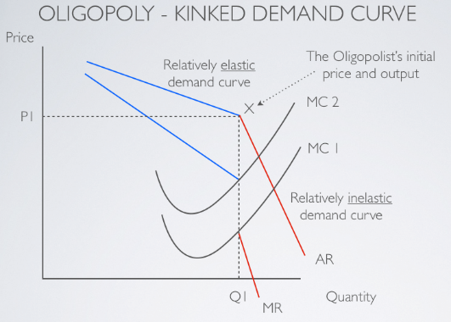
Year 13 have almost completed their look at the various market structures, ranging from the highly efficient Perfect Competition to the much-derided Monopoly. There have been some very heavy sessions covering some quite complex diagrams, especially the Kinked Demand Curve within oligopoly markets resulting in prices often becoming ‘sticky’ at the kink. If you have ever wondered why the prices of various goods are very similar across different firms, this theory explains the reasons. Students have also been introduced to the concept of Game Theory via the Prisoner’s Dilemma. John Nash, the main character in the film ‘A Beautiful Mind’ played by Russell Crowe, won the Nobel Prize in Economics for his work on Game Theory. Mr Hindle has also introduced the concept of Contestability via one his favourite case studies, Stagecoach, founded by Scottish brother and sister team Brian Souter and Ann Gloag, growing from a single coach in the mid-1980s to one of the largest public transport firms in Europe today, predominantly because of the deregulation of public transport under Mrs Thatcher from 1979 onwards.

Department Update - Social Sciences - Global Perspectives
Year 10 students are currently completing an investigation into Knife Crime with both Mrs Davies and Mrs Collins, looking into the various issues regarding both the causes and consequences. A variety of classroom displays have been produced to illustrate the various findings. The next initiative is to create a Poverty Wall, a visual representation of the issues facing the various groups affected by poverty, both at home and abroad.
In Year 11, students are in the process of completing their Reflective Paper as part of the Team Project, this is an essential part of the assessment process in which students have to reflect upon their own performance and that of their team members. Students are also beginning to prepare for their upcoming mock exams.
Year 12 have begun to develop their wider skills by preparing presentations focusing upon the impact of Poverty on Households from a variety of perspectives, including economic, social and ethical. The development of these skills is essential in Global Perspectives as the course is assessed in a variety of ways, not just public examinations.

Year 13 have spent recent weeks preparing for their public examination, sat just this week. Mrs Davies has invested a significant amount of time preparing students, ensuring they have the appropriate skills to confidently tackle their paper. Mrs Collins is continuing to support students in preparing for their 5,000 investigative reports into a topic of their choosing. Choosing areas of research and generating titles is always a real challenge and students have opted for a wide range of issues, from the varying effects of Covid upon the incomes of men and women to the impact of Globalisation upon food security.

Department Update - Social Sciences - Politics
Elections are the mechanism for picking our representatives to legislatures, and fresh from supporting the exit polls for the recent Manx General Election, Year 12 Politics students have been examining different methods for choosing representatives, including FPTP, AMS, SV and STV with Mr Davies.
Year 13 Politicians have begun to look at the polarity and the distribution of power globally. With a focus on whether the US can be seen as a hegemonic power, or whether China and other nations are challenging the USA or might even overtake the USA.

Department Update - Social Sciences - Enrichment
Social Sciences staff are also very heavily involved in the Year 12 Enrichment program, facilitating both the JA Company Program and Charity Challenge.

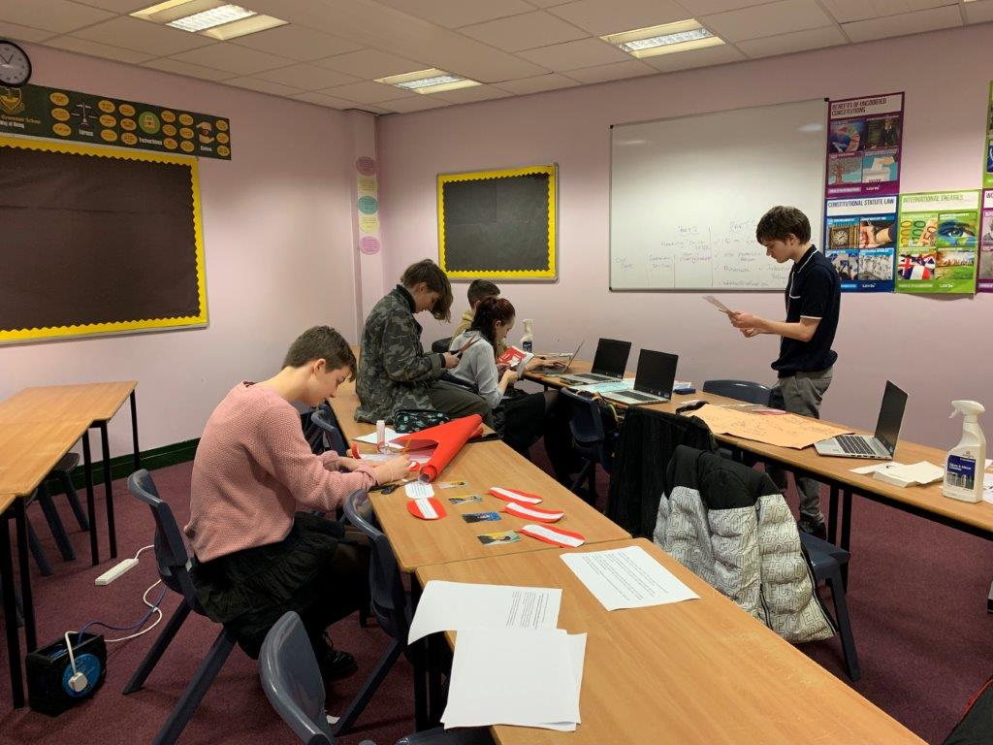
Department Update - Social Sciences - Junior Achievement
In recent weeks, Mr Foley has got the JA scheme off the ground, at the time of writing we currently have 4 JA Companies generating a variety of ideas, supported by external mentors. All participants recently attended a JA ‘Kick Start’ event at the Villa Marina, accompanied by both Mr Foley and Mr Curran, Head of Sixth Form.
Mrs Davies accompanied the Charity Challenge team to Douglas on Friday 15th October to 'Meet the Charities' that they would like to advocate. The level of interest and engagement from the students who attended was very encouraging. It was also great to be able to meet up with representatives of the Manx based charities. Students are busy working on a display board to promote the competition.

Department Update – English
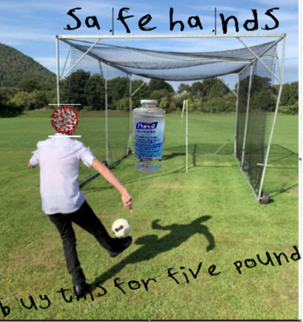
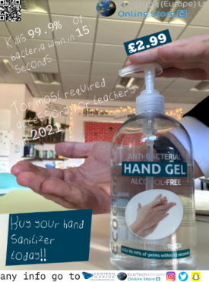
Our new Year 10 Media Studies students have produced their first products advertising hand sanitiser. Students have been acquiring new technical skills, learning to layer images, remove backgrounds and design their own fonts. A brilliant start by them in their GCSE course. Here are a couple of examples from our group.

Year 7 English students have been learning all about myths and legends from around the world. They have learnt how to use persuasive techniques successfully and have been practising their speaking and listening skills. Year 8 English students are studying a class novel. Each class is different – do ask your child what they are reading and talk to them about their reading. Year 10 have opened their GCSE course with a close study of the play ‘Journey’s End’ – an honest look at life in the trenches of WWI. This play will be one of the texts students will write about in their English Literature exams. Our Year 11 students have started the year reviewing their exam skills for GCSE English Language Paper 1 and also starting their prose study from a range of texts. Each class is studying something different so do ask your child what they are reading.

Key Dates:
Monday 24th – Friday 29th – Half Term
Wednesday 3rd November – Y11 College Taster Day
Monday 8th November – DoE Student Information Evening
Wednesday 10th November – GCSE Maths Resit
Thursday 11th November – Y11 Academic Review Day
Thursday 11th November – Y7 Restart a Heart Event
Tuesday 16th November – Year 9 Health Fair

