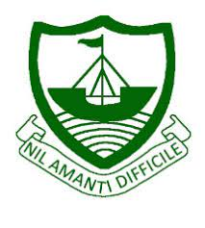
RGS Newsletter
Friday 17th September 2021 – Issue 1

Headteacher’s Award Winners - This week once again we held our Headteacher’s Friday Tea Party. The Headteacher’s award winners were invited along to share their experiences and the reasons for their nomination for this prestigious award. They were chosen by the staff at RGS over all other students in their year group to be recognised as students of excellence. They were nominated for many reasons but these included achieving an amazing number of house points already, a positive start to the year, excellent classwork, effort, going above and beyond during a medical emergency, maturity, support for others, kindness trustworthiness and growth mindset. A truly inspirational group of young people who really do embody our way of being here at Ramsey Grammar School. We are so proud to have these students as a part of our school community. Well done to them all.

- Year 8 Shayni Gardham
- Year 8 - Ollie Eyres 8C
- Year 9 - Annabel Ratcliffe
- Year 10 - Ryan Jones
- Year 11 - Peter Corteen
- Year 13 - Honey Fulton

International Day of Democracy Assembly - Democracy has come under pressure in the last decade around the world but remains strong here. Students right across the school have been reminded of the key role the Isle of Man has played in the story of modern democracy; being the first nation to give women the vote in 1881- and 16-year-olds the vote in 2006. Next week the students will vote in Year Council elections, with Ramsey Town Commissioners kindly loaning their ballot boxes and booths for students to have a genuine and immersive experience of the voting process. Sixth Form Politics students will also be out at polling stations in Sulby, Andreas and Ramsey on the 23rd on behalf of Manx Radio, taking exit polls at the General Election.

Catch Up School Photographs- Andrew Barton came into school last week to take our school student photographs. Once they have been processed they will be made available for parents to purchase. Should any students require a resit due to absence then Andrew will be in school to host a resit session on Monday 20th September in the West Hall from 08:40.

Pastoral and Wellbeing - Transition Parent Voice - Thank you to all parents of Year 7, 10 and 12 students who responded to the transition survey. Your feedback is valuable and I will share the reflections and subsequent actions soon with you. This is already feeding into our pastoral and curriculum discussions now.
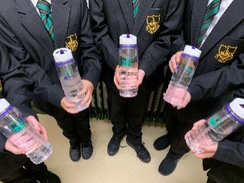

Year 7 RGS Water Bottles - All students in Year 7 have now received their reusable water bottles, courtesy of Conister Bank who have very kindly donated water bottles for the second year. Since Ramsey Grammar School collaborated with Conister Bank, over 80,000 refills have occurred which stops single-use plastic water bottles being sold.

RGS School Uniform - As part of our school expectations, students have had the uniform dress code reinforced this week. Please check the website and student planners for uniform information if you are unsure of what is expected. The majority of students have excellent uniform and look really smart, lots of achievement points have been awarded for smart-looking students. Very short tight-fitting lycra skirts have never been permitted at Ramsey Grammar School and students wearing these have been told by form tutors that they will need to purchase a suitable school skirt. Nose piercings must be clear and nose rings are not allowed to be worn. If you have any concerns, please contact the school and speak with your child's form tutor.

Sustainable September – This month is sustainable September. The students are challenged to take part in sustainable activities throughout the month of September. Every little thing we do to help the environment makes a difference. Is there a small change you can make to your everyday habits such as using your own bags for shopping rather than plastic ones, taking a shower instead of a bath or starting to use a refillable water bottle rather than a disposable one?

RGS Behaviour for Learning – We have launched our new behaviour policy at the start of this term. It has been designed to support our RGS Way of Being, encourages students to remain focussed during lessons and value those making positive contributions to our community. Parents and carers will be updated with any new house points through the Sims Parent App (this will be available for parents of year 7 students in the next 2 weeks). Should you child receive any behaviour points then an email will be sent notifying you of this at the end of the school day. Further details of the policy can be found on the school website under the “Key Information” tab.

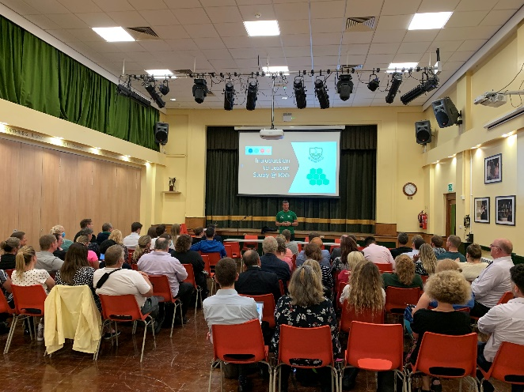
Teaching and Learning Update – Our staff returned enthusiastically on September 6th and 7th to engage in a range of different professional development activities. At the forefront of the development session was a review and re-stating of our Teaching and Learning approach. Based on the expert guidance previously provided by Mark Burns and supported by in his book, co-authored by Andy Griffith, "Outstanding Teaching: Teaching Backwards", colleagues engaged in establishing areas of expertise and areas where we would like to develop further during this academic year. As you may expect, it is quality teaching and learning that fires teachers up and there was certainly an energetic buzz throughout the sessions! We are all looking forward to continuing our own professional development and seeing the impact for students in all of our classrooms throughout the year. Our initial sessions will be supported by staff development meetings and collaborative action research at scheduled points to focus on the key areas of high expectations, starting points, clarity, evidence of learning, appropriate challenge and effective feedback.

Y12 Settling Update -The last week and a half has been busy, full of induction programmes, timetable adjustments and collaboration subject launches, but it was wonderful to see our new Year 12 take all of this in their stride. The school was awash with Sixth Form volunteers, and whether showing new students around, helping organise school photographs or coaching our year sevens on Northern Six day, they demonstrated our Way of Being to a fault.
Junior Achievements Update - Junior Achievement were in to launch their Company Programme Competition and it looks like we’ll be fielding three teams this year. Hopefully, between them, they will be able to build on the amazing success of last year’s RGS prize winners. All of our enrichment activities have been launched this week, with students choosing between conversational Italian or Mandarin courses, Core Maths, Sports Leaders or the ever-popular One World Charity Challenge, of which we are the current champions! What a wonderful bunch! Let’s see what the year brings!
Y7 Settling Update – Year 7 have had such a fantastic start to the year, with so many positive comments from Teachers, Support Staff and older students. The resilience they have shown has been outstanding and they should be very proud of themselves. On Tuesday we will be having a day where we will be learning all about Managing Change and we look forward to having the same excitement and participation as we had this week at the Northern 6 Day. We are so looking forward to seeing what fantastic things you are capable of here at Ramsey Grammar. Next week we will be encouraging them to join one of the many clubs that we have on offer and would appreciate your support in encouraging them to try something new.

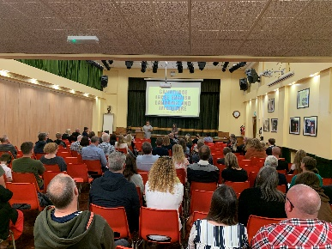
Year 10 Maths and English GCSE Information Evening – The Year 10 Information Evening was a great success this week. The turnout was excellent and the families have been very positive about the information provided. There was also a good amount of students in attendance and that will help boost their understanding of both the Maths and English courses. Our Assistant Head, Mr Wood also shared with families how we will be using the GL CAT4 assessments to support the progression of our Year 10 students this year. Thank you to all that came along.
Library Update – Our library has been closed over the last week as our librarian undertake the much needed full stocktake of the resources have on the shelves. She has also been getting the books ready for the launch of our new reading programme in Year 7 and 8, Accelerated Reader. More on that next week. The students have been eager to get back in and use the space once more, understandably. We are aiming to have the library up and running once again at the end of this week at the latest. Thank you for your patience with this.

Year 7 Northern 6 Day - Thanks to Ramsey Hockey Club, Ramsey Tennis Club, Northern Boxing Club, Sulby Badminton Club, Ramsey Rugby Club and Mr Guy (For Golf) for giving the year 7 students a fantastic day of sport. Hopefully, we’ve inspired them to join one of the local clubs in our Northern Community

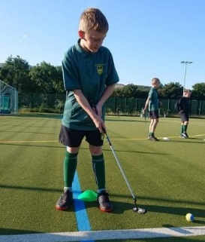
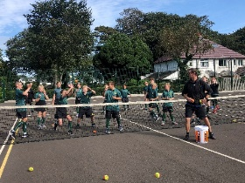
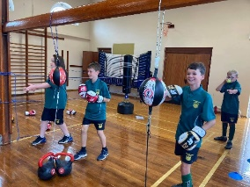

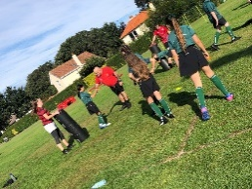
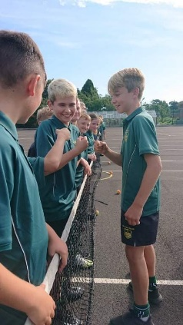
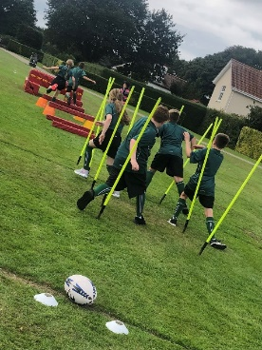

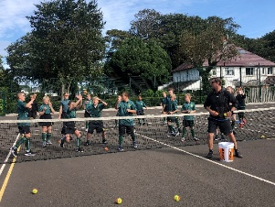

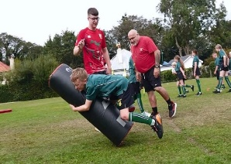

Department Update - English – Guest Speaker - Students in Media Studies welcomed a guest speaker this week - Stacey Smith, from the Isle of Man Advertising and PR. Stacey spoke to the class about how a marketing and advertising campaign begins. The class received their first advertising brief and began their mind-mapping session. Stacey tied their work to real-world of advertising and gave the students lots of hints and tips on how to create a great print advertisement.

Department Update - English – Poetry Slam - Students in Year 8 this week have spent their time practising their Poetry Slams ready for the RGS school finals on Friday. Good luck all in year 8! Our RGS winners will go on to compete against the island schools to win the much-coveted island championships.

Department Update – Art – Sovereign Art Foundation Finalist - We are very pleased to announce two Ramsey Grammar School Art’ students have been selected as finalists in the Sovereign Art Foundation Competition. The Sovereign Art Foundation (SAF) is a charitable organisation founded in 2003 to recognise, support and promote contemporary art talent; and to bring the therapeutic benefits of art to disadvantaged children. They run and fund programmes that use expressive arts to support children from low-income backgrounds and with special educational needs. This is a prestigious Art Competition run across the Island Secondary schools and the IOM College. Both finalists are successful A Level Art Students 2021, with Lily Byrnes achieving an A* and Zara attaining an A.

Lily Byrne Y13 SAF Finalist 2021 - Lily’s work is technically very well put together and has many different facets that lie beneath the surface. Her statement says a lot about the thought that has gone into her work.
‘’This piece encases the complementary crisp blues of the sky with the warmth of eccentric sunflowers. Deriving inspiration from the works of Vincent Van Gogh, Olan Ventura and compositionally reflecting on the botanical still life works of the Dutch Golden Age of painting from the mid to late 17th century. I have fused together two separate primary sources, one of flora and the other encapsulating the cool, precipitation filled Manx skies. The emotive, fluid background shows nature’s-controlled chaos - travelling from storm to sun as your eyes drift further up the piece. Though the acrylic background draws aspects specifically from Van Gogh’s ‘Wheat Field with Cypresses’, his typically energetic brushstroke style has been replaced by a smooth, animated depth of colour to contrast the texture and dimensions of the floral centrepiece. I show how driving above the earth's turmoil, nature and life can thrive. Olan Ventura, a Filipino artist who produced luxurious still life paintings, is known for his frantic modern glitched twists which rejuvenates and remodels what could be considered very traditional still life paintings. Here I have used the glitch to fiercely pierce nature's bounty and disturb the seemingly balanced matter.

The inhibition of life. For me, this painting represents the harmonious balance that can be formed between the organised and chaotic world in which we live. How contradictory to common belief, disorder and disarray can produce the most unexpected and bountiful beauties in the world. How pushing against the worst hardships that life throws at us, produces the most gloriously fulfilling outcomes. Though this outlook on life may seem slightly naive to some, I think that efforts will always be recognised and rewarded and there will always be somewhere over the rainbow.’’

I am particularly impressed by her mode of thought, the analysis of the wider world and how beauty can be found in the most hostile of places, physical or otherwise. The juxtaposition of her foreground and background, the contrast between chaos and control, all have their places in bringing the world together.

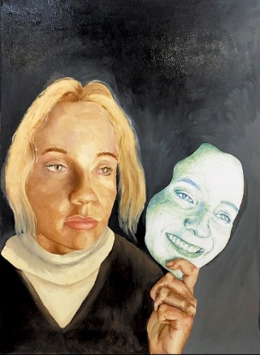
Zara Woodward Y13 2021 SAF Finalist - Zara took a traditional and academic route throughout her A Level Art, looking at the work of Rembrandt, his painting techniques, his subject matter and his play on light, favouring an element of realism. She was inspired by his paintings of Portraits, inspired by the Dutch Golden Age, often likened to the general European period of Baroque painting. His work was often associated with grandeur, richness, drama, movement and tension. Zara’s painting is all about drama, exploring the context of personality, the pretence of society, hiding behind a mask, the projection of persona. It asks questions of the viewer and addresses values, integrity and truth.

This link will take you to view all the finalists on the Isle of Man.

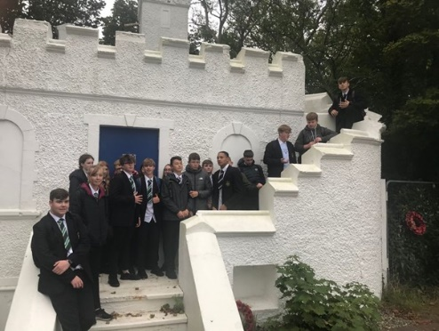
Department Update – History - On Monday our year 11 Historians visit Douglas as part of their course to see first-hand how the tourism boom of the late 1800s, early 1900s impacted the Isle of Man. They spent time on a walking tour of Douglas with Mr Wilkinson, visiting sites of interest such as the location of Cunningham’s Camp, the entrance to the Falcon Cliff Hotel, the site of the former Palace Ballroom and the Villa Gaiety, as well as taking the opportunity to visit the Manx Museum tourism exhibit and the library and archives. The day was a great success, even though we all got a little soggy. This photograph shows the only remaining part of Cunningham’s Camp.

