RGS Newsletter

Friday 14thth January 2022 – Issue 15

**Headteacher’s Award Winners**

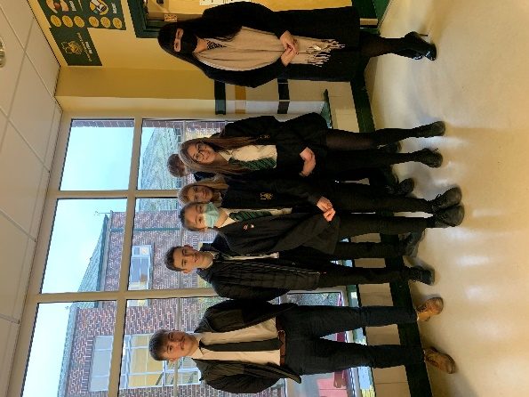This week once again we held our Headteacher’s Friday Tea Party. The Headteacher’s award winners were invited along to share their experiences and the reasons for their nomination for this prestigious award. They were chosen by the staff at RGS over all other students in their year group to be recognised as students of excellence. They were nominated for many reasons including being helpful to others, use of ICT skills, being polite and well mannered, showing kindness to peers, support of peers struggling in MFL, going above and beyond in their work in History, creativity in textiles, being quietly and consistently excellent in lessons outstanding performance in mock exams and achievement in History. A truly inspirational group of young people who really do embody our way of being here at Ramsey Grammar School. We are so proud to have these students as a part of our school community. Well done to them all.

* Year 7 – Caleb Corfield
* Year 8 – Emma Glover
* Year 9 – Arlarna Nicholls
* Year 10 – James Huyton
* Year 11 – Alexander Shimmin
* Year 12 – Ivo Morrey

**Headteacher’s Message**

As you are all aware, the island schools have all been faced with an extremely challenging couple of weeks with the spike in Covid-19 cases on the Isle of Man. Ramsey Grammar School is no exception to this. We have had an extremely high number of staff absences which has impacted our ability to run the school in the manner we normally would. We held off for as long as was humanly possible but sadly we had to make the call to send some year groups home on certain days this past week in order to continue to have the school open. We only had three days where we asked some students to remain home, and I am happy to say that today we were able to have all year groups back in school and in lessons once again. We hope that this will continue and that we are over the worst but will keep you informed if this changes.

I would like to thank the staff for their swift and professional adaptability over this time having to prepare additional work, support classes where colleagues were off school unwell and generally chip in with additional support in school. Our staff really did rally together and show what a wonderfully supportive staff body we have when times are hard. I am very grateful to them all. I would also like to thank our families who had children remain off school during this last week. I have had many supportive and kind messages from parents and carers which has really helped staff morale, knowing that we have your support.

Aside from this, we have had Year 13 sitting their mock examinations this week. They have conducted themselves with maturity and focus throughout, much as our Year 11 students who took mocks before the Christmas break did. We are so proud of them and wish them all the very best with the second week of examinations and their results this term. They will have feedback and target setting support once the results are in and this will enable them to perform their very best in the summer examinations.

Finally, this week we have hosted 5 of our 6 scheduled celebration assemblies. These assemblies showcased the amazing achievements of young people across the half term so far. We were unable to host these in person due to the government instruction not to run assemblies. Therefore, we screened them live into tutor rooms and provided the live link to parents so that they could join. Our winners were given their certificates to take home with them during the assembly slots. We have Year 8 left next week and will provide a feature in the newsletter once all these events have been concluded. Not our ideal mode of delivery for sure but we are so happy that we were able to host them, nonetheless. A huge thank you to our Heads of Year for all the work they put into the assemblies and then the reformatting of these events to move online at relatively short notice!

Wishing you all a wonderful weekend

Kind regards

Sarah Findlater

Headteacher

Ramsey Grammar School

**Ramsey Grammar School Association (RGSA)**

We are pleased to have RGSA as a registered charity to help support and fundraise for our school. RGSA acts as a ‘Friends of’ or PTA would in other schools, and is open to any parent or carer of a child on roll to join if they would like to contribute a little time to help, or feel they have a skill set we could benefit from for ideas and fundraising. RGSA meet approximately once every half term, as we understand everyone who volunteers their time has other commitments. In the past they’ve helped raise funds for the Bikers Café in SS&S; Lexia, a bespoke and individualised literacy support programme for students; and Audiovisual, lighting and sound equipment in the school. We are hugely appreciative of their ongoing work and support as the funds raised have such a positive impact on the day-to-day life and learning of students and staff in Ramsey Grammar, over-and-above the standard provision.

The next meeting is **Tuesday 18th January at 1830 in the West Hall** – all are welcome!

They can also be found on Facebook [@RGSAIOM](https://www.facebook.com/RGSAIOM/)

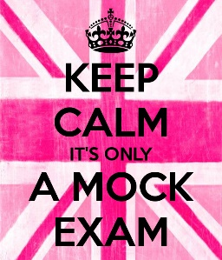**Year 13 Mock Exams**

With the January mock exams well underway now I'd like to take this opportunity to say a big "well done" to our students, for all of the additional revision undertaken over the festive period, congratulate them on a brilliant first week of mock exams and wish them good luck in their scheduled assessments next week! Tutors and the Sixth Form team are on hand if any of our students wish to talk about exam pressures and need more support or coping strategies, so please do speak up if you need us. We will be discussing the results with students towards the end of the month, and with the finish line in sight, students will be making the final preparations for their real exams. All in all, this term is a busy but rewarding one, and I look forward to seeing our students flourish as the year progresses!

*Mr Curran – Head of Sixth Form*

**RGS ‘Ways of Being’ in action**

Tutor Group 8S decided to take one of RGS’s ways of being, ‘Community’ and raised £564.00 for 2 local charities via a sponsored walk, cake sale and Christmas raffle. The chosen charities were [**Housing Matters**](http://housingmatters.im/) and **Greyhound Aid League** and both were extremely appreciative of the effort that the students had gone to. The Christmas raffle was won by one of our Sixth Form students, Arabella Ayan, and the cake prize was awarded to her by Head Teacher, Mrs Findlater.

**Extra-Curricular Clubs**

At RGS we are proud of the amount and variety of Extra-curricular activities and clubs that go on during the school week. Clubs give our students options to try out new activities and can give them a focus and place to be before school, during lunchtimes and after school, when necessary, especially in inclement weather. The list has been updated this week and can be found on the RGS website [here](https://rgs.sch.im/pages/index/view/id/265/Extra-Curricular%20Clubs).

**School Farm News**

Some very exciting news in from the RGS school farm. Our newest pig Martha has been settling in very well here at Ramsey Grammar School Farm. The Farm club students have been supporting her through the last stages of her pregnancy as she arrived with us. Martha is now a proud mother; having safely delivered 7 little piglets this week. Martha is a Tamworth, one of the oldest breeds on record, and her piglets are crossbreed Tamworth x Landrace. They will remain at the RGS Farm until June 2022.

We have also hatched several silkie chicks – although the rates of hatching were low, the three chicks who have hatched successfully and survived those difficult first days, are now thriving under the heating plate.

**CRUSE Non-Uniform Day**

[CRUSE](https://www.cruse.org.uk/) Bereavement Support put out a call to action to secondary schools across the Island to hold a non uniform day in December to help raise funds for them. RGS were proud to take up the challenge and support such an important organisation. We are proud to say our non uniform day raised £600.00, and it was an honour to present them with a cheque for the amount.

**Duke of Edinburgh Award Scheme**

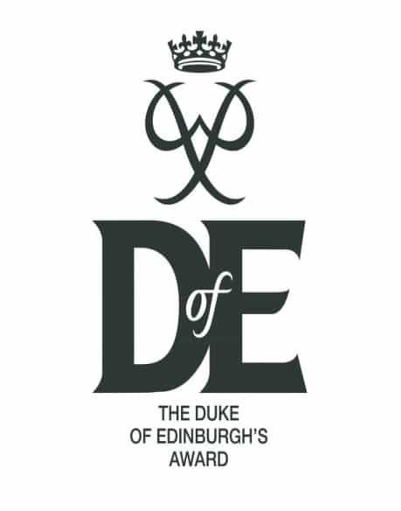

It is currently a bit of a quiet time for us on the [Duke of Edinburgh Award Scheme](https://www.dofe.org/), just some planning of dates and checking over kit to get prepared for what is looking to be another busy expedition season (all being well).   
We held the Year 9 Information Evening back in November 2021 and currently have 40 new Bronze Award participants with many more still thinking about signing up for the awards scheme. Well done to those who have enrolled and already started working on the Volunteering, Physical and Skills section of the award, we hope you continue in this positive manner during the rest of the award.

We will put dates and information out shortly for the commencement of the Year 9 Bronze Training sessions.

We still have many students working through sections of their awards and having them signed off ready for final completion once they have completed their expeditions.

Those who have recently completed their awards. Well done to you all.

|  |  |
| --- | --- |
| **Bronze Award** | **Silver Award** |
| Orla Goddard | Aaron Rielly |
| Emily Craig | Abigail Radcliffe |
| Nathan Bradley | Keira Brown |
| Josh Kewley | Hannah Stafford |
| Henry Huxham |  |
| Keeley Hannay |  |

There is a Bronze and Silver Certificate Presentation evening planned for Wednesday 16th March 2022. This is usually held at the Gaiety Theatre, all those who have completed their awards get an invitation to attend and receive their certificates on the stage. More information on this will follow when we have been notified of the times and when the invites will be sent to students from Mrs Barnes, who is the IOM DoE co-ordinator.

We will be planning all our expedition dates over the next few weeks and those involved will be informed, these are always tricky to organise, due to weather, students being involved in other sports/activities, but we will do everything we can to ensure that everyone has the opportunity to complete the expedition section of their awards.  If you have any concerns or need any further information, please contact us via the school enquires email address ( RGSEnquiries@sch.im), and we will be happy to contact you.

*RGS Duke of Edinburgh Team*

**Department Update – Design and Information Technology**

We’ve been busy as usual in D&IT. Textile Technology have been finishing their amazing cushions and there have been some fabulous designs!

In ICT students have been learning how to use Scratch. Scratch is a programme where students can use interactive media and animation. This encourages creative thinking and systematic reasoning. The outcome will be a maze, created by each student, with an animated figure working through each puzzle.

In Food Technology, students have been researching Street Food. Year 10 made a very popular Latin American dish this week -Churros! Some high-level skills were needed, choux pastry, deep fried, coated in cinnamon sugar with a chocolate sauce dip. The results were delicious!

**Department Update – Science**

](https://www.bbc.co.uk/iplayer/episode/m0012tzd/royal-institution-christmas-lectures-2021-1-the-invisible-enemy)Our Year 7, 8 and 9 (KS3) science students been studying all about Light, Combustion and Reproduction this week.

One of the most impressive scientific advances of the past two years has been the development of new testing techniques in our battle against Covid-19. Over the last week some Sixth Form students have been peeling back the mysteries of polymerase chain reaction (PCR) and have been looking at modern diagnostic technology that could shape the future of medicine and help fight future Pandemics. Some of our Year 10 and 11 Science Students have been exploring the inner workings of vaccines and how these medical marvels can help win the war on viruses and potentially fight diseases such as cancer. To help understand the involvement of science in this Pandemic, the Royal Institute have produced three online lectures which we highly recommend all students to watch. I’m sure that this pandemic will not just rewrite the history books but also the exam papers!

([Click here](https://www.bbc.co.uk/iplayer/episode/m0012tzd/royal-institution-christmas-lectures-2021-1-the-invisible-enemy) to view online Royal Institute lectures)

*Mr Ward – Head of Science*

**Department Update – Music**

Christmas Performance Success!* **-** At the end of last term, many students participated in our annual Carol Service and Christmas Extravaganza performances – with great success and high praise. The folk group, harp choir, string quartet, choir and Scratch Orchestra performed their solo elements with aplomb at the Carol Service – and the Senior evening service marked a wonderful start to Christmas celebrations for many of our local community (some who have been attending the RGS Senior Carol Service every year for more than 35 years!). I believe the Chief Minister Mr Cannan and MHKs Dr Allinson and Mrs Caine were also impressed with the quality of performances. Congratulations to Lexi Forbes and Ben Corkill for their organisation of the end of term Extravaganza – a slightly different affair to normal due to Covid mitigations, however a superbly organised event with fabulous performances at an incredibly high standard. Well done and thank you to all the performers and students involved in both events – we look forward to hearing more from you in future!

*Instrumental Lessons* **-** With moving into term 2, our Creative Arts rotations have changed for Years 7 and 9. Students should continue to attend their instrumental lessons regardless of the change in timetabled whole-class Music lessons. As well as displaying timetables in the RGS Music Department, the visiting Isle of Man Music Service instrumental teachers run Google Classrooms with their students – where this information is also shared. If there is any doubt as to when your child’s lessons are please don’t hesitate to contact us for clarification. In these times of longer periods of student absence, could you also remind your child to let their instrumental teacher know if they are unable to attend a lesson as the Music Service staff use their own register and pupil-tracking system, and therefore will not necessarily know that a student has been marked absent on the morning school register. There are still a few slots for instrumental lessons available through the Music Service – particularly for upper and lower orchestral string instruments (violin, viola, cello and double bass). If your son or daughter is showing interest in learning an instrument, then this could be a great opportunity for them.

*Music Clubs* **-** Whilst we do usually run Music clubs daily, with current advice not to mix year groups, we are looking at how we can work within these guidelines so as to keep our ensembles running. Students are asked to ‘watch this space’ for announcements in the near future – particularly concerning choir and our junior and senior Pep Bands. We can’t wait to get back making music with them soon.

*Online Learning in Music -*We are continuing to roll out our use of the online Music education software ***Focus on Sound***. By February half term, all Year 7, 8 and 9 students should have used this software to complete listening tasks as homework related to their in-class curriculum. Each student has a separate username which they will be told in class.

To log on:

Either use the **QR Code** here, or go to:

**portal.focusonsound.com**

(do **not** add ‘www.’ Or ‘http://’ beforehand)

Then, choose the third option down **Sign in with Application Cloud**

* Country: **United Kingdom**
* School ID: **rgs**
* Username: each student will be told their username in class (students can check these with Music staff if unsure)
* Password: **Music** (this is case sensitive, so needs a capital ‘M’)

Once they’ve logged on, they can access any set work through the ‘*My Class’* option in the menu bar. Once a set task has been completed, students can then save their final mark and it will come directly to our database.

*Focus on Sound* may also be useful for students who are wishing to extend their musical knowledge beyond the classroom – perhaps widening their knowledge of music theory, world music or finding out about different instruments. There are lessons relating to almost every aspect of music right up to A level.

**Key Dates:**

10th – 19th January 2022 – Year 13 Exams

18th January – RGSA Meeting @ 1830 West Hall

19th Januar – Year 11 Mock Results Day

25th of January – Y11 Reports Published

26th January – Student Voice Questionnaire – Teaching and Learning

27th January – Junior Achievement Event – All About the Money

27th January – Live Screening - Leopoldstadt

28th January – Parent Voice Questionnaire