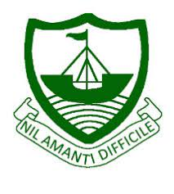
RGS Newsletter
Friday 4th February 2022 – Issue 18

Headteacher’s Award Winners

This week once again we held our Headteacher’s Friday Breakfast. The Headteacher’s award winners were invited along to share their experiences and the reasons for their nomination for this prestigious award. They were chosen by the staff at RGS over all other students in their year group to be recognised for working hard in lessons, being kind, academic achievements, positivity, exceptional project work, mentoring others, leadership skills, management of time and support of peers. A wonderful group of young people. They are a credit to the school. Well done to you all.
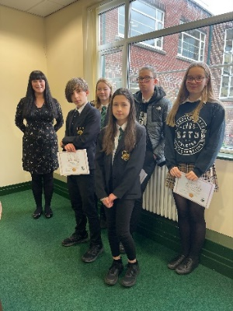

- Year 7 – Faye Huyton
- Year 8 – Isla Caine
- Year 9 – Oliver Miklos
- Year 10 – Brian Moore
- Year 11 – Victoria Johnson
- Year 12 – Reggie Cowan
- Year 13 – Millie Smith

Headteacher’s Message

This week we have been starting to talk to our Year 9 and Year 11 students about their plans for the next academic year. This is the start of these students planning for the next exciting stage of their academic careers. Starting the process with them now gives plenty of time for discussions with family, peers and staff and the ability to seek appropriate support and advice where necessary. The options process will not start in proper for some time but the discussions around their passion and subject they may want to choose start now. Staff are currently updating their course information to reflect their current course offering these will be published to students and families in due course.

On the matter of transitionary events and exciting next steps, we are hosting some events over the next few weeks to allow our northern school’s Year 6 students and their families to come into the school and have a guided tour. We know how important it is for the Year 6 students to feel a connection with the school that they will be starting at in September and are so looking forward to welcoming them in to get a taste of what the Grammar is like and ask the questions that they have about secondary school. Under normal circumstances, we would have hosted a Year 6 transition event already in school with all Year 6 students coming into the school on the same day. Due to the Covid-19 restrictions in place, we have been unable to do so. Our Transition team has been going into the primary schools to meet the students and teach sample secondary lessons already and they have loved meeting the children. We have the transition events later in the year planned in the school calendar as normal and very much hope these go ahead. Our Year 7 Transition Team will be writing out again to the Year 6 families with details of how to sign up for the tours and other exciting transition information.

Wishing you all a wonderful weekend.

Kind regards
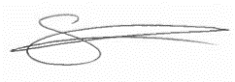
Sarah Findlater
Headteacher - Ramsey Grammar School
Parent App
Parent App is used to communicate live achievement points, behaviour points, links to the website and notes about upcoming events. This is one of the most important methods of communication. If you do not have Parent App set up, please use this link here to access instructions to set this up on your device. The new behaviour system is here for you as a reminder of what a Level 1, Level 2 and Level 3 sanctions mean.
Mrs Corrin – Associate Assistant Head

Achievement Points this week
2660 achievement points were awarded across the school this week! Well done to everyone working so hard both in and out of lessons!

Quote of the week:
“Constant kindness can accomplish much.
As the sun makes ice melt, kindness causes misunderstanding, mistrust, and hostility to evaporate.”
– Albert Schweitzer

The Big Splash Dolphins
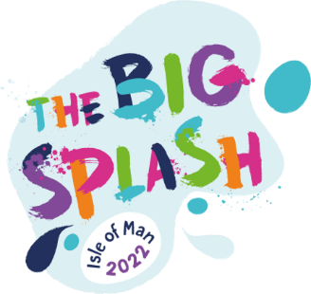
Following on from the Wallabies Gone Wild Art Trail in 2019, we are delighted to have the opportunity to play a part in the Hospice IOM Wild in Art sculpture trail, which this year is called ‘The Big Splash’ and will involve painting two Dolphin sculptures that arrived in at RGS this week!

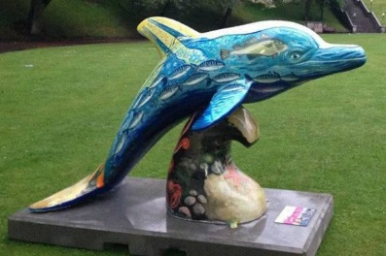
The finished Dolphins will be on display from May to September 2022 across the island. We will chose one winning design from Year 7, 8 and 9 students, and one winning design from Year 10, 11, 12 & 13 – and the winning design will get to paint their dolphin sculpture to be part of the trail. You have full creative license when designing and creating your dolphin, although it’s important that you avoid brands or trademarked imagery. Ideas can be wide ranging, purely decorative, topical and/ or have a local connection. Themes or topics can include – Wildlife, The Sea, The Harbour, Buildings – Towns, Environmental Issues – Climate Change, Pollution, Carbon Footprint, Landscape, Seascape, Decorative – patterns, colour, shape and form.

Please see Mr Quinn for a Design A Dolphin template along with a Sculpture Description form to support your design submission to take part!

ALL SUBMISSIONS MUST BE IN TO MR QUINN BY THE END OF THE SCHOOL DAY FRIDAY 18TH FEB 2022.
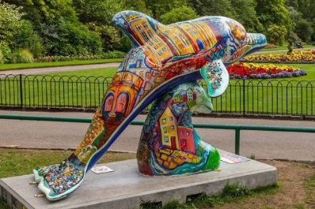
- Selected works will be put on display and a panel
of judges will select two winners.
- Exhibition and announcements of winners will
take place MONDAY 7th MARCH 2022.
- Painting begins – TUESDAY 8th MARCH 2022 (to be
completed in the Art Department at RGS by
01st MAY 2022)
- Winners may have assistance and support to
complete their dolphins as necessary
- Finished Dolphins will be exhibited as part of The
Big Splash Art Event held on the island over 12
weeks from May – October 2022.

Isle Listen – In Schools - Up-coming Support Sessions
Parent/Carer Drop-In Sessions
Throughout the year we’re holding drop-in sessions for parents/carers, which are an opportunity for them to talk to someone from our Schools and Therapeutic teams should they have any concerns about their young ones. Parents/carers do not need to register to attend these sessions.
Secondary School Drop-Ins:
- Thursday 10th February, 6.15pm – 7.15pm at Ramsey Grammar School (WEST building)

Pop in and meet Isle Listen, ask a question about the service or have a chat about a concern you have. Thank you - Steve Downard (Schools Team Lead)

International Linguistics Olympiad 2022 - UPCOMING COMPETITION For Ramsey Grammar School Sixth Form students
The Isle of Man has been chosen as the host of the 19th International Linguistics Olympiad on July 25 - 29, 2022. The IOL is one of 13 International Science Olympiads for secondary school students and has been held annually since 2003. Each year, teams of young linguists from around the world gather and test their minds against the world’s toughest puzzles in language and linguistics. No prior knowledge of linguistics or languages is required: even the hardest problems require only your logical ability, patient work, and willingness to think around corners. This competition is particularly suitable for those studying computer science, maths and languages.
For further information – please see Mrs Rousseau
Website: https://ioling.org/
Throwback Y Feeagh & Ramsey Grammar School Historic Items
A new feature, intended to be light-hearted and act as a throwback to days gone by in Y Feeagh, the Ramsey Grammar School magazine, or items found within our school archives.
Ramsey Grammar School PTA Manx Evening & Supper Invitation January 19th 1973.
(note the 15p per ticket entrance price!) Were you there or involved in organizing it? We would love to hear about it if you were and can remember the event!

Ramsey Grammar Old Scholars

Some of you may have seen a call to Old Scholars was put out last week across our social media platforms. Responses started coming in nearly immediately. We are hoping to build a repertoire not only of the notable alumni achieving OBE, MHK, or sports accolades on a global level, but of those who have set up and sustained businesses on and off island, achieved against the odds, given back, or taken other paths. We hope to be able to document these successes both in the newsletter and in other ways to impress upon our current students both the sense of history within RGS and the many many guises that ‘success’ takes once they leave us. We would love to hear from you, your parents, family and friends who attended RGS – all responses can be emailed to RGSEnquiries@sch.im
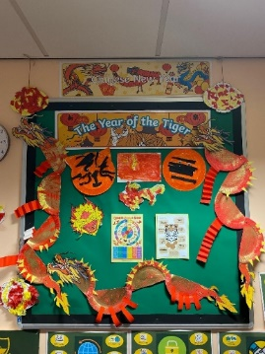
Chinese New Year with the LSU students
On Tuesday 01st February we entered the Chinese New Year of the Tiger.
The LSU students have put together a fantastic and colourful display as part of their learning to mark the celebrations this week.

Amazing Learning Feature - PE
Our focus this week for Amazing Learning turns to PE, and some great successes in reaching semi-finals and finals in Rugby and Hockey in different age groups. Cross country runners were superb last term! RGS also had a very successful Northern 6 Day and our Sports Leaders have been working with primary LSU students. Thank you to all team members, supporters, and coaches for everything you do to represent and champion RGS Sports!

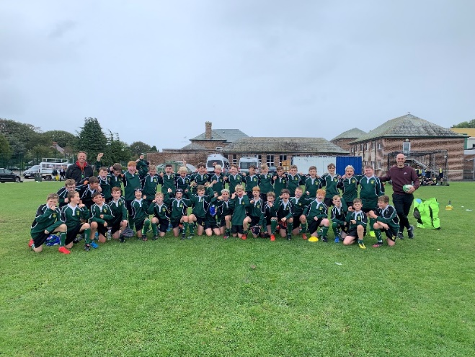
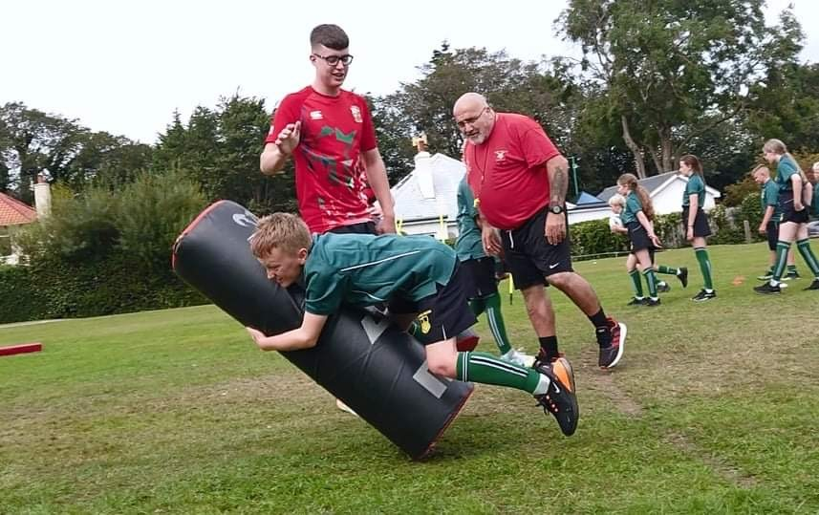

Department Update – Maths
A busy half term with Year 13 Mock exams and our Year 12 students sitting their first assessment. Some of our students achieved some excellent results and some of our students now realise that the revision for the Summer Exams starts here. There are specific revision lessons after school for Year 13’s on a Monday for Mechanics and Year 12 on a Tuesday also for Mechanics. Other sessions will be on offer as the term progresses.
Well done to Miss Nicholson’s Year 11 group who sat their GCSE Maths Exam in November and achieved some excellent grades. The majority of students who attained B/C grades have decided to continue on and try and achieve a higher grade on the higher paper. Also, Mrs Dyer’s Year 11 group have completed their Entry Level qualification and have them sent of to the exam board to be assessed. Well done to all. There is a specific Year 11 C-grade revision session on Tuesday at 12:45 in room 106. There will be another Mock Exam in March for our Year 11 students to get them exam ready for their actual exams in June.
Our Year 10’s are currently getting ready for their Mock exam next half-term. Revision lists will be made available for all students to use to get them prepared for this.
Top Sets in Year 9, 10 and 11 are sitting the UKMT Intermediate Maths Challenge in the coming weeks. This is a chance to challenge themselves against the best Mathematicians in the UK. In the past we have had some students attaining some excellent results and being offered places in the UK on the Math’s camps that are held every summer for the top 1% of students.
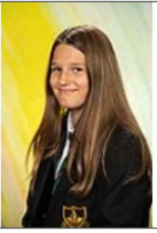
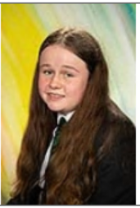
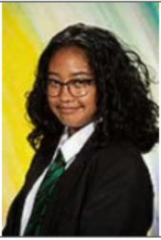
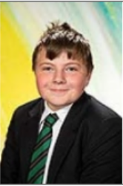
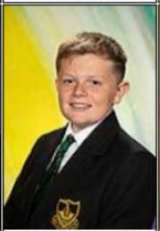
Mathematicians of the Month
Year 7: - Tyler Fleming and Aurelia Hitchen
Year 8: - Eleonor Correia and Lucy Crowe
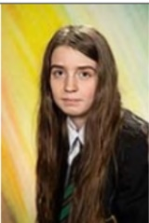
Year 9: - Harry Kinrade and Alyssa Mallorca
Year 10: - Kalease Dale and Leo Henderson
Year 11: - Jake Faragher and Tia Kelly
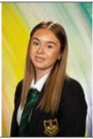
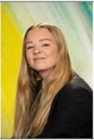
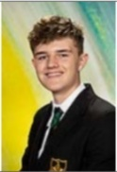
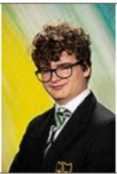
Year 12: - Alfonso Bacani
Year 13: - Josh Walker
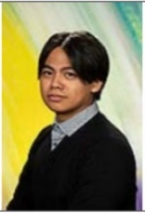
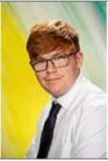

Department Update – Social Sciences
One World Charity Challenge 'Send a Cow'
Lexi Forbes, Neo Dixon, Chloe Hulbert, Connor Surridge and Oliver Moore in Year 12 have been extremely busy promoting the work of their chosen Charity 'Send a Cow'. The One World Charity Challenge is an inter-school project coordinated by the One World Centre and supported by AFD Software.

The group organised a coffee morning to promote the work of 'Send a Cow'. They prepared a display board explaining the work of the charity and they also handed out leaflets to everyone that bought a cake. The group raised £116. They are going to send the money to the charity. Well done team!
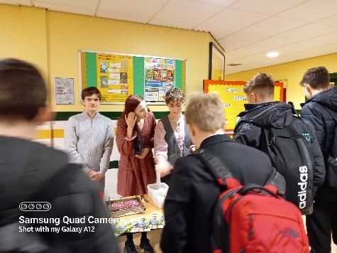
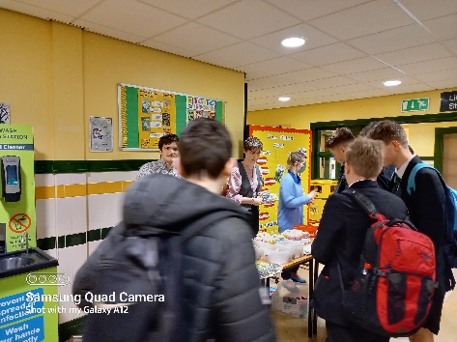

Department Update – Drama
‘Drama in schools should not be focused primarily on creating actors for creative industries. Drama embedded in a school curriculum is about active entitlement and access for all, that meets a wide range of personal, social, emotional, cultural and creative learning outcomes and agendas.’
-Patrice Baldwin, Chair: National Drama.
This half term Year 9 Dramatists have continued their study of drama practitioners. Having studied the major practitioners Stanislavski and Brecht, the students have moved on to look at lesser-known practitioners. These have included Steven Berkoff, Caryl Churchill and Augusto Boal, as well as the theatre company Frantic Assembly. The scheme of work helps students to achieve the learning objective of ‘interpreting material from assorted sources, including classical and contemporary texts, creating pieces of drama which can both educate and entertain.’ The scheme also covers all of the six Rs – most notably Resourcefulness and the ability to generate new ideas, be imaginative and explore possibilities. Studying Drama practitioners and their theories will be enormously beneficial for those students who go on to study Drama at GCSE and A-level, as practitioners are people who have had a massive influence on how plays are written, performed or staged. These people have changed the world of theatre and will certainly influence the work that the students devise and perform.
Our GCSE and AS/A2 students are currently busy rehearsing for their assessed performances. These performances are normally assessed by a visiting examiner from the exam board, however, due to the covid-19 travel restrictions for the past two years performances have been videoed, rather than performances being seen live. Let’s hope this situation changes next year, as having a visiting examiner present during the performances makes it much more of an occasion for the students involved. Good luck to all of our GCSE, AS and A2 students with their assessed pieces!
Key Dates:

8th February - Year 9 IoM Wellbeing Day
10th February – Parent Voice Questionnaire (Teaching & Learning)
10th February - Isle Listen Parent Drop In Session 1815 – 1915, West Hall
18th February – RGS Big Splash Entry Deadline

