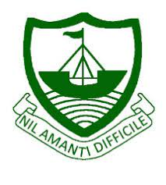
RGS Newsletter
Friday 28th January 2022 – Issue 17

Headteacher’s Award Winners

This week once again we held our Headteacher’s Friday Breakfast. The Headteacher’s award winners were invited along to share their experiences and the reasons for their nomination for this prestigious award. They were chosen by the staff at RGS over all other students in their year group to be recognised for being conscientious, participation in extra-curricular activities, doing excellent work, generosity, helping others, effort in lessons, supporting their peers and random acts of kindness.
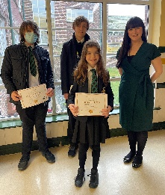

- Year 7 – Amelia Collister
- Year 8 – Isla Caine
- Year 9 – Jayden Thompson
- Year 10 – Charlie Gregory
- Year 12 – Reggie Cowan
- Year 13 – Robert Buxton

Headteacher’s Message

We were very pleased to have a much better week in terms of staff and student absence and illness. Long may this continue! The changes in restrictions have all been carefully implemented and government guidance followed. This has gone very smoothly and I would like to thank the staff and students for their cooperation during this transition period.

Year 11 and Year 13 have now all finished their mock examinations. I would like to congratulate them all on a successful mock period after what has been a very challenging two years of study. These examinations will see them in good stead for the summer examinations which we are still very optimistic will go ahead as planned for all students. Any information from examination boards on this matter will be shared with families promptly when we receive it.

You may have seen on social media this week that we are starting quite an exciting project here at RGS. We have been sorting out some of the wonderful historical documents and items we have on-site and looking at how we best display and celebrate them. As we started to discover the beautiful pieces of history that we have in school we felt it is only right to start to reach out to our alumni, always knows as ‘Ramsey Old Scholars’ and see where they are and what they are up to now. We would like to start to share the successes of our Ramsey Old Scholars with our current students as a source of inspiration and we would also love to share some of your own stories on our website for the community to celebrate. Here is the message that has gone out in case you have not seen it yet…

“Calling RGS Old Scholars - Travelled afield, started a business, lived a dream? Remained a home bird at heart, local to the last? We all have a story and we’d love to hear YOUR tale. It’d be wonderful to share stories, encourage one another and inspire students.” Feel free to reply to the post on social media or send us your story at RGSenquiries@sch.im.

I wish you all a wonderful weekend.

Kind regards
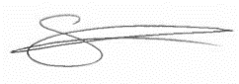
Sarah Findlater
Headteacher
Ramsey Grammar School

ParentPay
Parent App is used to communicate live achievement points, behaviour points, links to the website and notes about upcoming events. This is one of the most important methods of communication. If you do not have Parent App set up, please use this link here to access instructions to set this up on your device. The new behaviour system is here for you as a reminder of what a Level 1, Level 2 and Level 3 sanctions mean.
Mrs Corrin – Associate Assistant Head

Parent Voice Questionnaire – PGE Curriculum
This week we are asking your views on the PGE curriculum that your child has received. Please feel free to feedback to us on your views and your child’s experience of this area of our curriculum. We are looking to constantly improve and refine what we offer and how we deliver our curriculum content in all areas and welcome your input. The questionnaire can be found on our website as well as in this link.

Quote of the week:
“We rise by lifting others.” Robert Ingersoll

Throwback Y Feeagh
A new feature, intended to be lighthearted and act as a throwback to days gone by in Y Feeagh, the Ramsey Grammar School magazine.
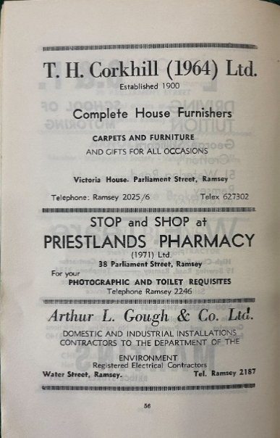
Adverts from ‘T H Corkhill Ltd’, ‘Priestlands Pharmacy’, ‘Arthur L. Gough & Co Ltd.’ From Y Feeagh 1972-1973
RGS School Farm - Piglet Update
The Tamworth x Lancet piglets have ventured outside for the first time this week and are having a wonderful time as you can see!

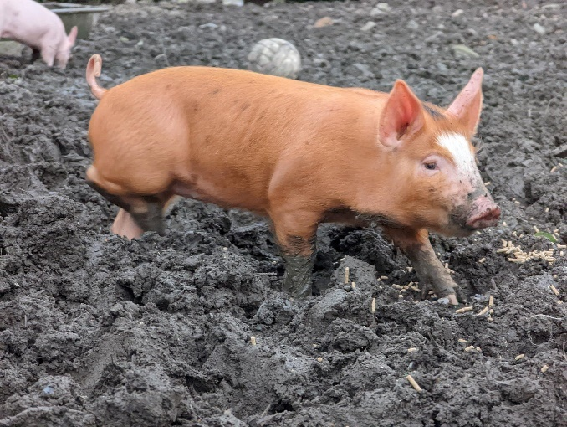

Ramsey Grammar Old Scholars

Some of you may have seen a call to Old Scholars was put out this week across our social media platforms. Responses started coming in nearly immediately. We are hoping to build a repertoire not only of the notable alumni achieving OBE, MHK, or sports accolades on a global level, but of those who have set up and sustained businesses on and off island, achieved against the odds, given back, or taken other paths. We hope to be able to document these successes both in the newsletter and in other ways to impress upon our current students both the sense of history within RGS and the many many guises that ‘success’ takes once they leave us. We would love to hear from you, your parents, family and friends who attended RGS – all responses can be emailed to RGSEnquiries@sch.im

Amazing Learning Feature - History
A highlight this week on our Amazing Learning, focusing in on History, and some shining examples of students work

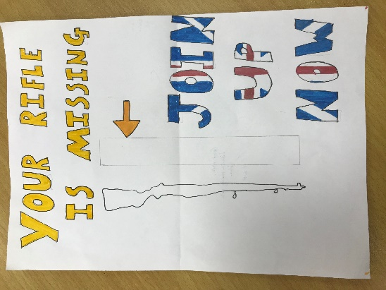
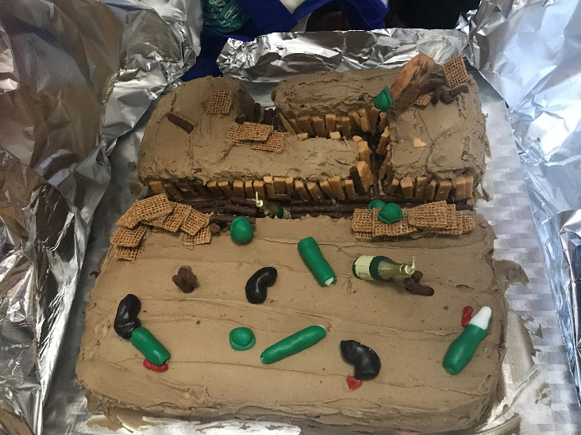
Y9 WW1 recruitment poster Trenches – models and cakes to show life in the trenches
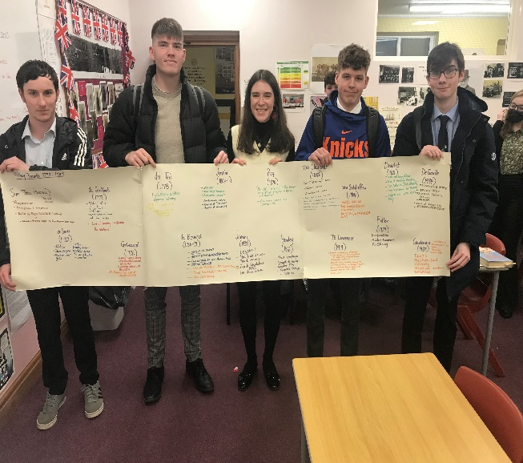
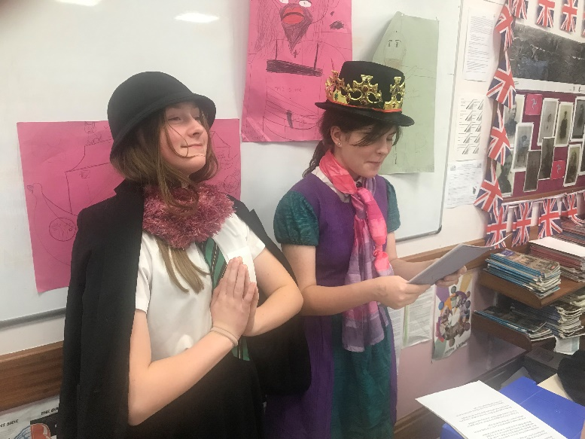Y13 synthesising understanding – timeline activity Y8 students changed the classroom into a Catholic Church (1534)
Department Update – Art
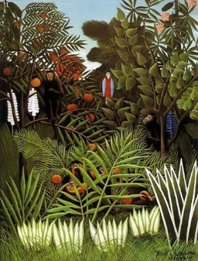
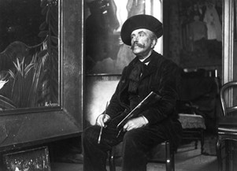
Year 7 students are learning about Henri Rousseau, an artist born on May 21, 1844, Rousseau grew up in Laval, a small town in North-Western France. He and his family moved to Angers in 1861, and Rousseau found a job as a clerk for the local bailiff. This role gained him the lifelong nickname Le Douanier, a humorous term for his occupation as a toll and tax collector. Although he didn’t pursue painting full-time until his 40s, it is quite possible that he practiced drawing during slow days at the office because he produced his first artworks around this time. He was considered an outsider in the Art world as he did not have formal training but did mix with established and recognised artists later in his life. His work is predominantly of jungles and animals, although he did not ever visit any of the native lands of some of these plants or animals. He worked from the Botanical Gardens and visited the Zoo to record his ideas and create his compositions.
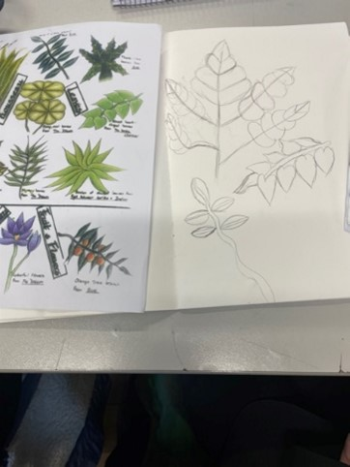
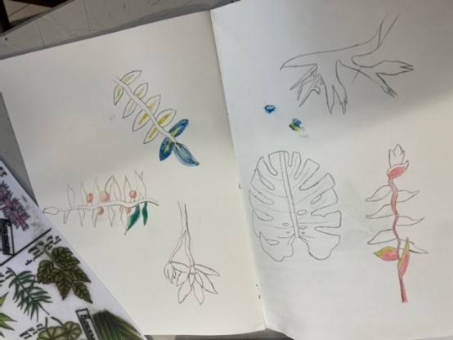
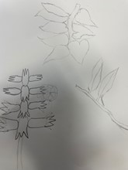
Year 7 are following in Rousseau’s footsteps and building a repertoire of work to create a Rousseau-style painting. Some of the drawings by 7R can be seen below.

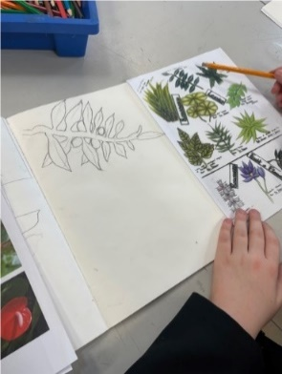
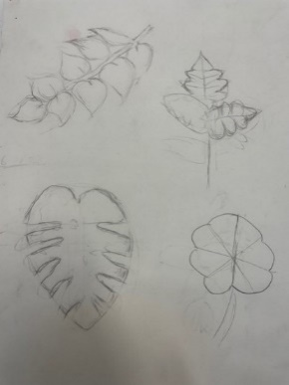
Students have been looking at drawing and painting techniques, making use of guidelines, to ensure proportion, shape and forms are accurate. They have been looking at water colour painting techniques, learning to work from light to dark and to build paint up in layers. They will develop this project further to create a Henri Rousseau Painting and the results should be exciting.

Key Dates:
01st February – Staff Voice Questionnaire
11th February – Parent Voice Questionnaire (Teaching & Learning)

