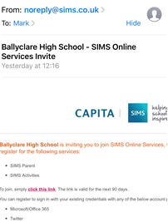
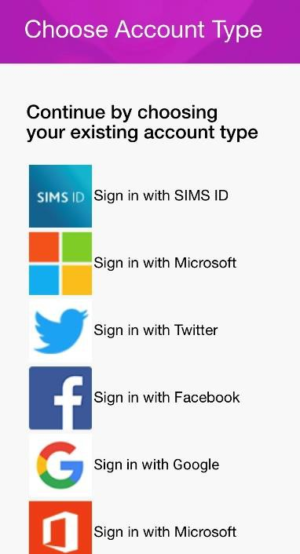
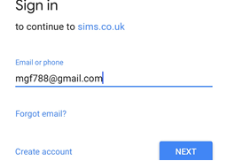
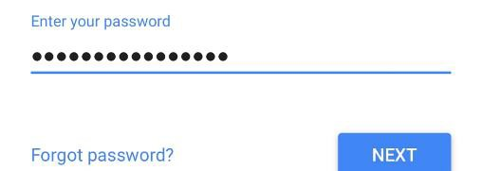
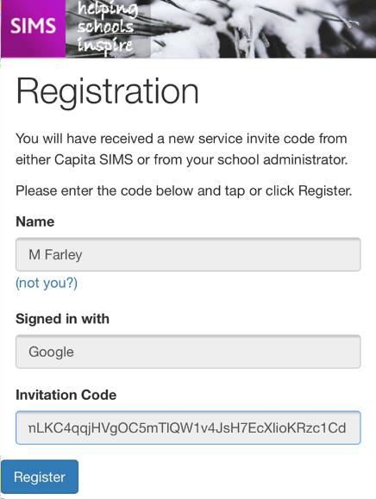
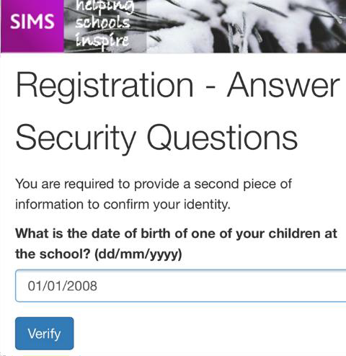
Guide for Parents – Getting the Parent App
These instructions are for use from February 2021, when adults with parental responsibility will receive an e-mail invitation to register with Parent App, this will go to the email stored on our Sims database.

You can use it on your computer or mobile phone/tablet. To use the Parent App on your phone or tablet there are two steps. The first is registering with the Parent App and the second is downloading and connecting the app. Capita make SIMS, the Management Information System which Manx schools use to keep pupil data.

Registering
- The school will instigate an e-mail from noreply@sims.co.uk – Click on “click this link” to get started.
Ramsey Grammar School- SIMs Online Services Invite

- You can sign up with a pre-existing account so that you don’t have to make a new one. To do this click on something that you already have an account for. This guide uses Google/Gmail. Unfortunately,
Twitter doesn’t seem to be working but you can use Facebook.

- Enter your Google username and password.

- The registration screen should appear with a very long code already inserted. Click Register. (The code is also in the e-mail.)

- You will need to type in the birthday of any one of your children at the school in the format shown, then you should be registered/ logged in.

Signing in on a PC
  - Open your browser and go to www.sims-parent.co.uk . You can also type “sims parent” into a search engine like Google.

  - Sign in with the same account that you used for registering earlier.

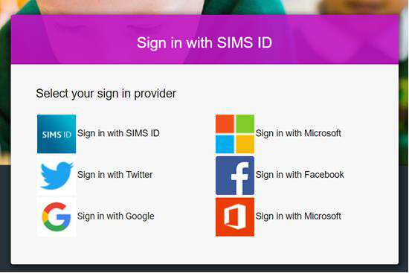
  - Type in your username/password.

SIMS [ Parent | Ramsey Grammar School | Sign Out
Ramsey Grammar School  01624 811000  ✉rgsenquiries@sch.im  www.rgs.sch.im | RAMSEY GRAMMAR SCHOOL  DELIVERING EXCELLENCE FOR ALL
✉Messages 1 NEW  Behaviour incident Update for Laura 20 Jan | Calendar 0 today  0 tomorrow | Activities
L
Laura
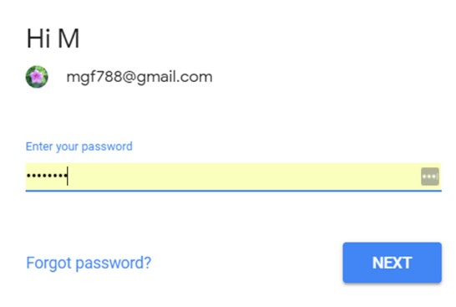

Signing in on an Android Phone/Device
- Open the Play Store, search for and install the SIMS Parent App.
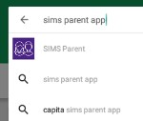
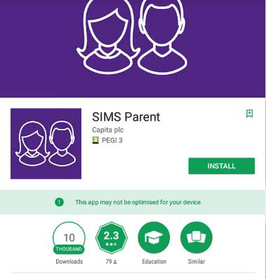
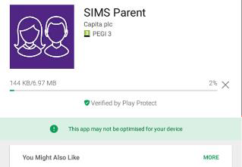

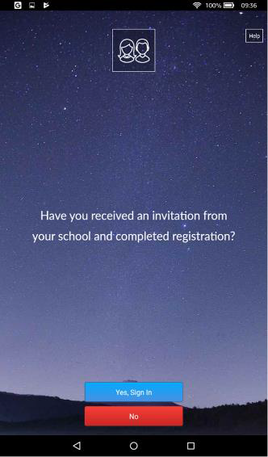
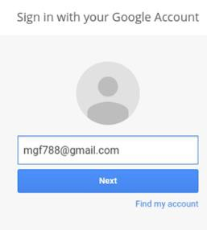
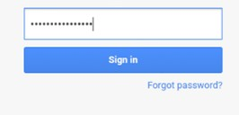
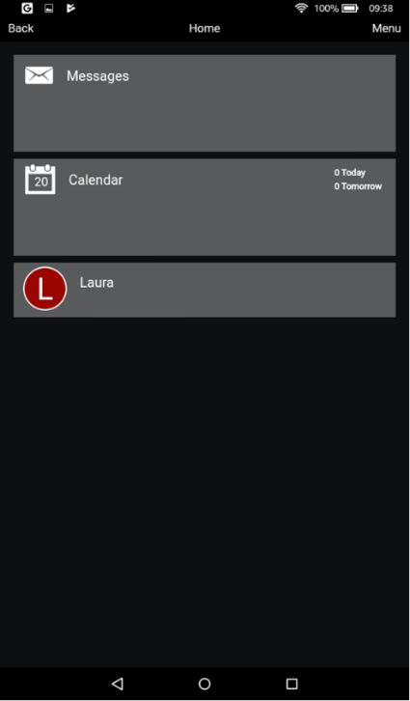
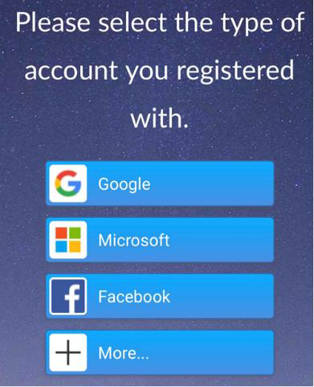
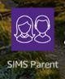
- Open the app and sign in with the same account you used for registering.

Signing in on an iPhone/iPad

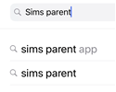
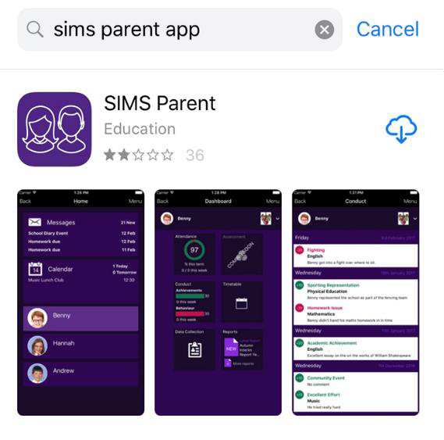
Open the App Store, search for and install the SIMS Parent App.

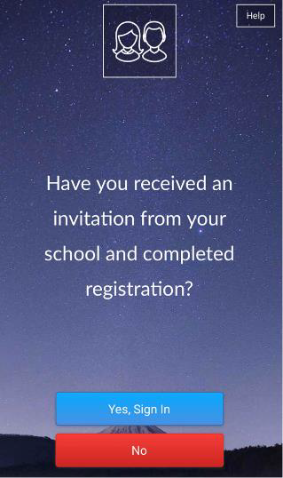
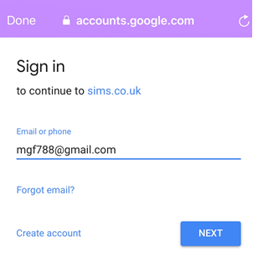
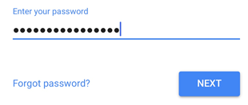
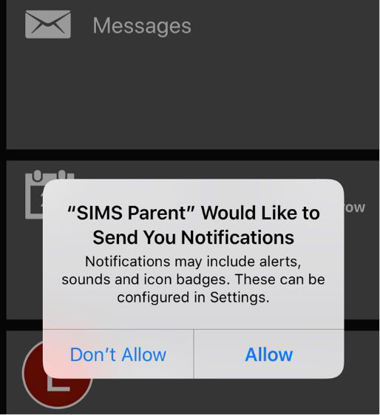
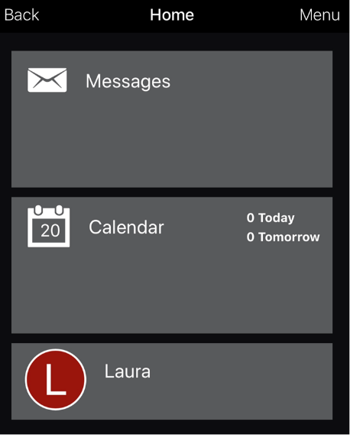
  - Open the app and sign in using the same account as before. This is similar to when you were registering.

