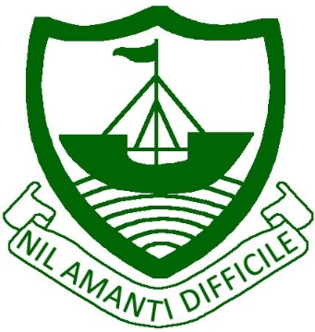
RAMSEY
Isle of Man
IM8 2RG

Telephone: 01624 811100
Fax: 01624 811101
E Mail: RGSenquiries@sch.im

Ramsey Grammar School
Scoill Ghrammeydys Rhumsaa

Headteacher
Ardynseyder
A G Baker M Ed NPQH

February 2020

Dear Parent/Carer

Year 13 BTEC Sports Events

As part of the BTEC Sport course, our Year 13 cohort are currently studying Unit 10: Sports Events Organisation. As a double award student, your son/daughter is invited to attend 2 mornings of organised activities in order to have participants for the events. There is a cost involved in attending both of these days which is unavoidable, however both groups have tried to keep costs to a minimum. The details of both of these events are as follows:-

Thursday 12th March
RGS students should get the collaboration bus from RGS East Building at 8.45am and meet the QEII students at the Tommy Clucas Sports Hall. They should wear sportswear and trainers.

The students will spend an hour participating in multi-sports in the Sports Hall before being transferred by minibus to the Fun Farm in Lonan. They will take part in a game of Laserblast and Bowling, as well as having lunch. The total cost for the day is £15 and includes lunch of either Sausage and Chips OR Chicken Nuggets and Chips. (Please circle your choice on the reply slip).

Thursday 26th March
This day will consist of a morning of Laser Mayhem followed by lunch at the Coffee Cottage.
We will leave RGS at 8.40am prompt in a minibus taxi, with a pick up at QEII at 9.10am before heading to South Barrule Plantation. We will return back in a minibus taxi and be back at school at approx 2pm. The cost of the day is £20 for Laser Mayhem plus the cost of lunch which is payable on the day (see menu below with prices, please fill in the pre order form).
Your son/daughter should wear appropriate clothing for the conditions at Laser Mayhem and a spare change of trainers is advisable.

Please complete the consent form at the bottom of this letter and return, along with the OSV form and your payment of £35, by Friday 6th March to RGS East Office.

Kind Regards,

Mrs T Mooney
Head of Girls PE and Teacher in charge of BTEC Sport
-------------------------------------------------------------------------------------------------------------------------------
Year 13 BTEC Sports Events

I give my permission for _____________________________ to attend the BTEC Sports Events on Thursday 12th March and Thursday 26th March 2020. I enclose £35 payment made payable to Ramsey Grammar School.

LaserBlast meal choice – Sausage & Chips / Nuggets & Chips (Please circle)

Coffee Cottage meal choice - ____________________________________________

Signed__________________________________________ Parent/Carer Date:_____________

